**i An update to this article is included at the end**



Waste Management 32 (2012) 890–900

Contents lists available at SciVerse ScienceDirect

Waste Management

journal homepage: [www.elsevier.com/locate/wasman](http://www.elsevier.com/locate/wasman)

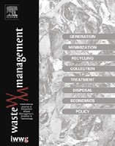

# Projecting the environmental proﬁle of Singapore’s landﬁll activities: Comparisons of present and future scenarios based on LCA

## Hsien H. Khoo a,⇑, Lester L.Z. Tan b, Reginald B.H. Tan b

a *Institute of Chem. & Engr. Sciences, 1 Pesek Road, Jurong Island, Singapore 627833, Singapore*

b *Natl. Uni. Singapore, Dept. Chem. & Biomolecular Engr., 4 Engineering Drive 4, Singapore 117576, Singapore*

### a r t i c l e i n f o

*Article history:*

Received 14 June 2011

Accepted 8 December 2011

Available online 16 January 2012

*Keywords:*

Life cycle assessment Landﬁll

Incineration ashes Transport emissions Land use

Lifespan

### a b s t r a c t

This article aims to generate the environmental proﬁle of Singapore’s Semakau landﬁll by comparing three different operational options associated with the life cycle stages of landﬁlling activities, against a ‘business as usual’ scenario. Before life cycle assessment or LCA is used to quantify the potential impacts from landﬁlling activities, an attempt to incorporate localized and empirical information into the amounts of ash and MSW sent to the landﬁll was made. A linear regression representation of the relation- ship between the mass of waste disposed and the mass of incineration ash generated was modeled from waste statistics between years 2004 and 2009. Next, the mass of individual MSW components was pro- jected from 2010 to 2030. The LCA results highlighted that in a ‘business as usual’ scenario the normal- ized total impacts of global warming, acidiﬁcation and human toxicity increased by about 2% annually from 2011 to 2030. By replacing the 8000-tonne barge with a 10000-tonne coastal bulk carrier or freigh- ter (in scenario 2) a grand total reduction of 48% of both global warming potential and acidiﬁcation can be realized by year 2030. Scenario 3 explored the importance of having a Waste Water Treatment Plant in place to reduce human toxicity levels – however, the overall long-term beneﬁts were not as signiﬁcant as scenario 2. It is shown in scenario 4 that the option of increased recycling championed over all other three scenarios in the long run, resulting in a total 58% reduction in year 2030 for the total normalized results. A separate comparison of scenarios 1–4 is also carried out for energy utilization and land use in terms of volume of waste occupied. Along with the predicted reductions in environmental burdens, an additional bonus is found in the expanded lifespan of Semakau landﬁll from year 2032 (base case) to year 2039. Model limitations and suggestions for improvements were also discussed.

© 2011 Elsevier Ltd. All rights reserved.

1. Introduction

The small island state of Singapore, spanning about 710 km2 in total land area, is densely populated with about 5 million people in 2010 (Statistics Singapore, 2011). With its robust industries and active economy, the nation faces limited land available for the dis- posal of municipal solid wastes (MSW). This makes sustainable waste management especially important. Singapore has experi- enced a steady increase in the amount of MSW generated since the 1970s. Between 2000 and 2009, total mass of MSW generated in Singapore has increased by 31%, from 4.6 million tonnes in 2000 to 6.1 million tonnes in 2009 (MEWR, 2010). MSW in Singapore can be classiﬁed into two primary categories according to the National Environmental Agency (NEA, 2010a) of Singapore:

1. Incinerable waste materials.
2. Inert, non-incinerable MSW.

⇑ Corresponding author. Tel.: +65 6796 3952; fax: +65 6267 8835.

*E-mail address:* [khoo_hsien_hui@ices.a-star.edu.sg](mailto:khoo_hsien_hui@ices.a-star.edu.sg) (H.H. Khoo).

The only landﬁll in the country’s size-constrained land area is situated 30 km offshore south of its mainland. Inert, non-inciner- able MSW, which is sent to the offshore landﬁll located on Sema- kau island, comprises mainly of construction and demolition (C&D) debris, treated sludge, and used slag (MEWR, 2010). Presently, trucks collect ash from incineration plants and inert waste from the main island to transfer them to Tuas Transfer Marine Station (TMTS). From there a barge is used to ferry the waste materials to Semakau landﬁll. The landﬁll has a capacity of 63 million m3.

* 1. *Incinerable and non-incinerable waste materials*

Incinerable waste materials, which comprise of various types of plastics, wood, cardboard, textiles, organic wastes and other sub- stances are sent to incineration plants. The incineration of MSW in turn produces bottom and ﬂy ash which is redirected to Sema- kau landﬁll. In order to forecast the amounts of wastes sent to the landﬁll, ultimate and proximate analyses are used to identify the amount of ash generated by each speciﬁc MSW components

0956-053X/$ - see front matter © 2011 Elsevier Ltd. All rights reserved. doi:10.1016/j.wasman.2011.12.010

(Niessen, 2002). MSW incineration residues can be classiﬁed according to the stage of incineration during which they were re- trieved. They can include bottom ash and grate siftings (20–30%), boiler and economizer ash (approximately 10%), ﬂy ash (1–3%) and air pollution control (APC) residues (2–5%) (e.g., Sabbas et al., 2003). Bottom ash and grate siftings have been collectively classi- ﬁed as bottom ash since their differences are generally undistinguishable.

* 1. *Leachate generation*

Currently, Semakau landﬁll is classiﬁed as an inert landﬁll, the deﬁnition of which stipulates a strict barring of all organic and haz- ardous waste materials. Incinerable MSW, containing mostly or- ganic substrate from the residences, is incinerated to ensure the removal of a large percentage of organic contents before landﬁll- ing. However, even in well conﬁned landﬁlls, leachate generation is a natural consequence of ﬂuid seeping through piles of stacked landﬁlled material (Qasim and Chiang, 1994). As the landﬁll mate- rial breaks down due to the anaerobic environment, coupled with exposure to elements of nature, such as extreme heat and high humidity, soluble toxic chemicals are produced (Qian et al., 2006).

In this article, long term leachate generation behavior is taken to emulate those from a well-controlled predominantly inorganic landﬁll in Europe (van der Sloot et al., 2003). As a conservative measure, we further assume that the amounts of toxic substances from incineration ash are 10% below UK Waste Acceptance Criteria (WAC) for inert landﬁll and US EPA Acceptance criteria; and also 10% below NEA’s TCLP test for wastes from industries. A Waste Water Treatment Plant (WWTP) is being planned on Semakau to start removing toxic substances from leachate for years 2011 onwards.

This article aims to generate the environmental proﬁle of Sema- kau landﬁll by comparing a few options associated with the life cy- cle stages of landﬁlling activities, against a ‘business as usual’ scenario or base case. A ‘business as usual’ scenario of landﬁlling management indicates unchanged activities including: (i) no expansion in landﬁll size; (ii) zero increase in recycling rates; and, (iii) no efforts on waste minimization.

1. Materials and methods

Before assessing the environmental proﬁle of Singapore’s Sema- kau landﬁll, an attempt to incorporate localized and empirical information into the amounts of ash and MSW sent to the landﬁll for the forthcoming years was made by performing a linear regres- sion model of the relationship between mass of waste disposed and the mass of incineration ash generated.

materials being incinerated. From the MSW statistics available be- tween 2004 and 2009 (displayed in Table A.1, Appendices), individ- ual MSW components were expressed as percentages of total MSW disposed. A trendline for each MSW component can be established as a proportion of the total MSW disposed within that year. A sec- ond set of linear regression was performed on the total mass of MSW disposed. By combining the two sets of correlation estab- lished for each individual MSW components and the total MSW disposed, the projected mass of individual MSW components from 2010 to 2030.

The projections of MSW trends were assumed to be linear. This was accomplished with the objective to present an averaged trend that has accounted for year-to-year ﬂuctuations, based on histori- cal MSW statistics. It is acknowledged that scenarios of non-linear- ity can exist. For instance, the possibility of tapering MSW percentage ﬁgures as it approaches zero, due to constrains such as peak recycling rates and various other inertia forces such as public reluctance resulting in difﬁculties with waste management policies being reinforced.

The results of the correlations are shown in Table 1. The speciﬁc volume parameters which were obtained through least square approximation were based on the waste statistics provided by NEA (1994–2010). The resultant graphs were further projected till 2030.

An estimation of the mass of total MSW disposed, incineration ash and non-incinerable MSW was performed. The period of pro- jection was determined to encompass the projected operational lifespan of Semakau landﬁll. The densities of landﬁlled MSW exhi- bit a great and direct inﬂuence on their ﬁnal volume occupied in situ. While post-landﬁlling compression effects, attributable to gravitational slide and compaction, are generally acknowledged in literature (e.g., Manfredi and Christensen, 2008), the exact dynamics and mathematical modeling of such effects are beyond the scope of this work.

The results of the projected amount of landﬁll material till year 2030 are shown in Table 2. These projected waste amounts will be used as inventory input for the LCA investigation. Veriﬁcation of the ﬁtted parameters for speciﬁc volumes was conducted through the comparison of the lifespan calculated by the model with ofﬁcial landﬁll lifespan reported by Singapore’s National Environmental Agency (NEA). The results displayed in Table 3 demonstrate that there exists a reasonable agreement between the projected results and the ofﬁcial NEA ﬁgures of Semakau lifespan.

Table 1

Sets of equations correlating MSW component percentages with total MSW disposed.

MSW component Percentage correlation equation (*Y* = %, A = Year)

*Non-incinerables*

Sludge *Y* = -0.0258A + 55.85

Slag *Y* = -0.2939A + 590.87

* 1. *MSW component projection*

Landﬁll models are often compromised by inherent methodo- logical uncertainty since primary landﬁll statistics are usually

Construction & demolition waste

Others (non- incinerables)

*Incinerables*

*Y* = -0.0772A + 155.94

*Y* = 0.1078A-215.35

scarce (Doka, 2007; Doka and Hischier, 2005). Since MSW is either incinerated or landﬁlled directly in Singapore, the mass of inciner- ation ash can be expressed as an autonomous function of the mass of MSW disposed:

Ferrous metals *Y* = -0.1131A + 229.44

Scrap tyres *Y* = -0.0345A + 69.464 Non-ferrous metals *Y* = -0.0357A + 72.194 Wood *Y* = -0.6672A + 1343.3

Paper *Y* = 0.3862A-751.49

Massash

¼ *f* ðMSWdisposed

; MSWlandfilled

Þ ð1Þ

Horticultural waste *Y* = 0.3644A-726.31 Glass *Y* = -0.1051A + 213.13

The waste management department of NEA has provided a ﬁxed list of incinerable and non-incinerable materials (NEA, 2011). Based on this set of guidelines, the resultant linear projection of incineration ash amounts is directly dependant on the incinerable and non-incinerable fractions of MSW generated. This simply means that ash materials increase linearly with more waste

Food *Y* = 0.1429A-266.94

Textiles *Y* = -0.0754A + 154.98

Plastics *Y* = 0.1729A-323.16

Others (incinerables) *Y* = 1.0892A-2177.6

MSW component Correlation equation (A = year, *X* = mass of MSW

disposed in million tonnes) Total MSW disposed *X* = (-16.903A + 36497)/1000

Table 2

Projected amount of wastes landﬁlled till 2030.

|  |  |  |  |  |  |  |
| --- | --- | --- | --- | --- | --- | --- |
| Year | Million tonnes |  | Year | Million tonnes |  |  |
|  | Mass Ash  According to statistics | Total MSW non-incinerable |  | Mass Ash  Projected | Total MSW non-incinerable |
| 1999 | 0.433 | 0.309 | 2010 | 0.550 | 0.157 |  |
| 2000 | 0.433 | 0.245 | 2011 | 0.561 | 0.153 |  |
| 2001 | 0.446 | 0.236 | 2012 | 0.572 | 0.152 |  |
| 2002 | 0.560 | 0.200 | 2013 | 0.582 | 0.151 |  |
| 2003 | 0.510 | 0.190 | 2014 | 0.592 | 0.150 |  |
| 2004 | 0.520 | 0.220 | 2015 | 0.602 | 0.149 |  |
| 2005 | 0.483 | 0.231 | 2016 | 0.611 | 0.148 |  |
| 2006 | 0.501 | 0.218 | 2017 | 0.621 | 0.147 |  |
| 2007 | 0.516 | 0.174 | 2018 | 0.630 | 0.146 |  |
| 2008 | 0.542 | 0.170 | 2019 | 0.639 | 0.145 |  |
| 2009 | 0.561 | 0.156 | 2020 | 0.648 | 0.145 |  |
|  | | | 2021 | 0.657 | 0.145 |  |
| 2022 | 0.666 | 0.146 |  |
| 2023 | 0.674 | 0.147 |  |
| 2024 | 0.682 | 0.148 |  |
| 2025 | 0.690 | 0.149 |  |
| 2026 | 0.698 | 0.149 |  |
| 2027 | 0.705 | 0.150 |  |
| 2028 | 0.713 | 0.151 |  |
| 2029 | 0.720 | 0.151 |  |
| 2030 | 0.727 | 0.152 |  |

Table 3

Comparison of modeled landﬁll lifespan against NEA ofﬁcial landﬁll lifespan.

air emissions, and potential leachate generation and its level of toxicity will also be analyzed. The impact of land use will be esti-

Year Modeled landﬁll lifespan (years)

Ofﬁcial NEA landﬁll lifespan (years)

mated according to Semakau’s landﬁll capacity. Impacts of biodi- versity and marine ecosystem will be excluded from the study.

2004 37.7 35–40

2005 40.5

2006 39.1

2007 38.1

2008 36.3

2009 35.1 35–45

2010 35.8

* 1. *Life cycle assessment*

Life Cycle Assessment is an objective-driven scientiﬁc tool ap- plied to assist in the evaluation of system performance by investi- gating the process transformation of products from cradle to grave. LCA can be applied to evaluate various parameters within different waste management or treatment systems and their associated gen- eration of by-products (Obersteiner et al., 2007; Khoo et al., 2010). LCA models have become the principal decision support tools for decision and policy makers at all levels for waste management strategies (Khoo, 2009; Manfredi and Christensen, 2008) and can also be effectively utilized in support of waste management plan- ning (Thomas and McDougall, 2004; Özeler et al., 2006).

Landﬁll models for LCA study are still in its infant stages of development, despite the potential pollution from landﬁlls that can affect human health and the natural environment (e.g., Damgaard et al., 2011). Moreover, land use impacts in LCA, espe- cially for landﬁlls, are yet to be well established or standardized (Obersteiner et al., 2007). Therefore the scope of ‘land use’ in the present investigation is limited to the volumetric space occupied.

* + 1. *LCA goal and scope*

The goal of the LCA is to quantify the annual impacts arising from the landﬁlling process of MSW in Singapore, taking into ac- count the number of road trips and sea transportation necessary in an annual basis, as well as, the pollution from these transport modes. Energy used for landﬁll operations and their associated

The amounts of waste landﬁlled from Table 2 (years 1999– 2009; and 2010–2030) are used as input to the LCA model. The LCA objectives in this research are to quantify the potential envi- ronmental proﬁle of landﬁlling activities of four simulated scenar- ios with different operating conditions.

* + 1. *Functional unit*

The functional unit for this LCA model, in accordance with ISO 14040 regulations, has been deﬁned as:

Per year of Singapore-generated landﬁll material, comprising a mixture of both incineration ash and non-incinerable MSW in variable proportions.

The composition of millions of tonnes of MSW on an annual ba- sis is according to historical waste statistics available from NEA for the period 2004–2009, and subsequently modeled projections for 2010–2030 based on correlations of MSW components.

* + 1. *System boundary*

The LCA system boundary for Semakau landﬁll is illustrated in Fig. 1. The stages associated with the life cycle of MSW landﬁlling system begin with the transportation of MSW by trucks from var- ious incineration plants and MSW sorting and handling facilities to Tuas Marine Transfer Station (TMTS). Barges facilitate the transport of MSW to Semakau island. Landﬁlling operations include loading/ unloading, ﬁlling and compacting of wastes. Energy demands from diesel power generators were accounted as they were necessary to power the activities on Semakau landﬁll. In the LCA model, the amounts and components of waste material ﬂow are simulated according to the amounts shown in Table 2 for all cases except for changes in increased recycling rates.

Based on discussions with waste disposal personnel, the follow- ing are modeled in the LCA system:

* Scenario 1 (base case). The ﬁrst scenario refers to ‘business as usual’ where the following operating conditions are applied:

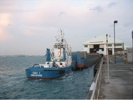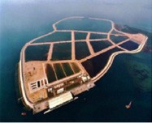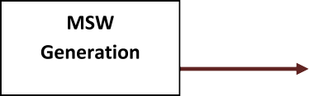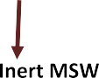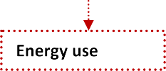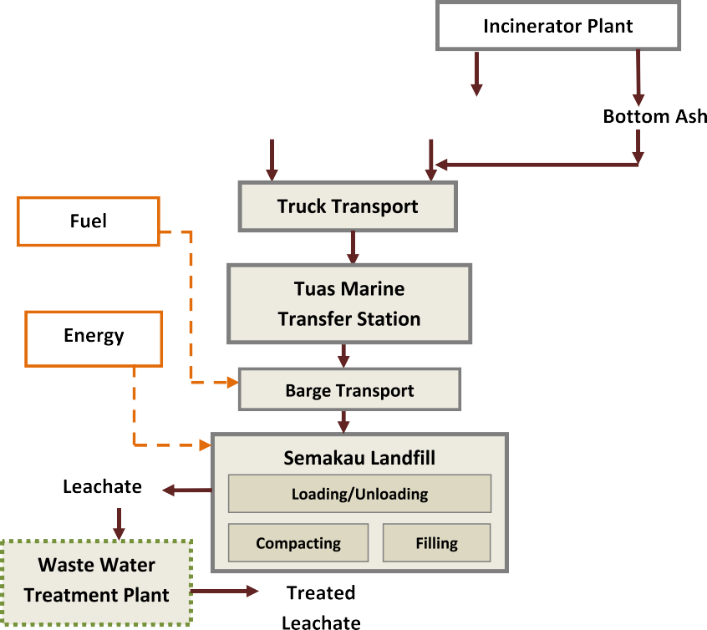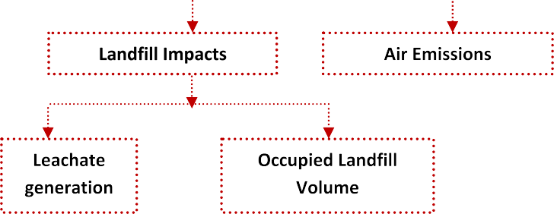

Fig. 1. LCA system boundary for Semakau landﬁll.

* 1. Energy requirements and their associated emissions to oper- ate Semakau landﬁll processes are all diesel generated.
  2. Truck emissions are modeled according to the latest Euro models (Euro II in 1999; Euro III in 2004; Euro IV in 2005 and Euro V in 2009 onwards); the exact timing and routes for road truck transportations are not considered as they are expected to have a negligible effect on the overall impacts.
  3. A diesel-powered barge with a carrying capacity of 8000 ton- nes is used to ferry waste from TMTS to Semakau.
  4. The amounts of toxic substances from incineration ash are 10% below UK Waste Acceptance Criteria (WAC) for inert landﬁll and US EPA Acceptance criteria; and also 10% below NEA’s TCLP test for wastes from industries.
* Scenario 2. In the second case, the barge is replaced by a fuel oil-

powered coastal bulk carrier or freighter with a carrying capac- ity of 10,000 tonnes in year 2011 onwards to ferry waste across the sea to Semakau. Apart from that, all other operating condi- tions on Semakau landﬁll remain unchanged.

* Scenario 3. In the third case, a Waste Water Treatment Plant (WWTP) is implemented to remove an additional 70% of toxic

Table 5

Barge transport emissions (SimaPro database, 2008a).

substances from leachate for years 2011 onwards. All other con-

ditions remain unchanged.

Barge transport emissions

Amount (kg/tonne- km)

* Scenario 4. In the last scenario, the recycling target of 70% set by the Singapore Green Plan 2012 is incorporated into the LCA model. Out of 70%, an estimated 26% of the waste mixtures

are classiﬁed as non-incinerables. Therefore by year 2030, 26% of non-incinerables (C&D, slag and sludge) are redirected away from landﬁlls, and the remaining 44% are the incinerable mate- rials (plastics, cardboards, paper, etc.) that will be redirected away from Singapore’s incineration plants. Hence, in the ﬁnal simulation, the waste materials from 2011 onwards are adjusted to take into account a linear increase in recycling rates from 57% in 2009 and 59% in 2010 to reach 70% in 2030. Apart

CO2 0.02814

CO 3.53 X 10-5

NOX 3.575 X 10-4

SOX 6.198 X 10-6

PM 8.865 X 10-6

HC n.a.

Barge 8000-tonne carrying capacity.

Table 6

Coastal bulk carrier/freighter (GaBi database, 2006).

from that, all other operating procedures (i–iv) remain unchanged.

Coastal carrier/ freighter

Amount (kg/tonne- km)

* + 1. *Life cycle inventory*

Due to unavailable on-site data from the landﬁll and NEA, the following was adopted:

* Euro emission standards are extracted from DieselNet (2011) and Spielmann et al. (2010).
* Generation of emissions from marine transportation and use of diesel for energy are extracted from SimaPro (2008a,b) and Gabi life cycle engineering database (2006).
  + - 1. *Transport emission.* It is assumed that all road vehicles used for delivering waste materials and ash to Tuas Marine Transfer Sta- tion (TMTS) are operating according to Euro standards for a 40- tonne truck (DieselNet, 2011; Spielmann et al., 2010). Vehicle emission standards are established in Singapore by the Ministry of Environment’s Pollution Control Department (PCD) that enforces stringent actions against road transport pollution. Based on this criteria, the latest Euro models are applied for truck transportation. The sample emissions of the latest Euro V are shown in Table 4. The shortest reasonable routes was assumed to be that adopted by col-

CO2 0.016

CO 1.87 X 10-5

NOX 1.38 X 10-5

SOX 1.05 X 10-6

PM 4.60 X 10-7

HC n.a.

Coastal bulk carrier/ocean freighter 10,000-tonne car- rying capacity.

transport vessels operated in an efﬁcient manner and adopted the shortest and most conventional route to Semakau landﬁll, translat- ing into a nautical mileage of 30 km each trip. The weather and sea conditions were assumed to exhibit negligible effects on marine transportation.

In the same manner as road transport vehicle, the number of trips by barge/bulk carrier necessary are estimated as: (*tonnes of waste per year*)/(*marine transport carrying capacity*).

Based on a carrying capacity of 8000-tonnes and 10,000-tonnes, the estimated number of trips for each year is projected. The re- sults are compiled in Table C.1 (Appendices). Marine transporta- tion emissions (in total kg/year) for both barge and coastal bulk carrier are calculated as:

lection trucks in their routine plying between incineration plants,

No: of trips X pollutant in kg

X wasteðtonneÞ

MSW sorting facilities and TMTS. The estimated average distance

year

tonne • km

is taken as 20 km for the transfer of MSW to TMTS. The number of road trips (or trucks) in a year is estimate as: (*tonnes of waste per year*)/(*truck carrying capacity*). Based on a full vehicle carrying capacity of 40 tonnes, the projected number of road trips esti- mated. The results are compiled in Table B.1 (Appendices).

The vehicle emissions (in total kg of pollutant/year) are calcu- lated as:

X distance travelledðkmÞper trip ð3Þ

* + - 1. *Leachate generation.* The leaching test acceptance criteria for landﬁll disposal of industrial waste set by NEA (2010b) is shown in Table 7. As a secondary safeguard, the acceptance criteria for toxic metals contained in incineration ash follow from the

No: of trips X

year

kg pollutant

km X distance travelledðkmÞ per trip ð2Þ

strictest of UK WAC (Waste Acceptance Criteria) for inert landﬁll and USEPA TCLP Acceptance criteria for incineration ash are dis- played in Tables D.1 and E.1 (Appendices).

The nautical mileage from TMTS to Semakau landﬁll is around

25–30 km. The barge’s carrying capacity was estimated at 8000 tonnes. Barge emissions, expressed on a basis of tonne-km are extracted from SimaPro (2008a) database for waterway barge transportation. Emissions from the 10,000-tonne coastal bulk car- rier are extracted from Gabi life cycle engineering (2006). The data are presented in Tables 5 and 6. It was assumed that both marine

Table 4

Euro V emission standards.

|  |  |  |  |  |  |  |
| --- | --- | --- | --- | --- | --- | --- |
| Emissions | CO | CO2 | NOX | SOx | HC | PM |
| (kg/km) | 0.00227 | 0.8 | 0.00264 | n.a. | 0.00016 | 0.00003 |

After performing stringent TCLP tests, the mixture of materials sent to Semakau are predominantly inert. Based on a three-year study of a predominantly inorganic landﬁll, van der Sloot et al. (2003) demonstrated that, despite the heterogenous mix of mate- rials, leachate characteristics met very stringent EU landﬁll criteria in The Netherlands. Since the parameters of Semakau landﬁll matches the conditions of a well-governed inorganic landﬁll in Europe, the leachate generated from the island was assumed to display the same characteristics. In addition, a conservative esti- mation of 10% below the limits set by Tables D.1 and E.1 are ap- plied for the ash materials sent to Semakau (for scenarios 1, 2 and 4).

In scenario 3 alone, the planned Waste Water Treatment Plant (WWTP) is estimated to remove another 70% of toxic levels from

Table 7

Leaching test acceptance criteria for landﬁll disposal of industrial waste (NEA, 2008b).

|  |  |
| --- | --- |
| Substrate | Acceptance limit (mg/L) |
| Arsenic | 5 |
| Barium | 100 |
| Cadmium | 1 |
| Chromium | 5 |
| Copper | 100 |
| Cyanide (total) | 10 |
| Fluoride | 150 |
| Iron | 100 |
| Lead | 5 |
| Manganese | 50 |
| Mercury | 0.2 |
| Nickel | 5 |
| Phenolic compounds (as phenol) | 0.2 |
| Selenium | 1 |
| Silver | 5 |
| Zinc | 100 |

Table 8

Pollutants in kg/kg diesel (SimaPro, 2008b).

Pollutant CO2 CO HC NOx SOx PM kg/kg diesel 0.505 0.00087 0.000021 0.00265 0.00276 0.000202

Diesel = 0.84 kg/L; caloriﬁc value = 42.9 MJ/kg.

leachate. Therefore with the WWTP in operation, a total of 80% toxic substances from leachate are removed (for years 2011 onwards).

* + - 1. *Energy utilization.* The electrical energy required for build- ing and facilities are estimated as 0.2 kWh/tonne waste (McDou- gall et al., 2004); as for landﬁll operations including loading, unloading, ﬁlling and compacting, the energy required is rated as

0.38 MJ/tonne wastes handled in all cases. The emissions for the usage of diesel-generated energy are shown in Table 8. The emis- sion data was extracted from SimaPro (2008b).

1. Results

The environmental proﬁle for scenarios 1–4 are presented as normalized results combining the total impacts of global warming potential, acidiﬁcation and human toxicity.

The selection of the impact categories is considered taking into account the unique environmental circumstances of Singapore. The set of local impact categories that are relevant to the country in- clude acidic gases, toxic substances and land use. Energy security is another challenge faced by the nation due to the lack of natural resources (Chan et al., 2012). Climate change impacts are also in- cluded due to rising concerns of global greenhouse gas emissions, along with the threats faced by small island-nations due to sea le- vel changes.

A separate comparison of scenarios 1–4 is also carried out for:

* Energy utilization. Due to lack of natural resources, the nation depends on the import of fossil fuels from other countries. Therefore a comparison of energy use is regarded as an impor-

tant element in waste management.

* Landﬁll occupation. Since there is no standard model for land use, these impacts are projected according to volume occupied (m3/year). The justiﬁcation for this comparison basis is due to

the fact that Singapore faces land constraint and the operational lifespan of Semakau is of utmost importance.

* 1. *Normalized results*

The normalization for global warming and acidiﬁcation poten- tial were carried out based on the national inventory of pollutants in Singapore as the reference system. The emission inventories are extracted from Ohara et al. (2007) and Singapore’s National Green- house Gas Inventory (2010). No local data is available for human toxicity levels and the European EDIP normalized value (Potting and Hauschild, 2003) is adopted based on the robust industrial activities and population densities found in parts of Europe that matches Singapore country proﬁle. The normalized values are dis- played in Table 9.

The ﬁrst normalized results – for scenario 1 (base case) – are displayed in Fig. 2. It is shown in the graphs that the normalized impacts are distributed quite evenly between global warming po- tential (mostly by GHGs from barge transportation), acidiﬁcation (by NOx emissions, also from barges) and human toxicity. Accord- ing to the MSW statistics (NEA, 2010b), the waste material amounts from years 1999 to 2009 does not give a well-deﬁned pat- tern therefore the same projection of the environmental burdens can be observed.

Incineration ﬂy ash and bottom ash typically shows some sub- stantial levels of toxic substances (Qian et al., 2006). Although the types of waste sent to Semakau are restricted to non-reactive, inert, inorganic and no-corrosive materials, the human toxicity results in Fig. 2 look as dominant as the results of global warming potential. It should also be highlighted that these toxicity results are estimated according to the discount of 10% below UK Waste Acceptance Criteria (WAC) for inert landﬁll, US EPA Acceptance criteria; and NEA’s TCLP test for wastes from industries.

Assuming that there are no efforts spent to minimize MSW, nor any plans to redirect MSW away from landﬁlls, the simulated trend of total impacts (global warming, acidiﬁcation, and human toxic- ity) shows a steady uphill climb from year 2010 onwards. The total impacts after year 2011 increase by about 2% annually to nearly 40% in 2030.

Figs. 3–5 display the total normalized impacts of scenarios 2, 3 and 4 respectively. For all three graphs, the normalized impacts of scenario 1 are embedded in the background for comparing various waste management options against the backdrop of ‘business as usual’.

Although the nautical mileage to Semakau is only 30 km, the accumulated emissions of exhaust gases and particles from marine

Table 9

Applied normalized values.

|  |  |  |  |
| --- | --- | --- | --- |
| Impact category | Normalized values | Unit | Reference |
| Global warming | 7569.9 | CO2 kg/capita/year | Singapore’s National Greenhouse Gas Inventory (2010) |
| Acidiﬁcation potential | 1289 | UES m2/capita/year | Ohara et al. (2007) |
| Human toxicity | 1.70 X 108 | m3/capita/year | Adopted from EDIP 2003 |

Based on Singapore population of 5.08 million in 2010 (Statistics Singapore, 2011).

896 *H.H. Khoo et al. / Waste Management 32 (2012) 890–900*

Fig. 2. Normalized results (scenario 1: base case).

transportation over a year can be rather signiﬁcant. Research on pollution from sea transport has already been done extensively as a call for marine emission exhaust reductions (e.g., Eyring et al., 2010). In scenario 2 (Fig. 3), the diesel-powered barge with a carrying capacity of 8000-tonne is replaced by a heavy fuel-pow- ered coastal carrier with a carrying capacity 10,000-tonne to trans- fer wastes from TMTS to Semakau. A higher capacity carrier reduces the trips required to ferry waste from the mainland to Semakau island. Apart from the less occurrence of pollution from the number of trips made, this option also reduces the amount of

air emissions released from marine exhaust engines. Fig. 3 shows that the potential global warming impacts decreased by around half, and acidiﬁcation impacts by at least 90%. By year 2020, the to- tal normalized impacts are 48% lower than scenario 1; and by 2030, a 50% reduction can be realized.

As anticipated, the results in scenario 3 show that human toxic- ity impacts dropped uniformly each year by 70% with the WWTP in operation (Fig. 4). The resultant total normalized impacts from years 2011 to 2030 are approximately 24% lower than those of scenario 1.

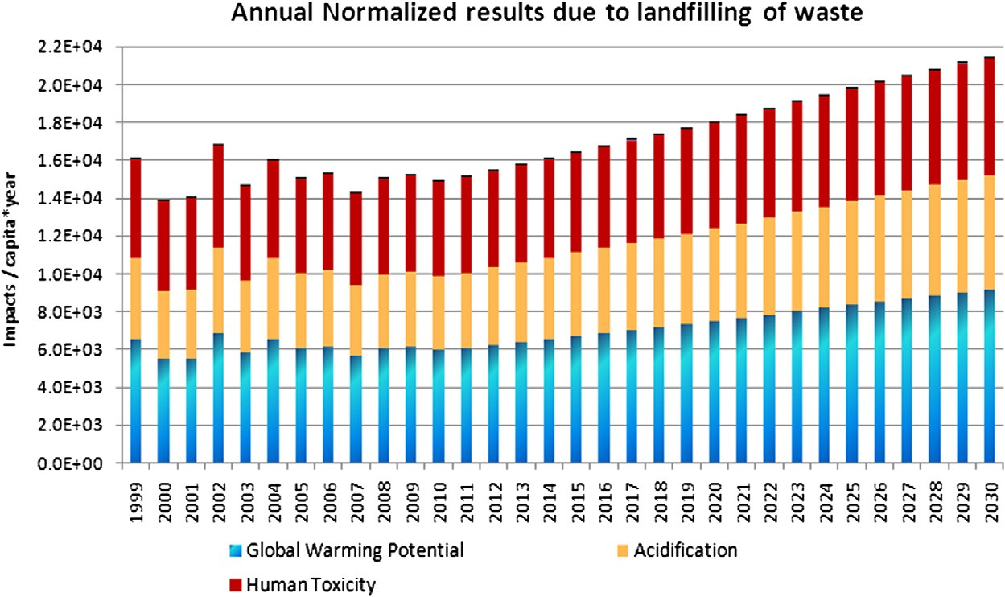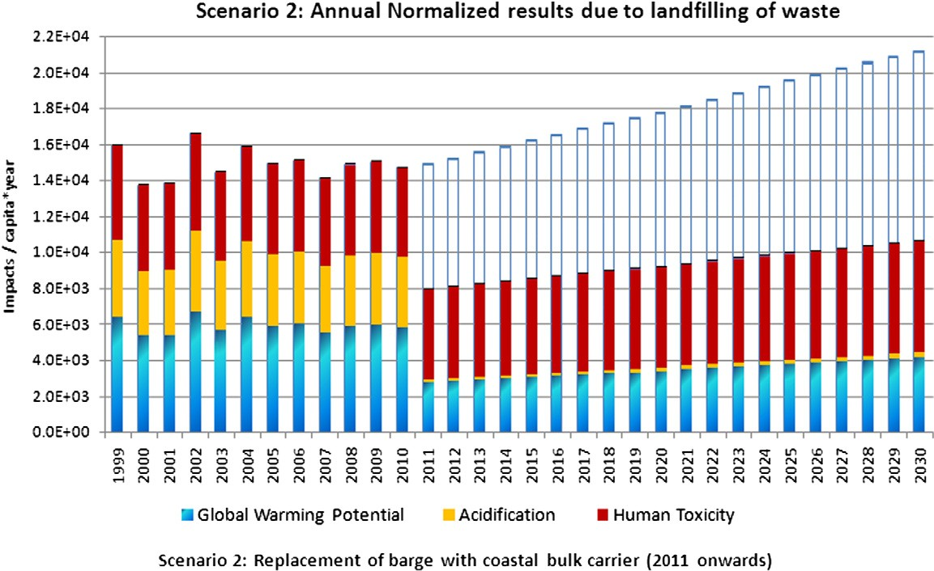

Fig. 3. Normalized results (scenario 2).

*H.H. Khoo et al. / Waste Management 32 (2012) 890–900* 897

Fig. 4. Normalized results (scenario 3).

Fig. 5. Normalized results (scenario 4).

Finally, for scenario 4 (Fig. 5), a steady downward trend of all combined main impacts (global warming potential, acidiﬁcation and human toxicity) can be clearly observed. Although the envi- ronmental beneﬁts observed are initially shown as small gradual reductions (compared to scenarios 2 and 3), the beneﬁts increases substantially with time. At the year end of 2030 where the 70% recycling target is met, the overall normalized impacts are reduced by around 58%, as compared to the base case 1.

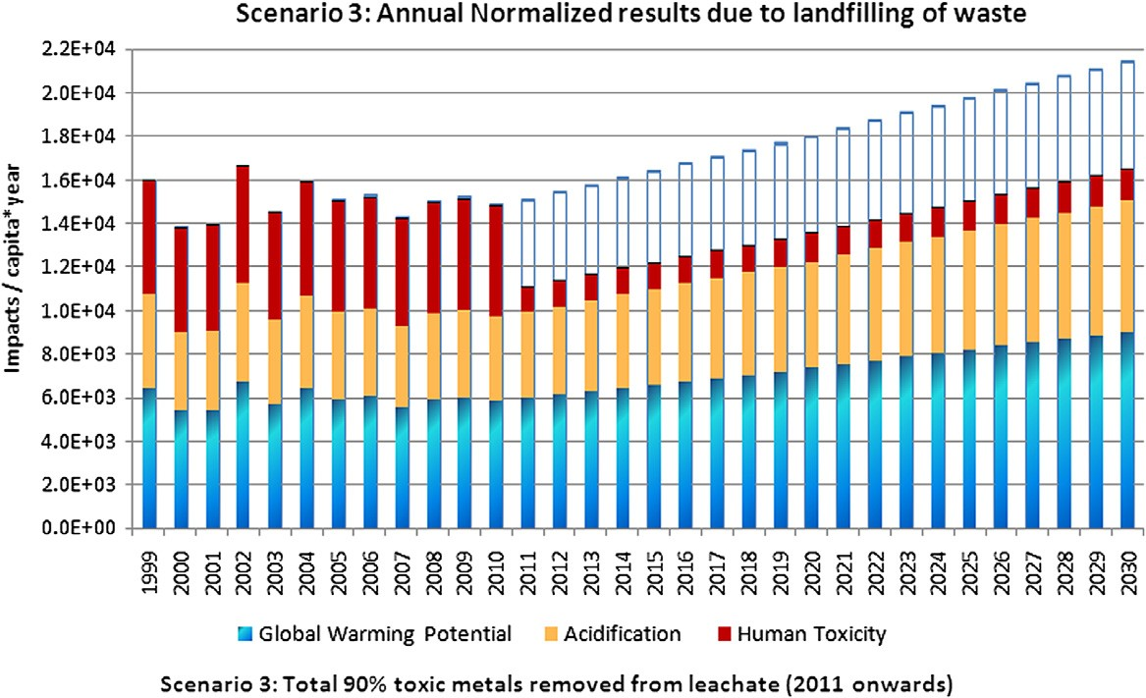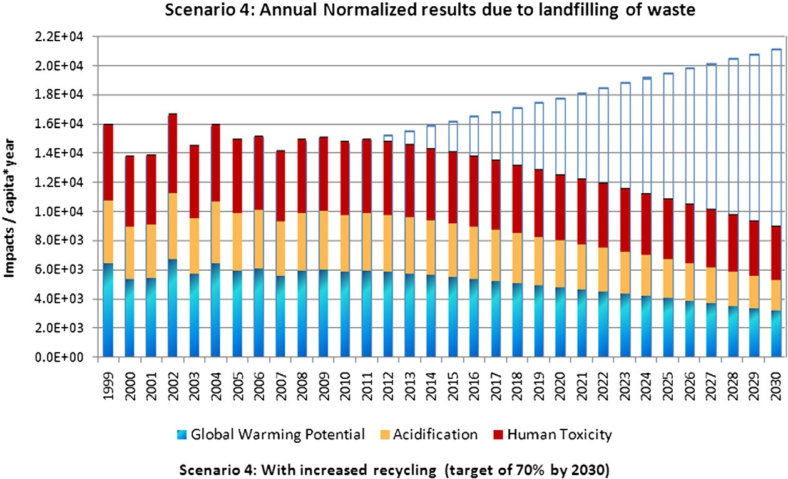

Normalization for land use and energy use are not usually in- cluded in normalization and are therefore presented separately.

* 1. *Energy utilization*
     1. *Scenarios 1, 2 and 3*

Energy security is one of the main challengers for the small is- land nation as Singapore lacks natural resources (Chan et al., 2012).







Fig. 6. Comparison of energy utilization with increased recycling rate.

Assuming that no measures are taken to reduce the nation-wide waste disposal rates, a steady uphill climb of energy utilization can be anticipated for the projected years of 2011–2030. This up- ward trend is expected in Semakau as a result of increased activity necessary to handle a corresponding higher MSW landﬁll load. Based on the pattern of waste generation over the years, the annual increase in energy demands is predicted at approximately 1% per annum. If the trend of MSW continues to climb, the total energy consumed is expected to be over 18,000 MJ per year in 2030.

* + 1. *Energy utilization in scenario 4 (70% recycling rate by 2030)*

A comparison between scenarios 1 and 3 with scenario 4 for en- ergy utilization is displayed in Fig. 6. As the recycling rates were gradually increased year-by-year, the potential energy savings in- creased from around 2% in 2012 to 19% in year 2020 and ﬁnally

to 40% in 2030.

* 1. *Landﬁll occupation*
     1. *Scenarios 1, 2 and 3*

Land use impact can be characterized by the percentage of decreasing volume of landﬁll available. The computation of volu- metric impact is performed through a summation of mass–volume conversion after accounting for the densities of incineration ash, q*ash* , and non-incinerable MSW, qlandfilled, listed in Eq. (4). Speciﬁc

volumes, 1/qash and 1/qlandﬁlled, were obtained through a simulta-

neous *least-square approximation* parameter ﬁtting with MATLAB based on the NEA statistics available in 2003 and 2004. They corre- sponded to: 3161.9 m3/kg for incineration ash and 124.3 m3/kg for non-incinerable MSW.

63 X 106*m*3

Volume of landfill material ¼ *L*

1 1

¼ ðMassashÞþ

q

q

ash landfilled

maintain the same uphill trend as those projected in Table 2, the estimated volume occupied will increase by approximately 3% per year. It is deduced that by the year 2030, only 3.33% of the landﬁll capacity remains available, which translates into a remain- ing lifespan of approximately 2 years. This implies that the contin- uous uphill trend of annual waste generation by a population size of 5 million will unfortunately cause Semakau’s lifespan to end around year 2032.

In order to prolong the lifespan of the landﬁll, recycling rates have to be signiﬁcantly increased. This action requires nation-wide efforts to involve active participation from both households and industry. Another option, waste minimization, is not explored here due to lack of supporting data on the exact types of MSW that can be reduced in Singapore Green Plan 2012 (MEWR, 2006).

* + 1. *Landﬁll occupation in scenario 4 (70% recycling rate by 2030)*

In scenario 4, the recycling target of 70% set by the Singapore Green Plan 2012 is incorporated into the LCA model. Out of 70%, an estimated 26% of the waste mixtures are classiﬁed as non- incinerables. Therefore by year 2030, 26% of non-incinerables (C&D, slag and sludge) are redirected away from landﬁlls, and the remaining 44% are the incinerable materials (plastics, card- boards, paper, etc.) that are redirected away from Singapore’s incineration plants.

Fig. 7 displays the comparison between the cumulative landﬁll volume occupied and the remaining volume capacities for both normal vs. increased recycling cases. Inevitably, increased recy- cling activities will cause fewer amounts of waste materials and ash transferred to Semakau. In the simulated results for scenario 4, the remaining landﬁll volume in year 2030 increased from 3.33% (scenarios 1, 2 and 3) to around 18.5%, which means having a remaining lifespan of about 9 years, therefore enabling the land- ﬁll lifespan to last till year 2039.

*Where*

X ð*Mass*landfilledÞ ð4Þ

NEA’s projection of Semakau landﬁll lifespan, starting from 2009 onwards, is 30–45 years. Taking a conservative value of 30 years, the lifespan of the landﬁll is planned to last till the year

*L = landﬁll lifespan, dated from 1999* 63 X 106 m3 = total landﬁll

capacity.

Since the amount of environmental burdens are directly linked to the amounts of wastes that have to be handled, it has to be highlighted that the linear regression modeling of MSW (from Sec- tion 2.1) form the basis of the environmental impacts for years 2011 till 2030. Assuming that the landﬁlled waste amounts

2039, which is in agreement with the projected values displayed in Fig. 7. It has to be highlighted however, that the goal of 2039 life- span can be only realized with the recycling target of 70% by 2030 in place. Another accompanying solution is to expand the landﬁll beyond its present capacity of 63 million m3. This scenario also as- sumes that the mass of MSW generated is not reduced but follows the linear trend projected earlier in Section 2.1.

*H.H. Khoo et al. / Waste Management 32 (2012) 890–900* 899







Fig. 7. Comparison of percentage landﬁll volume capacity (scenarios 1, 2 and 3) with increased recycling (scenario 4).

1. Discussions
   1. *Model limitation*

Semakau landﬁll is a tightly regulated landﬁll for the disposal of inert, inorganic wastes. Due to lack of information, the characteris- tics of leachate generated from Semakau is expected to comply with a tightly-controlled inorganic landﬁll found in The Nether- lands (van der Sloot et al., 2003). It is suggested, however, that more realistic results can be obtained if on-site data is available from Semakau landﬁll.

The trend lines generated in the article are modeled to give an overall pattern of waste disposal amounts – consisting of mixtures of ﬂy ash, bottom ash, and inert MSW – that are fated to be land- ﬁlled each year. In the model, each volumetric amounts of ash pro- jected from each speciﬁc or individual waste types are dissolved in the accumulated total. Another limitation is found in the linear nature of the projections; the inﬂuence of waste generation due to changes in economic trends, population growth and any other social indicators were not factored in any of the cases. Such dyna- mism (if proven necessary) would require a highly in-depth study using a highly sophisticated waste management model.

Despite these few limitations, the resultant graphs displayed an overall trend that that is in reasonably good agreement with the ofﬁcial estimated lifespan of Semakau landﬁll. Moreover, it was anticipated that despite ﬂuctuations caused by the waste genera- tion behavior of 5 million people, an uphill trend will still be ob- served in the graphs, and its associated environment results, if no strategic changes are introduced into Singapore’s waste dis- posal activities.

* 1. *Implications for waste management*

With limited land available (710 km2) for the disposal of wastes, sustainable waste management becomes especially impor- tant. Overall, the LCA results highlight that the major environmen-

tal impacts of landﬁlling activities. In the LCA model, different operating options are explored and compared. In a ‘business as usual’ scenario the emissions of GHG from barge transportation to transfer waste from TMTS to Semakau are rather high, followed by acidic gases. Based on linear projection of waste amounts, the combined total impacts of global warming, acidiﬁcation and hu- man toxicity increased by about 2% annually from 2011 to 2030.

By replacing the 8000-tonne barge with a 10,000-tonne coastal bulk carrier or freighter (in scenario 2) a grand total of both global warming potential and acidiﬁcation can be realized by year 2030. Scenario 3 explored the importance of having the WWTP in place to reduce human toxicity levels – however, the overall long-term beneﬁts were not as signiﬁcant as scenario 2.

The ﬁnal environmental beneﬁts of scenario 4 championed all other cases and highlighted the importance and beneﬁts of having increased recycling activities across the nation. The target materi- als for recycling should include construction and demolition waste, plastics, cardboards, and various types of metals. Along with the predicted reductions in environmental burdens, an additional bo- nus is found in the projected expanded lifespan of Semakau land- ﬁll. One of the examples of high rates of success in recycling is demonstrated by Taiwan (Li et al., 2006). Public education, along with mandatory participation in recycling efforts nation-wide has already been proven to be successful in Taiwan. Such practices can also be emulated in Singapore. The nation has already started recycling schemes and efforts that are spearheaded by NEA, as illustrated by Zhang et al. (2010).

Generally in LCA, potential environmental impact are quantiﬁed and assessed based on input–output ﬂow of material. In this manner, the beneﬁts of operating alternatives can be compared against a base case. However, it is noted that for landﬁlling, no there is yet to be a standardized model for land use. Although presented as two separate results, the impacts of energy use and land use both emulate the steady decrease of the total (normalized) environmental impacts of scenario 4, thereby reinforcing the option of recycling over the op- tions of the other suggested operational changes in scenarios 2 and 3.

Another suggestion is to ﬁnd uses for incineration ash instead of disposing them at landﬁlls. Two such examples are found in The Netherlands and Germany. In The Netherlands, over 90% of the country’s annual bottom ash from waste incinerators are recycled as embankments and road applications; and ﬂy ash is also reused as admixture in asphalt ﬁllers (van der Sloot et al., 2001). And in Germany, approximately 60% of the bottom ash from incinerators is utilized in road construction (Vehlow, 1996). However, as ash materials are expected to meet speciﬁcations similar to construc- tion materials used for the same purpose, some quality control of incineration ash has to be implemented. Van der Sloot et al. (2001) suggested that one way to achieve this is to have more stringent criteria for waste materials sent to incinerators. The authors also introduced the treatment of incineration residues as another form of leachate control.

1. Conclusion

As Singapore advances its economic development plans and joins the ranks of other developed countries like the US and other developed nations across Europe, the country is likely to face increasing expectations to contribute to setting good sustainable environmental plans, along with tighter climate change targets that are in line with the rest of the advanced economies. In a coun- try faced with spatial constraints, Singapore continues to struggle for outward development within a conﬁned geography. As the eco- nomical development of the nation continues to rise, so does the burden of Municipal Waste Generation or MSW. For years, the dis- posal of incinerable MSW has pre-dominantly depended on incineration.

From the LCA results, it can be clearly observed the most fa- vored option for a long-term sustainable waste management sys- tem is to redirect waste away from incinerators and landﬁll by fulﬁlling the goal of 70% recycling rate by 2030. This goal is part of Singapore Green Plan 2012, which was drafted out to provide a blueprint for the nation’s holistic and long-term view of the envi- ronment with an attempt to underpin economic activities with the principle of sustainable development (MEWR, 2006). As shown in scenario 4, the option of increased recycling championed over all other three scenarios in the long run, resulting in a total 58% reduc- tion in year 2030 for the total normalized results.

The option of increased recycling championed over all other operating scenarios in the long run, resulting in a total 58% reduc- tion in year 2030 for the total normalized results. A separate com- parison of scenarios 1–4 is also carried out for energy utilization and land use in terms of volume of waste occupied. Along with the predicted reductions in environmental burdens, an additional bonus is found in the expanded lifespan of Semakau landﬁll from year 2032 (base case) to year 2039.

Appendix A. Supplementary data

Supplementary data associated with this article can be found, in the online version, at doi:10.1016/j.wasman.2011.12.010.

References

Chan, Y.T., Tan, R.B.H., Khoo, H.H., 2012. Characterisation framework development for the SIMPASS methodology. Int. J. LCA 17, 89–95.

Damgaard, A., Manfredi, S., Merrild, H., Stensøe, S., Christensen, T.H., 2011. LCA and economic evaluation of landﬁll leachate and gas technologies. Waste Manage. 31, 1532–1541.

DieselNet, 2011. EU Emission Standards for Light Commercial Vehicles. Available on-line <<http://www.dieselnet.com/standards/eu/ld.php>>.

Doka, G., 2007. Life cycle inventories of waste treatment services – Ecoinvent report No. 13, Part III Landﬁlls – Underground Deposits – Land farming, Swiss Centre for Life Cycle Inventories, Dubendorf, Switzerland.

Doka, G., Hischier, R., 2005. Waste treatment and assessment of long-term emissions. Int. J. LCA 10, 77–84.

Eyring, V., Isaksen, I.S.A., Berntsen, T., Collins, W.J., Corbett, J.J., Endresen, O., Grainger, R.G., Moldanova, J., Schlager, H., Stevenson, D.S., 2010. Transport impacts on atmosphere and climate: shipping. Atm. Environ. 44, 4735–4771.

GaBi life cycle engineering, 2006. Transport Waterway – Coastal Bulk Carrier. PE International, Germany.

Khoo, H.H., 2009. Life cycle impact assessment of various waste conversion technologies. Waste Manage. 29, 1892–1900.

Khoo, H.H., Tan, B.H., Lim, T.Z., 2010. Food waste conversion options in Singapore: environmental impacts based on an LCA perspective. Sci. Tot. Environ. 408, 1367–1373.

Li, T.L., Hsiao, T.Y., Shang, N.C., Yu, Y.H., Ma, H.W., 2006. MSW management for waste minimization in Taiwan: the last two decades. Waste Manage. 26, 661– 666.

Manfredi, S., Christensen, T.H., 2008. Environmental assessment of solid waste landﬁlling technologies by means of LCA-modeling. Waste Manage. 29, 32–43. McDougall, F.R., White, P., Franke, M., Hindle, P., 2004. Integrated Solid Waste Management: A Life Cycle Inventory, second ed. Blackwell Pub., Cornwall, UK. Ministry of Environment, 2000. Singapore’s Initial National Communication Under the United Nations Framework Convention on Climate Change (UNFCCC).

Available on-line <<http://www.unfccc.int/resource/docs/natc/sinnc1.pdf>>.

MEWR (Ministry of the Environment and Water Resources), 2010. Together a Sustainable Singapore, Available on-line <<http://www.app.mewr.gov.sg/web/> Common/homepage.aspx>.

MEWR (Ministry of Environment and Water Resources) 2006. Singapore Green Plan 2012, 2006 Edition, Ministry of Environment and Water Resources, Singapore. Available on-line: <<http://www.cbd.int/doc/world/sg/sg-nbsap-v2-en.pdf>>.

National Environment Agency (NEA), 2010a. Waste statistics and recycling rate.

Available on-line [http://app2.nea.gov.sg/topics_wastestats.aspx.](http://app2.nea.gov.sg/topics_wastestats.aspx)

National Environmental Agency (NEA), 2010b. Disposal of Treated Toxic Industrial Wastes/Compliant Industrial Wastes at Dumping Ground. Available on-line [http://app2.nea.gov.sg/onlinesvcs_disposal.aspx.](http://app2.nea.gov.sg/onlinesvcs_disposal.aspx)

National Environmental Agency (NEA), 2011. Waste management. <http:// [www.app2.nea.gov.sg/topics_waste.aspx](http://www.app2.nea.gov.sg/topics_waste.aspx)>.

Niessen, W.R., 2002. Combustion and Incineration Processes: Applications in Environmental Engineering, third ed. Marcel Dekker, Inc., New York.

Obersteiner, G., Binner, E., Mostbauer, P., Salhofer, S., 2007. Landﬁll modeling in LCA: a contribution based on empirical data. Waste Manage. 27, S58–S74.

Ohara, T., Akimoto, H., Kurokawam, J., Horii, N., Yamaji, K., Yan, X., Hayasaka, T., 2007. An Asian emission inventory of anthropogenic emission sources for the period 1980–2020. Atmos. Chem. Phys. 7, 4419–4444.

Özeler, D., Yetis, Ü., Demirer, G.N., 2006. Life cycle assessment of municipal solid waste management methods: Ankara case study. Int. J. LCA 32, 405–411.

Potting, J., Hauschild, M., 2003. Background for Spatial Differentiation in LCA Impact Assessment – The EDIP2003 Methodology. Danish Environmental Protection Agency, Denmark.

Qasim, S.R., Chiang, W., 1994. Sanitary Landﬁll Leachate: Generation, Control and Treatment, ﬁrst ed., CRC Press.

Qian, G.G., Cao, Y.L., Chui, P.C., Tay, J.H., 2006. Utilization of MSWI ﬂy ash for stabilization/solidiﬁcation of industrial waste sludge. J. Hazard. Mat. 129, 274– 281.

Sabbas, T., Polettini, A., Pomi, R., Astrup, T., Hjelmar, O., Mostbauer, P., Cappai, G., Magel, G., Salhofer, S., Speiser, C., Heuss-Assbichler, S., Klein, R., Lechner, P., 2003. Management of municipal solid waste incineration residues. Waste Manage. 23, 61–88.

Singapore’s National Greenhouse Gas Inventory, 2010. Singapore’s Second National Communication: Under the United Nation’s Framework Convention on Climate Change. Available on-line <<http://www.unfccc.int/resource/docs/natc/> sinnc2.pdf>.

SimaPro, 2008a. Water transport database: diesel-power barge, PRé Consultants. SimaPro, 2008b. Fuel database: diesel, PRé Consultants.

Statistics Singapore, 2011. Key Annual Indicators, Government of Singapore.

Available on-line <<http://www.singstat.gov.sg/>>.

Spielmann, M., Faltenbacher, M., Stoffregen, A., Eichhorn, D., 2010. Comparison of energy Demand and Emissions from Road, Rail and Waterway Transport in Long-Distance Freight Transport. PE International GmbH, Germany.

Thomas, B., McDougall, F., 2004. International expert group on life cycle assessment for integrated waste management. J. Clean Prod. 13, 321–326.

Van der Sloot, H.A., van Zomeren, A., Dijkstra, J.J., Hoede, D., Jacobs, J., Scharff, H., 2003. Prediction of long term leachate quality and chemical speciation for a predominantly inorganic waste landﬁll, Ninth International Waste Management and Landﬁll Symposium, October 6–10, Sardinia, Italy.

van der Sloot, H.A., Kosson, D.S., Hjelmar, O., 2001. Characteristics, treatment and utilization of residues from municipal waste incineration. ECN Soil and Waste Research, The Netherlands.

Vehlow, J., 1996. Municipal solid waste management in Germany. Waste manage.

16, 367–374.

Zhang, D., Tan, S.K., Gersberg, R.M., 2010. A comparison of municipal solid waste management in Berlin and Singapore. Waste Manage. 30, 921–933.

**Update**

**Waste Management**

**Volume 52, Issue , June 2016, Page 395**

**DOI: https://doi.org/10.1016/j.wasman.2016.03.014**



Waste Management 52 (2016) 395

Contents lists available at ScienceDirect

Waste Management

journal homepage: [www.elsevier.com/locate/was man](http://www.elsevier.com/locate/wasman)

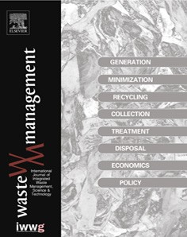

Corrigendum

# Corrigendum to ‘‘Projecting the environmental profile of Singapore’s landfill activities: Comparisons of present and future scenarios based on LCA” [Waste Manage. 32 (2012) 890–900]



## Hsien H. Khoo a,⇑, Lester L.Z. Tan b, Reginald B.H. Tan b

a *Institute of Chem. & Engr. Sciences, 1 Pesek Road, Jurong Island, Singapore 627833, Singapore*

b *Natl. Uni. Singapore, Dept. Chem. & Biomolecular Engr., 4 Engineering Drive 4, Singapore 117576, Singapore*

In Section 3.3.1 of the published article, the last sentence of the first paragraph: ‘‘They correspond to: 3161.9 m3/kg and for incineration ash and 124.3 m3/kg for non-incinerable MSW.”

Should be corrected to ‘‘They correspond to: 0.003162 m3/kg and for incineration ash and 0.00124 m3/kg for non-incinerable MSW. Both values translate to around 316 kg/m3 and 806 kg/m3, which is reasonably close to those reported in literature (Hosetti, 2006; Xu, 2008)”.

The author would like to apologise for any inconvenience caused.

References

Hosetti, B.B., 2006. Prospects and Perspectives of Solid Waste Management. New Age International.

Xu, T.J., 2008. Bioleaching of heavy metals from municipal solid waste (MSW) incineration fly ash: kinetics and mechanism PhD thesis. Chemical and Biomolecular Engineering. National University of Singapore.

DOI of original article: <http://dx.doi.org/10.1016/j.wasman.2011.12.010>

⇑ Corresponding author. Tel.: +65 6796 3952; fax: +65 6267 8835

*E-mail address:* [khoo_hsien_hui@ices.a-star.edu.sg](mailto:khoo_hsien_hui@ices.a-star.edu.sg) (H.H. Khoo).

<http://dx.doi.org/10.1016/j.wasman.2016.03.014> 0956-053X/© 2016 Elsevier Ltd. All rights reserved.

[Waste Management 115 (2020) 15–24](https://doi.org/10.1016/j.wasman.2020.07.006)



Contents lists available at [ScienceDirect](http://www.sciencedirect.com/science/journal/0956053X)

Waste Management

journal homepage: [www.elsevier.com/locate/was man](http://www.elsevier.com/locate/wasman)

# Optimization of municipal solid waste management using a coordinated framework

## Aurora del Carmen Munguía-López a, Victor M. Zavala b, José Ezequiel Santibañez-Aguilar c,

José María Ponce-Ortega a,⇑

a *Chemical Engineering Department, Universidad Michoacana de San Nicolás de Hidalgo, Santiago Tapia S/N, Edificio V1, Ciudad Universitaria, Morelia, Mich. 58060, Mexico*

b *Department of Chemical and Biological Engineering, University of Wisconsin-Madison, 1415 Engineering Dr., Madison, WI 53706, USA*

c *School of Engineering and Science, Tecnologico de Monterrey, Av. Eugenio Garza Sada 2501, Monterrey 64849, Mexico*

### a r t i c l e i n f o

*Article history:*

Received 18 April 2020

Revised 5 June 2020

Accepted 4 July 2020

Available online 25 July 2020

*Keywords:*

Municipal solid waste Stakeholders Coordinated markets Optimization Taxation

Waste management

### a b s t r a c t

Municipal solid waste (MSW) management is an important but complex logistical problem. The deploy- ment of MSW management systems is hindered by the ever-growing generation of waste and the often insufficient infrastructure to manage, process, and dispose of waste. This paper presents a coordinated framework for complex MSW management systems. The framework accommodates multiple key stake- holders in MSW systems, such as suppliers of waste, consumers of waste and derived products, and pro- viders of transportation and processing services. Here, the stakeholders submit bids to a coordinator that solves an optimization problem to determine allocations and clearing prices that maximize the collective profit for all stakeholders and that balance supply and demand for waste and products. Furthermore, the clearing process guarantees that the individual profits are non-negative (no stakeholder loses money). Notably, the framework operates as a competitive market that accelerates transactions between stake- holders and that handles complex logistical constraints that would be difficult to handle in peer- to-peer transactions. The framework also facilitates the integration of policy incentives and the monetization of environmental impacts. In this regard, we evaluate a tax applied to open dump disposal. To illustrate the applicability, an MSW system in Mexico was analyzed as a case study. Results reveal that taxation can be used to incentivize the provision of services for all stakeholders. Specifically, we found that an appropriate tax can completely avoid disposal in open dumps. A tax of 5.1 USD/tonne was iden- tified as the minimum penalization that avoids diverting waste to open dumps.

© 2020 Elsevier Ltd. All rights reserved.

1. Introduction

Waste management is a growing and overwhelming concern around the world; this is particularly true in developing countries, where waste generation is sharply increasing and there is no suffi- cient collection and processing infrastructure (Yousefloo and Babazadeh, 2020). The lack of these types of systems has led to sig- nificant social and environmental issues that increase year by year with the generation of waste. According to the World Bank, the annual solid waste generation globally was 1.3 billion tons in 2012 and is expected to grow to 2.2 billion tons by 2025 (Hoornweg and Bhada-Tata, 2012). In the USA, the waste genera- tion per day is approximately 0.64 MT, followed by Germany with

0.14 MT, Mexico with 0.13 MT, and Japan with 0.10 MT (Das et al., 2019). Landfill space and the collection and processing infrastruc-

⇑ Corresponding author.

*E-mail address:* [jmponce@umich.mx](mailto:jmponce@umich.mx) (J.M. Ponce-Ortega).

ture are becoming increasingly constrained in large urban centers and might require the use of uncontrolled (open dump) sites for disposal (Ojeda-Benitez and Beraud-Lozano, 2003). The use of open dump systems is a common practice in developing countries such as Mexico. The Mexican environmental protection agency (SEMAR- NAT) reported in 2012 that, of all waste generated in the country, 72% was disposed of at sanitary landfills and regulated sites, 23% was disposed at open dumps, and only 5% was recycled (Semarnat, 2012).

Unfortunately, the environmental, social, and safety impacts of open dump systems have not received as much attention from policy-makers and academics (Medina, 2010). These systems do not provide technologies of controlled landfills, such as leachate treatment, geological protection, and gas treatment (Ojeda- Benitez and Beraud-Lozano, 2003). As a result, methane, produced by the decomposition of organic materials, can leak to the environ- ment and can trigger fires. Also, strong leachates can pollute sur- face and groundwater. Food leftovers can attract wildlife which

<https://doi.org/10.1016/j.wasman.2020.07.006> 0956-053X/© 2020 Elsevier Ltd. All rights reserved.

Nomenclature

*Parameters c*

*f*

*d*

*m*

*g*

*s*

*q*

*k*

*ad*

*b*

*s*

*dm*

Maximum capacities for the consumers Maximum capacities for the technology providers Maximum capacities for the suppliers

Maximum capacities for the transportation providers Bidding information for the consumers

Bidding information for the suppliers

Bidding information for the technology providers Bidding information for the transportation providers Conversion factor for each technology and product

*gs qk pd ps pk pm*

*/D*

*/S*

*d*

*s*

*c*

*k*

*/K*

*k*

Allocations for the suppliers

Allocations for the transportation providers Clearing prices for the consumers

Clearing prices for the suppliers

Clearing prices for the transportation providers Clearing prices for the technology providers Profits for the consumers

Profits for the suppliers

Profits for the transportation providers

*1m*;*p*

*Variables*

*cd* Allocations for the consumers

*f m* Allocations for the technology providers

can transmit diseases to humans. In addition to this, biodegrada- tion of organic waste can take many years, limiting the future use of the land used by the open system (Medina, 2010).

Recently, the collection, storage, and recycling of solid wastes in Mexico have started to be incentivized. Recycling has increased from 2.3% in 2000 to 5% in 2012 (Botello-Álvarez et al., 2018). How- ever, this percentage remains very small comparing to waste recy- cled worldwide (approximately 19%) (Gutberlet, 2015). Several policies and financing strategies are currently being investigated to accelerate the deployment of more advanced waste manage- ment systems around the world. A hypothetical scenario reported in Korea considers a tax collection framework that incentivizes the deployment of recycling facilities. This analysis indicates that peo- ple are willing to bear the cost of discarding recyclable waste (Ko et al., 2020). Similarly, studies in Serbia have revealed that resi- dents are in general willing to pay for a pharmaceutical disposal program (Paut Kusturica et al., 2020). These studies also argue that there is a need to establish policy regulations for waste-dumping and the allocation of financial resources for waste collection. On the other hand, a hypothetical landfill tax scenario in Israel shows that recycling does not improve greatly with the inclusion of exter- nality costs (Lavee, 2007). Furthermore, a management cycle for waste, including the participation of infrastructure managers, workers, and households, was recently proposed by Jiang et al. (2020). Here, the waste-dumping behavior and empirical decisions of each part are considered to guide policy regulations.

Financial sustainability is a major issue in the design of solid

waste management (SWM) systems. In this regard, a cost- revenue analysis for an SWM system in Bahir Dar revealed that the cost-structure of waste services must be improved to enable sustainability (Lohri et al., 2014). This study proposed some alter- natives to achieve this: improving fee collection, increasing the value chain by sales of recyclables and derived products, including financing mechanisms (such as polluter payments and cross- subsidies), and improving overall efficiencies. Furthermore, models for waste recycling between enterprises through industrial sym- biosis have been reported. Here, different supply–demand relation- ships were considered to find optimal waste pricing decisions. The results show that industries tend to cooperate when the marginal cost of recycling is lower than the cost of the raw materials (He et al., 2020). An important observation is that this symbiosis is effectively a coordinated market framework. Recently, a general coordinated market framework for organic waste that facilitates transactions between multiple stakeholders (suppliers of waste, consumers of waste and derived products, transportation provi- ders, and processing facilities) was proposed by Sampat et al.

(2019). This approach seeks to find allocations for all stakeholders and clearing prices for waste and derived products that maximize the collective profit of all stakeholders. Notably, it is shown that the management framework is equivalent to a competitive market and inherits key economic properties for such markets, such as revenue adequacy (payments from consumers cover costs associ- ated with waste supply, collection, and processing). Moreover, this framework can help monetize environmental impacts to foster investment and development efforts. The authors argue that the framework can be used to predict the impact of distinct regulations or incentives and is scalable since it provides open access that pro- motes transactions between large numbers of stakeholders.

Other optimization models have been previously proposed for MSW management systems. A supply chain optimization model for an MSW system that considers economic, social, and environ- mental factors was proposed by Mohammadi et al. (2019). Further- more, a mathematical optimization approach that includes waste reduction processes and landfilling has been reported by Garibay-Rodriguez et al. (2018). The results show that the deploy- ment of a landfill gas-to-energy system and a material recycling facility can improve the overall economics of the MSW system (a step towards achieving financial sustainability). Regarding the eco- nomic efficiency of recycling, an approach that reveals its viability has been reported by Lavee (2007). The presented results show that 51% of the municipalities of Israel can benefit from adopting recycling. The beneficiaries were mostly large municipalities. An important issue here is the uncertainty related to the price of recy- cled materials, which may discourage municipalities and make them prefer landfill disposal (Lavee et al., 2004). To overcome this problem, options to stabilize prices and ensure long-term contracts with recycling plants have been proposed. This approach avoids unnecessary investments given by the repeated change of disposal methods (Lavee et al., 2009). Moreover, a multi-objective model including the minimization of costs and risk objectives for an MSW supply chain network has been developed by Yousefloo and Babazadeh (2020). The risk function captures the population affected by waste treatment centers and emissions that result from waste processing. This work involves a real case study in Iran. Another multi-objective model to allocate waste to treatment technologies was proposed by Minoglou and Komilis (2013). Here, operational and transportation costs are considered, as well as dif- ferent processing options (incineration, compost, anaerobic diges- tion, and landfilling). The minimization of costs and emissions are used as objective functions. Distinct methods to capture the collec- tion and transportation of waste were reported by Paul et al. (2018). In their linear programming model, the optimal allocation

of waste to different processing technologies was evaluated. Mixed-integer programming models have also been proposed to find the optimal number of collection trucks in an MSW system in Hong Kong (Lee et al., 2016). A mathematical model to perform optimal planning that maximizes the profit has been reported by Santibañez-Aguilar et al. (2013). Here, the maximization of recy- cled waste is considered. Optimal technologies along with their geographical location, as well as the distribution of waste and products from and to different cities, are selected through the model. The results also identify tradeoffs between economic and environmental objectives. A common issue with these studies is that they take a ‘‘central” view of the problem in which the entire MSW system is operated by a single stakeholder. As a result, these models do not provide insights into how different components of the system should be remunerated. Furthermore, previous approaches have not focused on every stakeholder that partici- pates in the MSW system and on their profits. Specifically, a frame- work where the total welfare or collective profit of all stakeholders is considered along with the profits and allocations of each stake- holder has not been reported. These considerations are important, since in a real application of MSW management all participants matter. Moreover, balancing supply and demand through a coordi- nated framework avoids economic losses, because the revenue col- lected from the consumers covers the payments of suppliers and providers.

In this work, we present an optimization formulation for MSW

management systems within a coordinated market framework. The proposed model includes the optimal planning for MSW con- sidering different alternatives for the disposal of waste: sanitary landfills, open dumps, and reuse. Specifically, the mathematical model involves several stakeholders: urban centers that produce waste, sanitary landfills and open dump systems, processing tech- nologies for different types of waste, and financial consumers of derived products. From a coordinated market perspective, suppli- ers and consumers (demand) of waste and products, as well as pro- viders (both transportation and technology), can be identified in the MSW system. Additional details about the coordinated man- agement are explained in chapter 2. Moreover, in chapter 4, we show how to use the coordinated framework to identify suitable tax structures for the disposal of waste in open dumps. The results reveal that taxation can effectively incentivize the provision of ser- vices by all stakeholders. Specifically, we found that an appropriate tax can avoid open dumps disposal completely. Moreover, the opti-

mal allocation that provides positive profits for each stakeholder was identified through the coordinated framework. To illustrate the applicability of this approach, an MSW system in Mexico was analyzed as a case study. However, the formulation is general and can be applied to any MSW system. In this regard, our objec- tive is to provide a coordinated management perspective for MSW systems by including taxation to avoid negative environmen- tal impacts. Particularly, we focused on the impact of open dump systems, but the approach can be extended to include other envi- ronmental issues.

The presented approach is structured as follows: chapter 2 describes the elements of the MSW system and additional consid- erations for the coordinated management. Chapter 3 describes the mathematical model formulation of the proposed system. Chapter 4 refers to the applicability of the formulation through a case study in the central-west region of Mexico.

1. Coordinated MSW management system

The proposed system comprises different suppliers, consumers, and providers of transportation and processing (transformation) services involved in MSW management. As mentioned in chapter 1, these stakeholders can be identified from a coordinated market perspective. Furthermore, each of these stakeholders manages dis- tinct waste or products at a particular geographical location. These considerations can be visualized in the superstructure shown in Fig. 1. Here, we can see that several urban centers (geographical locations) are considered, each of them involves a specific genera- tion rate of different types of waste (plastic, metal, organic, glass, and non-recyclables). Moreover, these types can be classified in subtypes (such as clear, green, and brown glass). Note that the urban centers act as suppliers of waste for the sanitary landfills (which act as consumers) and the processing facilities. Urban cen- ters also act as consumers that purchase products from the pro- cessing facilities. It is considered that the waste that is not allocated to consumers is sent to open dumps. This is a common practice in developing countries, despite the environmental, social, and safety impacts (Medina, 2010). In a typical situation, it is assumed that this can be done at no cost (or at a small cost). This cost is economic and does not involve the environmental cost, which can be greatly expensive. Therefore, to prevent open dump disposal, we include a tax for the waste disposed at such systems.

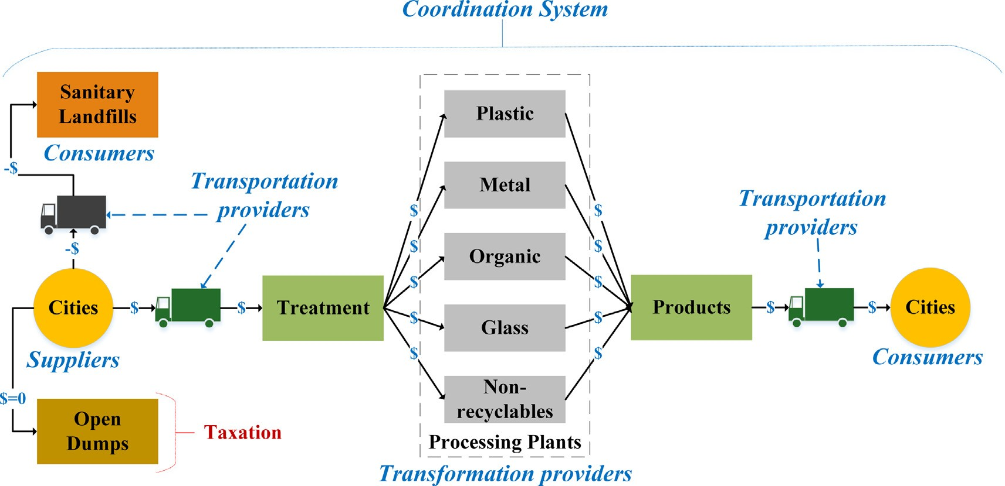

Fig. 1. Proposed superstructure for the coordinated MSW system.

This tax can be interpreted as a service that the environment pro- vides to society (the environment absorbs the impacts of the waste but at a cost). The MSW system also includes sanitary landfills, open dumps, and processing facilities in each urban center. The

processing providers offer different types of treatment and tech-

centers to landfills and plants, and from plants to urban centers; and (v) the processing providers refer to the different technologies to treat waste.

The bidding information ð*ad*; *bs* ; *ck*; *dm*Þ as well as the maximum

capacities (*c*; *g*; *q*; *f* ) for the demand ð*cd*Þ, supply ð*gs* Þ, trans-

*d s k m*

nologies for each waste type. The transportation providers can move waste to sanitary landfills, to processing facilities, and final consumers. The stakeholders are categorized by the type of waste they handle (plastic, metal, organic, glass, and non-recyclables).

Some additional considerations of the coordination system are explained in the following. First of all, suppliers, consumers, and service providers submit bids into the coordinated system. Then, a coordinator, known as an independent system operator (ISO), uses bid information to determine allocations and prices to clear the market. All stakeholders offer positive bids, except for landfills, which offer negative bids. On the one hand, the negative bid of landfill suppliers is a payment that they are willing to give to the

market to take away their waste. On the other hand, the negative

portation ð*qk* Þ, and transformation ð*f m* Þ are given (as previously indicated in chapter 2). The objective function in Eq. (1) maximizes the total welfare, which refers to the difference between the

demand served and the costs of supply, transportation, and trans- formation. The solution to the problem includes finding the corre- sponding allocations ð*cd*; *gs*; *qk*; *fm*Þ and prices that clear the market and maximize the collective profit of all the stakeholders (total

welfare). These allocations satisfy the physical conservation laws in Eq. (2), and capacity constraints in Eqs. (3)–(6). The dual vari-

ables (*pn*;*p*); ð*n*; *p*Þ 2 *N* x *P* act as market clearing prices by setting

values for products at different locations. Here, *1m*;*p* refers to the

conversion factor for each technology and product.

bid of a landfill demand indicates that the landfill will take the waste only if it is paid for doing so (such as a disposal cost or tip-

max P*d D*

*adcd* - P*s S*

*bsgs* - P

*k*2*K*

*ckqk* - P

*m*2*M*

*dmf m* ð1Þ

ping fee). Given this information, the coordinator clears the market

2

2

s:t:P*s*

*gs* - P

*cd* þ P

*in qk* - P

*out qk* þ P

*1m fm* ¼ 0; ð*n*; *p*Þ 2 *N* x *P*; (*pn*;*p* )

by solving an optimization problem that maximizes the total wel- fare (collective profit of all the stakeholders). The optimization for-

2*Sn*;*p*

*d*2*Dn*;*p*

*k*2*Kn*;*p*

*k*2*Kn*;*p*

*m*2*Mn*

ð2Þ

;*p*

mulation solved by the ISO includes the sales and costs of the market stakeholders. The cleared stakeholders are paid based on their product allocations and associated clearing prices. Trans- portation providers are paid based on differences in clearing prices at the source and destination locations, while the processing provi- ders are paid based on the clearing prices or their input and output products. When a stakeholder is not cleared (it is allocated no pro- duct), this means that this player does not participate in the mar- ket. All of these considerations are used for the formulation of the model, as shown in chapter 3. Furthermore, two scenarios are ana- lyzed: I) the base case (without taxation) and II) a case with a tax for the amount of waste that ends up in open dumps. This tax rep- resents the service that the environment provides and may prevent open dump disposal. The solutions of the ISO problem satisfy a set of fundamental economic properties of a competitive market (Sampat et al., 2019). Specifically, the clearing process guarantees that no cleared player loses money and that there is revenue ade- quacy (total payments collected equal total payments made).

1. Formulation of the coordination problem

The proposed model is deterministic, and it is based on the superstructure shown in Fig. 1 as well as on the considerations mentioned above. In the following, the equations of the model for the MSW management system using the coordinated frame- work are presented. Additionally, complementary equations, based on the formulation proposed by Santibañez-Aguilar et al. (2013), are shown in the supplementary material section. As stated in chapter 2, we consider a framework that is composed of a set of geographical locations *N*, products *P*, consumers *D*, suppliers *S*, transportation providers *K*, and transformation (technology) provi- ders *M*.

In the MSW system addressed here, previous elements are iden- tified as (i) the geographical locations refer to where waste is gen- erated, where the products are consumed, and where sanitary landfills and processing plants are placed; (ii) the products repre- sent the different types of waste and derived products obtained from the processing facilities; (iii) the suppliers represent the urban centers that generate waste, while the consumers are the urban centers that demand waste (sanitary landfills) and useful products (from processing plants); (iv) the transportation provi- ders refer to the service of transport to move the waste from urban

0 ::: *cd* ::: *c*; *d* 2 *D* ð3Þ

0 ::: *gs* ::: *g*; *s* 2 *S* ð4Þ

*d*

*s*

0 ::: *qk* ::: *q*; *k* 2 *K* ð5Þ

*k*

0 ::: *f m* ::: *f* ; *m* 2 *M* ð6Þ

*m*

The computed allocations and prices from the optimization problem are used to remunerate providers and to charge con- sumers. This leads to revenue adequacy, which means that the rev- enue collected is equal to the payments made. We use the notation ð*pd*; *ps* ; *pk* ; *pm*Þ to refer to the locational marginal prices (clearing

prices) at the corresponding locations of each stakeholder. For con-

sumers, *adcd* refers to the monetary value of the allocated demand, while *pdcd* is the payment made to the market. Therefore, the profit for consumers (*/D*) is the difference between these values, as

*d*

shown in Eq. (7). For suppliers, *psgs* represents their revenue and *bsgs* refers to their operating cost. The profit for suppliers is thus the difference between these values (Eq. (8)). The profit for trans- portation providers is estimated by Eq. (9). Here, *pk* are the trans- portation prices that are estimated by the difference between the prices of the destination nodes and the prices of the origin nodes. The quantity *pkqk* is the payment made to the transportation pro- viders and *ckqk* is their operating cost. The transformation prices

*pm* are calculated as a weighted sum of marginal prices (weighted

by conversion factors) for the products involved in the processing step. Note that the conversion factors are given parameters. The profit of these providers is computed as shown in Eq. (10), *pmfm* represents their revenue while *dmfm* is their operating cost.

*/D* ¼ ð*ad* - *pd* Þ*cd*; *d* 2 *D* ð7Þ

*d*

*/S* ¼ ð*ps* -*bs* Þ*gs* ; *s* 2 *S* ð8Þ

*s*

*/K* ¼ ð*pk* - *ck* Þ*qk*; *k* 2 *K* ð9Þ

*k*

*/M* ¼ ð*pm* - *dm*Þ*f m*; *m* 2 *M* ð10Þ

*m*

The clearing process guarantees that these profits are non- negative (no stakeholder loses money), this is a key benefit of the coordinated market.

1. Results and discussion

We apply our framework to a case study that seeks to analyze how an MSW system would operate in the central-west region of Mexico. As shown in Fig. 2, five urban centers (Morelia, Celaya, Apatzingan, Lazaro Cardenas, and Leon) act as suppliers and con- sumers into the coordination system. Here, the different partici- pants are identified as follows: *S* for suppliers, *D* for consumers, *K* for transportation providers, and *M* for processing providers. The numbers *1*–*5* denote where each stakeholder is situated. For instance, the technology provider *M1* is situated in the city of Morelia. Note that each processing provider has equal technologies locally available to treat each type of waste (plastic, metal, organic, glass, and non-recyclables). The different types of plastic are denoted by *R1*, *R2*, *R3*, *R4*, and *R5*. The different types of glass are denoted by *G1*, *G2*, and *G3*. Representative parameters of this appli- cation, such as the generation rate of waste at each city, are shown in the supplementary material section. The complete information of the case study, as well as the corresponding parameters, have been previously reported and can be found in Santibañez-Aguilar et al. (2013). Note that Fig. 2 is just a schematic representation of the case study to facilitate the visualization of all the participants and the possibilities of the system.

Associated with each of the MSW system participants there is a

specific flow, product type, capacity, location, and bidding cost. For all types of waste, the same geographical locations (nodes) are con- sidered, along with two possible pathways: sending the waste to a processing facility for treatment and sending the waste to a sani- tary landfill. We also include the possibility of sending waste to open dumps. To account for this environmental impact, two sce- narios are analyzed: I) base case in which we ignore the impact of dumps and II) a tax is applied to any waste amount disposed of at open dumps. After solving the problem, we find that the total welfare (collective profit) of the system is 871,744 USD and 784,061 USD for Scenarios I and II, respectively. As expected, accounting for the environmental impact incurs a penalty in the total welfare. Note that previous approaches have included taxa- tion schemes, but to foster recycling. For instance, a tax applied to landfill disposal to increase the level of recycling has been

reported by Lavee (2007). Furthermore, a tax collection scenario to install a recycling facility was evaluated by Ko et al. (2020). However, we focus on the taxation for open dump disposal to mon- etize this environmental impact. Our approach also considers pro- cessing facilities to treat waste and sanitary landfill disposal, but without applying direct taxation to these activities.

We use a tax of 5.1 USD/tonne; this value was identified as the minimum penalization that avoids diverting waste to open dumps. To obtain this value, we first used a tax equal to 12.35 USD/tonne (which corresponds to the cost of sending waste to the landfill). The results with this tax are shown in the supplementary material section. Then, the obtained lowest prices (marginal values) for the landfill supply of all types of waste were identified and evaluated as tax values. Distinct values from these prices were evaluated until the reported minimum tax (5.1 USD/tonne) was found. Com- paring the allocations (profits) in the following results to those obtained in the supplementary material section with a tax equal to 12.35 USD/tonne, we can see that the minimum tax yields sim- ilar profit levels for all stakeholders. These results illustrate how our methodology can be used to systematically identify policies that incentivize different stakeholders in MSW systems.

The impact of the variability of the distinct prices involved in MSW systems has been previously addressed. For instance, the prices of waste recycling in an industrial park were analyzed by He et al. (2020). Besides, Mohammadi et al. (2019) found that the profit of an MSW system, involving the efficient use of waste, is affected by changes in electricity prices. Similarly, Lavee et al. (2009) reported that the uncertainty in recycling prices may make decision-makers prefer landfill disposal. On the other hand, our approach provides the clearing prices for all the involved stake- holders in the MSW system, including suppliers, consumers, and providers (of transportation and transformation). We observe that, depending on the scenario (with or without taxation for open dump disposal), the prices vary. Nevertheless, the prices related to the transformation providers do not change with the taxation since the tax do not have an impact on the recycled waste. The profits for each participant are estimated as well. Note that all the profits are non-negative. This occurs because participants do not lose money within a coordinated system.

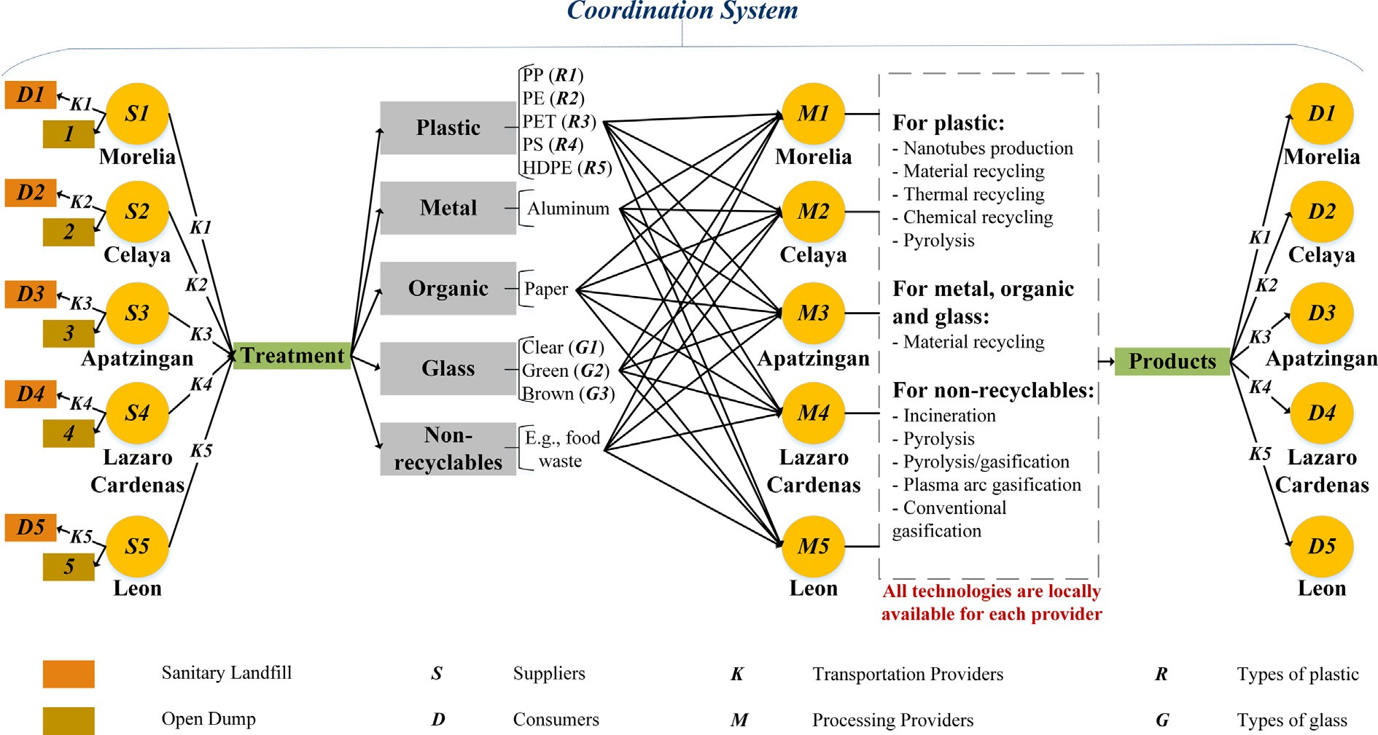

Fig. 2. Representation of the case study addressed for the MSW system.

* 1. *Analysis for plastic waste*

We first analyze the solutions for the evaluated suppliers (*S1*- *S5*), consumers (*D1*-*D5*), and transportation providers (*K1*-*K5*) of plastic. No transformation providers participate in the optimal solution for this type of waste. Thus, supply, demand, and transport refer to the plastic sent to the landfill. We can see that, for both scenarios, the supply and demand offer negative bid costs (see Table 1). These costs are equal for all types of plastic. The landfill supply with a negative bid is a payment that the suppliers are will- ing to pay the market to take away the waste. On the other hand, it was reported that disposal facilities can act as consumers (Sampat et al., 2019). Specifically, the landfill demand with a negative bid indicates that the landfill will take the waste only if it is paid for doing so (such as a disposal cost or a penalty cost). This behavior is included in the model because such incentives (suppliers are willing to pay) and penalties (disposal cost) are common in this type of market to promote appropriate waste management. Such as in (Paut Kusturica et al., 2020), where it was reported that res- idents are willing to pay for a pharmaceutical disposal program. Besides, Ko et al. (2020) found that people agree with a tax to be able to discard their recyclable waste. We can see that all the obtained clearing prices for the landfill supply (see Table 1) are such that the profit is non-negative for all players (no player loses money in the MSW system). This is a key property of coordinated markets (Sampat et al., 2019). In Scenario I, there is no plastic sent to the sanitary landfill and, thus, the profit is zero. The landfill sup- pliers do not participate in this scenario since all the waste is dis- posed of at open dumps. Contrary to Scenario II, where all the waste is disposed of at sanitary landfills due to the involved tax. On the one hand, the prices only vary depending on the stake- holder and not on the type of plastic; on the other hand, the profit varies by type of plastic due to the distinct flows of each material sent to the sanitary landfill (see Fig. 3).

Table 1 also shows the clearing prices for the landfill demand.

Here, we can see that in Scenario I, all the clearing prices are higher than the bids; and, thus, the consumers are not allocated any pro- duct (they do not participate in the market). Therefore, all waste is allocated to open dump systems. We also observe that in Scenario II (with taxation), the obtained prices are such that all profits are non-negative and all waste is sent to sanitary landfills. This illus- trates how, regardless of the tax used, participants do not lose money in a coordinated MSW system. Regarding the transporta- tion providers of plastic entering the landfill, their prices are shown in Table 1 as well. Here, the obtained prices for Scenario I are lower than the bids, while for Scenario II all the clearing prices are greater. Therefore, only the prices from Scenario II allow find- ing positive profits, since they satisfy the constraints required for the transportation providers to have non-negative profits. As a con- sequence, the waste is transported to sanitary landfills in this sce- nario. Note that for the transportation providers’ profits, we only

consider the operational costs and not the optimal number of col- lection trucks as in Lee et al. (2016). Alternatively, our approach includes the optimal number of transportation providers that par- ticipate according to the clearing process. Within their operational costs, the expenses related to the needed trucks are included. The profits are categorized in Fig. 3 by type of plastic. Here, we observe some interesting trends; specifically, stakeholders 1 and 5 always make the largest profits followed by stakeholders 2 and 4; while stakeholder 3 makes the smallest profit. Regarding the types of plastic, *R1* and *R2* (corresponding to PP and PE) represent most of the total profit. Note that landfill suppliers attain the highest prof- its. Overall, we can see that the taxation scenario in the coordi- nated system avoids diverting waste to open dumps and simultaneously allows landfill providers to attain profits.

* 1. *Analysis for metal waste*

The following results refer to the solutions for metal waste. Table 2 and Fig. 4 present the information for the different suppli- ers (*S1*-*S5*), consumers (*D1*-*D5*), transportation providers (*K1*-*K5*), and technology providers (*M1*-*M5*). We only evaluate one type of metal (aluminum). For the landfill supply (see Table 2), we can see that all the prices are greater than the bids and, thus, the profits are all non-negative. Positive profits are only achieved in Scenario II (see Fig. 4). This occurs because the involved taxation prevents open dump disposal by making landfill suppliers participate. Con- sequently, the waste is disposed of at sanitary landfills. Contrary to Scenario I, where metal waste is sent to open dumps since the prices are not lower than the bids for the landfill demand. There- fore, these consumers are not cleared (there is lacking demand for waste) according to the requirements for the consumers to have non-negative profits. On the other hand, in Scenario II, the clearing prices are equal to the bids, so these consumers participate in the market (there is a landfill demand for waste), but their profit is zero. The optimal solution of metal waste includes transformation providers to process the waste in a processing facility for sale. Regarding the processing supply, we can see that all the clearing prices are greater than the bids and equal for both scenarios. Thus, we have positive and equal profits for both scenarios (see Fig. 4). For the processing plant demand, we observe that in both scenar- ios, only the prices of the consumer *D1* are lower than the bids. Therefore, *D1* attains a profit greater than zero. Such as in He et al. (2020), where it was reported that industries tend to cooper- ate when the marginal cost of recycling is lower than the cost of raw materials. Note that the other consumers (*D2*-*D5*) could be cleared obtaining a profit equal to zero, however, only *D4* partici- pates in the market. As expected, the taxation scheme does not impact on the processing plant supply and demand, since the tax is applied only to the waste at open dump systems. The results for the transportation providers of the metal entering the landfill and processing plant, and of the products leaving the processing

Table 1

Bids and clearing prices for landfill supply, landfill demand, and transportation providers for plastic waste.

|  |  |  |  |  |  |
| --- | --- | --- | --- | --- | --- |
|  | Bids (USD/tonne) | Prices (USD/tonne) |  | | |
| *Landfill supply* | *S1-S5* | *S1 S2* | *S3* | *S4* | *S5* |
| Scenario I | -12.35 | 0 0 | 0 | 0 | 0 |
| Scenario II (with tax) | -12.35 | -4.27 -4.26 | -4.28 | -4.29 | -5.1 |
| *Landfill demand* | *D1-D5* | *D1 D2* | *D3* | *D4* | *D5* |
| Scenario I | -12.35 | -12.29 -12.31 | -12.28 | -12.28 | -12.26 |
| Scenario II (with tax) | -12.35 | -16.57 -16.57 | -16.57 | -16.57 | -17.36 |
| *Transportation providers (entering landfill)* | *K1-K5* | *K1 K2* | *K3* | *K4* | *K5* |
| Scenario I | 0.0165 | -12.29 -12.31 | -12.28 | -12.28 | -12.26 |
| Scenario II (with tax) | 0.0165 | 5.64 5.64 | 5.64 | 5.64 | 4.84 |

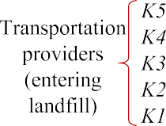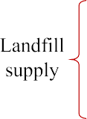





Fig. 3. Profits for landfill supply, landfill demand and transportation providers by types of plastic in Scenario II.

Table 2

Bids and clearing prices for supply, demand, transportation and technology providers for metal waste.

|  |  |  |  |  |  |
| --- | --- | --- | --- | --- | --- |
|  | Bids (USD/tonne) | Prices (USD/tonne) |  | | |
| *Landfill supply* | *S1-S5* | *S1 S2* | *S3* | *S4* | *S5* |
| Scenario I | -12.35 | 0 0 | 0 | 0 | 0 |
| Scenario II (with tax) | -12.35 | -0.14 -0.11 | -0.16 | -0.17 | -0.21 |
| *Landfill demand* | *D1-D5* | *D1 D2* | *D3* | *D4* | *D5* |
| Scenario I | -12.35 | -12.24 -12.19 | -12.18 | -12.14 | -12.21 |
| Scenario II (with tax) | -12.35 | -12.35 -12.35 | -12.35 | -12.35 | -12.35 |
| *Plant supply* | *S1-S5* | *S1 S2* | *S3* | *S4* | *S5* |
| Scenario I | 223.5 | 1204.2 1198.4 | 1196.6 | 1198.5 | 1196 |
| Scenario II (with tax) | 223.5 | 1204.2 1198.4 | 1196.6 | 1198.5 | 1196 |
| *Plant demand* | *D1-D5* | *D1 D2* | *D3* | *D4* | *D5* |
| Scenario I | 1300 | 1290 1300 | 1300 | 1300 | 1300 |
| Scenario II (with tax) | 1300 | 1290 1300 | 1300 | 1300 | 1300 |
| *Transportation providers (entering landfill)* | *K1-K5* | *K1 K2* | *K3* | *K4* | *K5* |
| Scenario I | 0.04 | -12.21 -12.24 | -12.19 | -12.18 | -12.14 |
| Scenario II (with tax) | 0.04 | -11.56 -11.56 | -11.56 | -11.56 | -11.56 |
| *Transportation providers (entering plant / leaving plant)* | *K1-K5* | *K1 K2* | *K3* | *K4* | *K5* |
| Scenario I | 0.04 | 90.1 101.64 | 103.44 | 101.52 | 104 |
| Scenario II (with tax) | 0.04 | 90.1 101.64 | 103.44 | 101.52 | 104 |
| *Technology providers* | *M1-M5* | *M1 M2* | *M3* | *M4* | *M5* |
| Scenario I | 90 | 1294.2 1300 | 1300 | 1300 | 1300 |
| Scenario II (with tax) | 90 | 1294.2 1300 | 1300 | 1300 | 1300 |

plant are also presented in Table 2. For the transportation provi- ders of the metal entering the processing plant, we observe that all the prices are greater than the bids, which allows the profits to be positive. These profits are equal for both scenarios since the clearing prices are equal as well. We observe that the prices for the transportation providers of the metal leaving the processing plant are equal to those obtained for the transportation providers of the metal entering the processing plant. However, only the pro- viders *K1* and *K4* are cleared here. Again, the profits are equal for both scenarios. The total profits for the transportation providers of each scenario are presented in Fig. 4. These total profits are the sum of the profits of the providers of the metal entering the sanitary landfill and processing plant, and of the providers of the

products leaving the processing plant. We can see that the profits are positive for both scenarios, but in Scenario I the profits are greater since no metal is sent to the landfill (instead, open dump disposal occurs). For the technology providers, we observe that all the clearing prices are greater than the bids, but only the provi- der *M1* participates in the market for both scenarios (the tax does not impact on these stakeholders). Here, material recycling is used to process the metal and the profit for provider *M1* is 1,070,035 USD. Note that this provider attains the highest level of profit fol- lowed by the processing plant suppliers, the transportation provi- ders, the landfill suppliers, and the processing plant demand. Furthermore, we can see how including taxes fosters the sanitary landfill disposal, despite only landfill suppliers (and not landfill

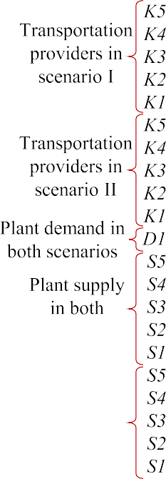





Fig. 4. Profits for supply, demand and transportation providers of metal for Scenarios I and II.

consumers) attain profits greater than zero. This occurs since even with the profit of landfill consumers being zero, they do not lose money and, thus, participate in the market.

* 1. *Analysis for glass waste*

The solutions for the different types of glass (*G1*, *G2*, and *G3*) are presented in Table 3 and Fig. 5. Note that no processing players participate here (as in the case of plastic). The results reveal that taxation incentivizes the provision of landfill services and avoids open dump systems for every type of glass. Specifically, for landfill supply, all the prices are greater than the bids; however, positive profits are attained only for Scenario II because in Scenario I there is no glass sent to the sanitary landfill. Therefore, all waste is diverted to open dumps. For the landfill demand, every consumer in Scenario II has positive profits as well. Note that the taxation scenario allows the generation of landfill demand to prevent open dump disposal of glass waste. Interestingly, we can see that only the transportation providers of glass entering the landfill partici- pate. For these providers, the prices in Scenario II allow finding

positive profits because they are greater than the bids. Therefore, glass waste is transported to the landfill only when the tax is involved. Otherwise, the waste is sent to open dump systems (sce- nario I). As in the case of plastic, we observe that the prices vary depending on the stakeholder and not on the type of glass since the bids are equal for all types. We can see that the transportation providers make the smallest profits while the landfill suppliers attain the highest benefits. Regarding the type of glass, *G3* (corre- sponding to brown glass) represents most of the total profit. Com- paring these results to those obtained for plastic, we observe that the profits for providers of glass are greater than the profits for pro- viders of plastic. This is because of the different bids and flows of waste (more glass waste is generated).

* 1. *Analysis for organic waste and non-recyclables*

The figures referring to the profits for organic waste and non- recyclables are shown in the supplementary material section. We only evaluate one type of each waste (see Fig. 2). For organic waste, we consider all types of paper-based products (such as card-

Table 3

Bids and clearing prices for landfill supply, landfill demand, and transportation providers for glass.

|  |  |  |  |  |  |
| --- | --- | --- | --- | --- | --- |
|  | Bids (USD/tonne) | Prices (USD/tonne) |  | | |
| *Landfill supply* | *S1-S5* | *S1 S2* | *S3* | *S4* | *S5* |
| Scenario I | -12.35 | 0 0 | 0 | 0 | 0 |
| Scenario II (with tax) | -12.35 | -3.09 -3.07 | -3.12 | -3.13 | -5.1 |
| *Landfill demand* | *D1-D5* | *D1 D2* | *D3* | *D4* | *D5* |
| Scenario I | -12.35 | -12.21 -12.24 | -12.19 | -12.18 | -12.14 |
| Scenario II (with tax) | -12.35 | -15.31 -15.31 | -15.31 | -15.31 | -17.24 |
| *Transportation providers (entering landfill)* | *K1-K5* | *K1 K2* | *K3* | *K4* | *K5* |
| Scenario I | 0.04 | -12.21 -12.24 | -12.19 | -12.18 | -12.14 |
| Scenario II (with tax) | 0.04 | 2.2 2.2 | 2.2 | 2.2 | 0.27 |

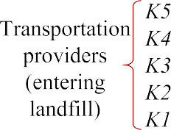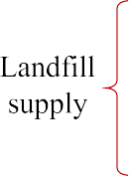





Fig. 5. Profits for landfill supply, landfill demand and transportation providers by types of glass in Scenario II.

board). While for non-recyclables, food waste is considered. No transformation providers participate in the optimal solution for these types of waste. For both organic waste and non-recyclables, their bids and clearing prices for the landfill supply are equal to those obtained for plastic. The same occurs with their bids and prices for the landfill demand (see Table 1). However, their profits are different due to the involved flows. Regarding the transporta- tion providers of organic and non-recyclable waste entering the sanitary landfill, their bids and prices are also equal to those obtained for plastic (see Table 1) and, thus, the waste is trans- ported to sanitary landfills. We observe positive profits for all land- fill stakeholders only in Scenario II. Importantly, this indicates that taxation is necessary to activate the market and foster the partici- pation of landfill providers to avoid open dump disposal. On the other hand, in Scenario I, all organic waste and non-recyclables are disposed of at open dumps and no participant makes a profit. For the profits of these types of waste in scenario II, the same trends found for plastic are observed. For instance, stakeholders 1 and 5 of every service (supply, demand, and transport) obtain greater profits than the other providers. Furthermore, all landfill suppliers attain the highest profits. We also observe that the profits for the participants of non-recyclables are slightly higher than those obtained for the stakeholders of organic waste.

It is important to note that in Scenario II, for every type of waste

(plastic, metal, organic, glass, and non-recyclables), nothing is dis- posed of at open dumps. This occurs due to the involved taxation (5.1 USD/tonne). This tax was identified as the minimum penaliza- tion that avoids diverting waste (of all types) to open dumps. Lower taxes allow sending only some types of waste to sanitary landfills. However, this partial improvement is not of interest since the aim is to eliminate open dump systems and promote appropri- ate waste management.

Note that metal is the only type of waste that involves transfor- mation providers (for both scenarios). Regarding the metal that is not recycled, in scenario I, it is disposed of at open dumps, while in scenario II it is disposed of at sanitary landfills (equally to the other types of waste). Specifically, 36% of the generated metal is processed in a treatment facility for sale. As mentioned above,

the collective profit of the system is positive in all cases. Contrary to the study reported by Santibañez-Aguilar et al. (2013), where the recycled metal is maximized (100% is recycled), but the total profit is negative (this is not a coordinated approach).

1. Conclusions

This paper has presented a coordinated market framework for an MSW system. Here, different stakeholders were identified, including suppliers, consumers, as well as transportation and transformation providers. Each of these offers different bids and, through the solution of the problem, their clearing prices and prof- its are obtained. Furthermore, the possibility of sending waste to sanitary landfills or plants for treatment is considered. The waste ending up in open dumps is involved as well. A tax is included in the formulation to monetize this environmental impact. We show that this has the effect of activating the market and preventing open dump disposal. To show the applicability, an MSW system in Mexico was evaluated as a case study. However, the presented model is general and can be applied to any case study. Results show the allocations and prices that maximize the collective profit for all stakeholders and types of waste involved in distinct scenar- ios (with and without taxation). An important benefit of the pro- posed framework is that the clearing process guarantees that the individual profits are non-negative by balancing supply and demand for waste and products. The minimum tax required to avoid waste in open dumps was identified through the marginal values. Also, we found that the only type of waste that allows prof- itable recycling is metal. The proposed system in this approach results of special interest in regions where MSW collection is not efficient and MSW management needs to be greatly improved. Therefore, starting points such as including taxation to eliminate open dumps and considering the profits of all stakeholders to find a profitable system were addressed here. As part of future work, an analysis that includes varying bids of recyclables based on clearing prices could be interesting. Besides, we focused on the impact of open dump systems, but the approach can be extended to include other environmental issues.

Declaration of Competing Interest

The authors declare that they have no known competing finan- cial interests or personal relationships that could have appeared to influence the work reported in this paper.

Acknowledgements

The authors acknowledge the financial support by CONACyT.

Appendix A. Supplementary material

Supplementary data to this article can be found online at <https://doi.org/10.1016/j.wasman.2020.07.006>.

References

Botello-Álvarez, J.E., Rivas-García, P., Fausto-Castro, L., Estrada-Baltazar, A., Gomez- Gonzalez, R., 2018. Informal collection, recycling and export of valuable waste as transcendent factor in the municipal solid waste management: A Latin- American reality. J. Clean. Prod. 182, 485–495. [https://doi.org/10.1016/j.](https://doi.org/10.1016/j.jclepro.2018.02.065) [jclepro.2018.02.065](https://doi.org/10.1016/j.jclepro.2018.02.065).

Das, S., Lee, S.H., Kumar, P., Kim, K.-H., Lee, S.S., Bhattacharya, S.S., 2019. Solid waste management: Scope and the challenge of sustainability. J. Clean. Prod. 228, 658–678. <https://doi.org/10.1016/j.jclepro.2019.04.323>.

Garibay-Rodriguez, J., Laguna-Martinez, M.G., Rico-Ramirez, V., Botello-Alvarez, J.E., 2018. Optimal municipal solid waste energy recovery and management: A mathematical programming approach. Comput. Chem. Eng. 119, 394–405. <https://doi.org/10.1016/j.compchemeng.2018.09.025>.

Gutberlet, J., 2015. Cooperative urban mining in Brazil: Collective practices in selective household waste collection and recycling. Waste Manag. 45, 22–31. <https://doi.org/10.1016/j.wasman.2015.06.023>.

He, M., Jin, Y., Zeng, H., Cao, J., 2020. Pricing decisions about waste recycling from the perspective of industrial symbiosis in an industrial park: A game model and its application. J. Clean. Prod. 251,. [https://doi.org/10.1016/j.](https://doi.org/10.1016/j.jclepro.2019.119417) [jclepro.2019.119417](https://doi.org/10.1016/j.jclepro.2019.119417) 119417.

Hoornweg, D., Bhada-Tata, P., 2012. What a waste: a global review of solid waste management. https://siteresources.worldbank.org/INTURBANDEVELOPMENT/ Resources/336387-1334852610766/What_a_Waste2012_Final.pdf (accessed February 2020).

Jiang, P., Fan, Y. Van, Zhou, J., Zheng, M., Liu, X., Klemeš, J.J., 2020. Data-driven analytical framework for waste-dumping behaviour analysis to facilitate policy regulations. Waste Manag. 103, 285–295. [https://doi.org/10.1016/j.](https://doi.org/10.1016/j.wasman.2019.12.041) [wasman.2019.12.041](https://doi.org/10.1016/j.wasman.2019.12.041).

Ko, S., Kim, W., Shin, S.C., Shin, J., 2020. The economic value of sustainable recycling and waste management policies: The case of a waste management crisis in South Korea. Waste Manag. 104, 220–227. [https://doi.org/10.1016/j.](https://doi.org/10.1016/j.wasman.2020.01.020) [wasman.2020.01.020](https://doi.org/10.1016/j.wasman.2020.01.020).

Lavee, D., 2007. Is municipal solid waste recycling economically efficient?. Environ.

Manage. 40, 926–943. <https://doi.org/10.1007/s00267-007-9000-7>.

Lavee, D., Regev, U., Zemel, A., 2004. Optimal intervention in uncertain waste recycling markets, Monaster Center for Economic Research, Ben-Gurion University of the Negev, Israel

Lavee, D., Regev, U., Zemel, A., 2009. The effect of recycling price uncertainty on municipal waste management choices. J. Environ. Manage. 90, 3599–3606. <https://doi.org/10.1016/j.jenvman.2009.06.012>.

Lee, C.K.M., Yeung, C.L., Xiong, Z.R., Chung, S.H., 2016. A mathematical model for municipal solid waste management – A case study in Hong Kong. Waste Manag. 58, 430–441. <https://doi.org/10.1016/j.wasman.2016.06.017>.

Lohri, C.R., Camenzind, E.J., Zurbrügg, C., 2014. Financial sustainability in municipal solid waste management – Costs and revenues in Bahir Dar, Ethiopia. Waste Manag. 34, 542–552. <https://doi.org/10.1016/j.wasman.2013.10.014>.

Medina, M., 2010. Solid wastes, poverty and the environment in developing country cities: Challenges and opportunities. (No. 2010/23). WIDER Working Paper. UNU-WIDER, Helsinki. https://doi.org/10.1093/acprof:oso/9780199590148. 003.0015

Minoglou, M., Komilis, D., 2013. Optimizing the treatment and disposal of municipal solid wastes using mathematical programming - A case study in a Greek region. Resour. Conserv. Recycl. 80, 46–57. [https://doi.org/10.1016/j.resconrec.2013.](https://doi.org/10.1016/j.resconrec.2013.08.004)

[08.004](https://doi.org/10.1016/j.resconrec.2013.08.004).

Mohammadi, M., Jämsä-Jounela, S., Harjunkoski, I., 2019. Sustainable supply chain network design for the optimal utilization of municipal solid waste. AIChE J. 65,. <https://doi.org/10.1002/aic.16464> e16464.

Ojeda-Benitez, S., Beraud-Lozano, J., 2003. The municipal solid waste cycle in Mexico: final disposal. Resour. Conserv. Recycl. 39, 239–250. [https://doi.org/](https://doi.org/10.1016/S0921-3449(03)00030-2) [10.1016/S0921-3449(03)00030-2](https://doi.org/10.1016/S0921-3449(03)00030-2).

Paul, K., Chattopadhyay, S., Dutta, A., Krishna, A.P., Ray, S., 2018. A comprehensive optimization model for integrated solid waste management system: A case study. Environ. Eng. Res. 24, 220–237. <https://doi.org/10.4491/eer.2018.132>.

Paut Kusturica, M., Golocorbin-Kon, S., Ostojic, T., Kresoja, M., Milovic, M., Horvat, O., Dugandzija, T., Davidovac, N., Vasic, A., Tomas, A., 2020. Consumer willingness to pay for a pharmaceutical disposal program in Serbia: A double hurdle modeling approach. Waste Manag. 104, 246–253. [https://doi.org/](https://doi.org/10.1016/j.wasman.2020.01.029) [10.1016/j.wasman.2020.01.029](https://doi.org/10.1016/j.wasman.2020.01.029).

Sampat, A.M., Hu, Y., Sharara, M., Aguirre-Villegas, H., Ruiz-Mercado, G., Larson, R.A., Zavala, V.M., 2019. Coordinated management of organic waste and derived products. Comput. Chem. Eng. 128, 352–363. [https://doi.org/10.1016/](https://doi.org/10.1016/j.compchemeng.2019.06.008) [j.compchemeng.2019.06.008](https://doi.org/10.1016/j.compchemeng.2019.06.008).

Santibañez-Aguilar, J.E., Ponce-Ortega, J.M., Betzabe González-Campos, J., Serna- González, M., El-Halwagi, M.M., 2013. Optimal planning for the sustainable utilization of municipal solid waste. Waste Manag. 33, 2607–2622. [https://doi.](https://doi.org/10.1016/j.wasman.2013.08.010) [org/10.1016/j.wasman.2013.08.010](https://doi.org/10.1016/j.wasman.2013.08.010).

Semarnat, 2012. Informe de la Situación del Medio Ambiente en México. Compendio de Estadísticas Ambientales. Indicadores Clave y de Desempeño Ambiental. México. https://apps1.semarnat.gob.mx:8443/dgeia/informe15/ tema/pdf/Informe15_completo.pdf (accessed January 2020).

Yousefloo, A., Babazadeh, R., 2020. Designing an integrated municipal solid waste management network: A case study. J. Clean. Prod. 244,. [https://doi.org/](https://doi.org/10.1016/j.jclepro.2019.118824) [10.1016/j.jclepro.2019.118824](https://doi.org/10.1016/j.jclepro.2019.118824) 118824.

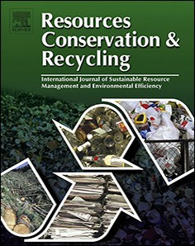Resources,Conservation&Recycling151(2019)104438

Contents lists available at ScienceDirect

Resources, Conservation & Recycling

journal homepage: [www.elsevier.com/locate/resconrec](http://www.elsevier.com/locate/resconrec)

Full length article

# Zero waste manufacturing: A framework and review of technology, research, and implementation barriers for enabling a circular economy transition in Singapore

## Piya Kerdlapa,⁎, Jonathan Sze Choong Lowb, Seeram Ramakrishnaa

a *National University of Singapore, 21 Lower Kent Ridge Road, 119077, Singapore*

b *Singapore Institute of Manufacturing Technology, 2 Fusionopolis Way, 138634, Singapore*

A R T I C L E I N F O

*Keywords:*

Industrial ecology Industrial symbiosis Waste management

Sustainable manufacturing Industry 4.0

A B S T R A C T

Zero waste manufacturing (ZWM) is a concept to support countries transition to a circular economy by devel- oping manufacturing technologies and systems that eliminate waste across entire waste value chains to the fullest extent possible through reuse and recycling. Implementation of ZWM, particularly in dense urban settings such as Singapore, presents challenges for stakeholders, which stem from issues related to land scarcity, pro- ductivity, and labor shortage. A framework to address these challenges is proposed comprising six themes of design for zero waste, smart waste audit and reduction planning, smart waste collection, high-value mixed waste processing, collaborative platform for industrial symbiosis, and waste to resource conversion and recycling. A systematic literature review is used to examine industry technologies and research across the six themes to determine how the technologies can support ZWM. The research reveals that a variety of mature waste mea- surement, collection, and conversion technologies can be integrated through internet-of-things applications and a collaborative platform for industrial symbiosis to support Singapore and other countries in developing a ZWM ecosystem. This research examines the technical limitations of implementing ZWM technologies in dense urban settings using Singapore as a case study. Future areas of research are then proposed to overcome the im- plementation barriers so that ZWM can be enabled.

1. Introduction

Transitioning to a circular economy has drawn signiﬁcant attention from countries across the world as a new pathway for mitigating the growing volumes of waste that is coupled with today’s economic growth. The predominant linear “take, make, and dispose” economic development model has resulted in ineﬃcient use of resources that threatens the stability of natural ecosystems and survival of humanity (Ghisellini et al., 2016). More recently, the unsustainable nature of the linear economic system has gained even greater attention due to China’s decision in late 2017 to implement a ban against imports of 24 categories of waste from the rest the world. A year later, other countries in Asia such as India, Malaysia, Thailand, and Vietnam have followed the same initiative by implementing their own waste import bans and tightening restrictions. This has forced nations such as the United States, the United Kingdom, Australia, and Japan to urgently rethink their waste management practices. Global municipal solid waste (MSW) generation is estimated at 2.01 billion tonnes per year and by 2050 it is

expected to increase to approximately 3.4 billion tonnes per year (World Bank, 2018). A majority of the global waste ends up in landﬁlls, open dumps, oceans, or other parts of the environment due to sub- optimal waste management systems and low recycling rates around the world. Only 7% of global plastic waste was recycled (National Geographic, 2017) while for electronic wastes, it was estimated that only 20% of the global total is documented to have been collected and recycled properly (Baldé et al., 2017). Strategies are therefore needed that prioritize reducing material consumption levels and break away from conventional waste management in a linear economy and transi- tion to a circular economy where wastes are reduced and reused as resources across multiple supply chains at every opportunity (Young et al., 2010).

Singapore is working towards becoming a zero waste nation as the country is faced with the similar global challenge of ﬁguring out the next destination to put its growing amounts of waste. As outlined in the Sustainable Singapore Blueprint by the Ministry of the Environment and Water Resources (MEWR), the country is prioritizing development

⁎ Corresponding author.

*E-mail address:* [piyakerdlap@u.nus.edu](mailto:piyakerdlap@u.nus.edu) (P. Kerdlap).

https://doi.org/10.1016/j.resconrec.2019.104438

Received 22 August 2018; Received in revised form 31 March 2019; Accepted 2 August 2019

Availableonline20September2019

0921-3449/©2019ElsevierB.V.Allrightsreserved.

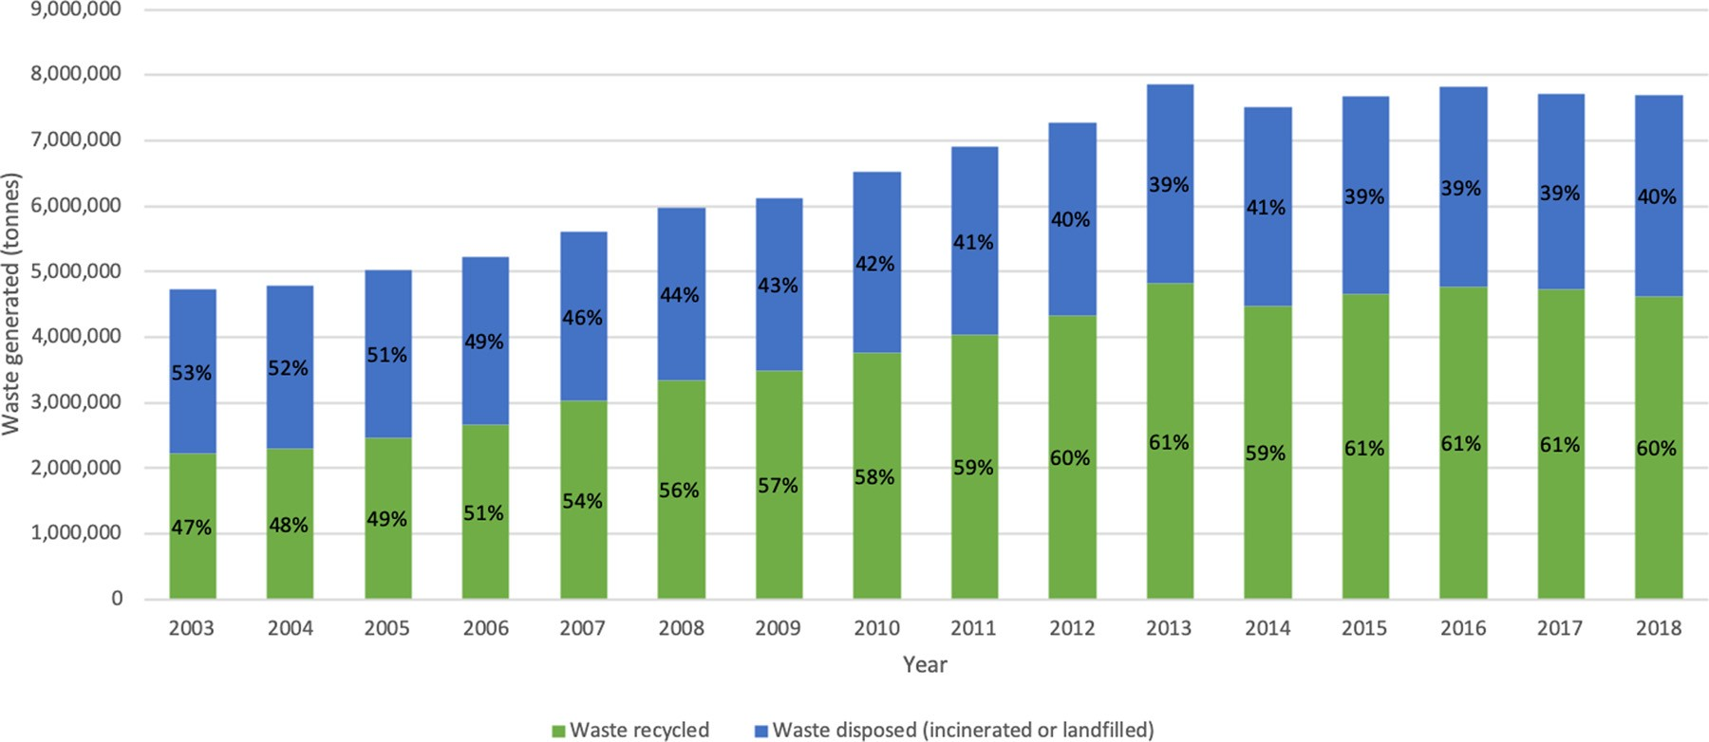

Fig. 1. Waste disposal and recycling in Singapore between 2003 and 2018 (National Environment Agency).

of eﬃcient waste collection, management, recycling, and disposal sys- tems (Ministry of the Environment and Water Resources, Government of Singapore, 2015). As an aﬄuent and highly urbanized country with very little land available for use, Singapore is highly reliant on its four waste-to-energy plants to incinerate its non-recyclable wastes. The in- cineration bottom ash and non-incinerable wastes are stored at its ﬁrst and only oﬀshore landﬁll on Semakau island. Space on Semakau island will quickly disappear as the landﬁll is expected to max out by 2035, a decade sooner than the original 2045 projection. The population and aﬄuence of the city-state is expected to climb which will correspond- ingly increase future waste generation. As shown in Fig. 1, in 2018, Singapore generated 7.7 million tonnes of waste with 60% of the vo- lume recycled and 40% either incinerated or sent to a landﬁll.

The steady rise in recycling rates from 47% in 2003 to 60% in 2018 has helped Singapore mitigate waste challenges. However, the rate of waste generated has also increased similarly and the amount of waste sent to the incinerators and landﬁll has not shown much improvement. In parallel to the waste challenges, Singapore has prioritized ad- vancing its manufacturing sector which contributes to 20% of its gross domestic product (GDP) and 14% of total employment (Ministry of Trade and Industry, 2017). To advance the manufacturing sector, Sin- gapore has adopted industry 4.0 technologies as a pathway that is ex- pected to add USD27 billion in total manufacturing output, boost labor productivity by 30%, and create 22,000 new jobs by 2024 (Boston Consulting Group, 2017). Industry 4.0 is the fourth stage of the in- dustrial revolution where computers, automation technologies, and manufacturing systems integrate together into cyber-physical systems that monitor the physical processes of a factory and make its own de- cisions (Zheng et al., 2018, Lopes de Sousa et al., 2018, Lee et al., 2015). The two-way communication of data between the components, machines and digital devices results in networked manufacturing sys- tems that are intelligently cross-linked across all hierarchical levels of a value chain (Stock and Seliger, 2016). To catalyze the adoption of I4.0, the Government of Singapore has committed USD2.4 billion under the ﬁve-year Research, Innovation and Enterprise 2020 plan to support advancements of technological capabilities in the manufacturing and engineering sectors (National Research Foundation, 2016). Global ex- periences have shown however that although advancements in manu- facturing result in rising living standards, it also brings about adverse environmental impacts due to unsustainable consumption and pro-

duction patterns (Tseng et al., 2018).

Zero waste manufacturing (ZWM) oﬀers a solution to Singapore and other countries’ waste management and manufacturing objectives. The concept focuses on developing manufacturing systems that eliminate waste across entire value chains to the fullest extent possible by

minimizing waste generation and maximizing the use of wastes as re- sources in other supply chains. In ZWM, waste is viewed as a manu- facturing value chain where waste is generated, collected, and recycled. ZWM aims to improve waste reduction and recovery across multiple supply chains and stakeholders to maximize resource eﬃciency.

The holistic life cycle approach of ZWM can address the dual ob- jectives of future advancements in manufacturing and waste reduction. However, an overarching challenge of achieving ZWM is that as global manufacturing moves through the fourth industrial revolution, the di- versity and volume of waste will continue to evolve and stakeholders along the waste value chain may not be able to keep up at the same pace (World Economic Forum, 2016). To identify the technologies that stakeholders can implement to achieve ZWM, this study proposes a holistic framework comprising six technology themes that aim to mi- tigate waste generation across the life cycle stages of production and consumption systems. These six themes include:

1. design for zero waste
2. smart waste audit and reduction planning
3. smart waste collection
4. high-value mixed waste processing
5. collaborative platform for industrial symbiosis
6. waste to resource conversion and recycling.

As shown in Fig. 2, the six themes of the ZWM framework are connected together by addressing speciﬁc technical needs of stake- holders across the manufacturing waste value chain: producers who are also the waste generators, waste collectors, and waste to resource converters or recyclers.

The ways in which all six themes support the three major waste value chain stakeholders move towards ZWM is outlined in Table 1.

Integrated together, the collection of technologies under all six themes can minimize waste along the whole waste value chain. The ZWM framework oﬀers both environmental and economic beneﬁts for a country’s manufacturing sector. Implementing technologies under the six themes allows manufacturing companies to reduce the volume of waste generated and prevent waste from entering the landﬁll. Waste reduction and recycling through ZWM reduces greenhouse gas emis- sions, energy consumption, and reliance on virgin materials which translates to economic cost savings.

Previous studies have reviewed how the zero waste concept and diﬀerent technologies have been applied in diﬀerent stages of produc- tion and waste management systems (Zaman, 2015; Singh et al., 2017). However, there is a need for studies to examine the technical challenges stakeholders of the waste value chain - waste generators, waste

2

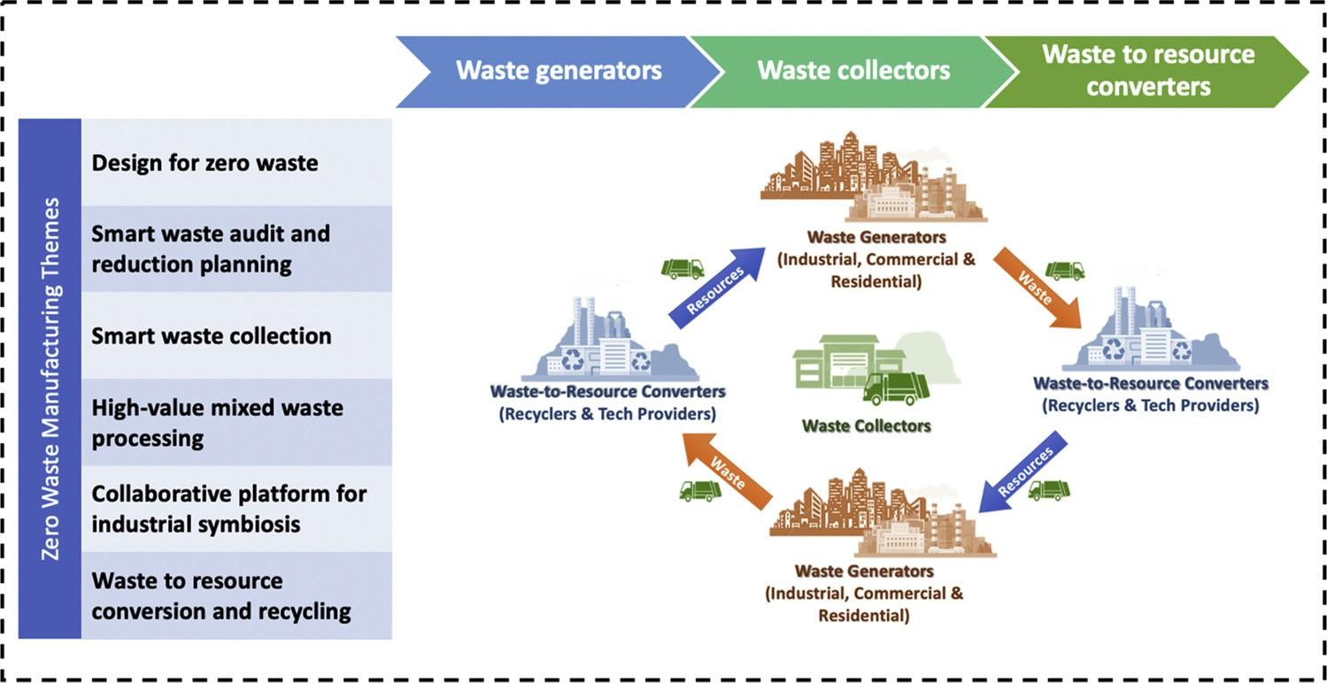

Fig. 2. Overview of zero waste manufacturing framework.

collectors, and waste to resource converters - may face in implementing existing technologies to meet their zero waste goals and transition to a circular economy. Certain ZWM technologies may face barriers during implementation in dense urban settings. There is a need to identify the technical challenges waste stakeholders operating in dense urban set- tings may face as per capita waste generation is greater for countries or regions with high urbanization rates (World Bank, 2018) and it is projected that more than two-thirds of the world’s population will be residing in urban centers by 2050 (United Nations, 2018). The objective

of this research is to therefore answer the questions, what are the latest industry technologies under each theme of ZWM and what are the challenges that hinder implementation of these technologies to achieve the goals of ZWM in Singapore and other highly urbanized regions around the world? This study ﬁrst used a systematic review approach to identify and review the state-of-the-art technologies and research lit- erature under the six themes of the ZWM framework. Based on the thematic review, the feasibility of implementing the technologies is examined using Singapore as a case study for a high income and highly

Table 1

Stakeholder beneﬁts under each theme of ZWM.

Theme Stakeholder Support the theme provides to stakeholder

Design for zero waste Generators Products can be designed and manufactured that use less materials or can be reused which minimizes waste

generation.

Collectors Products can be designed for disassembly allowing for easy collection, sorting and thereafter, reuse or waste recycling.

Converters Products can be designed to be broken down more easily into sub-components and materials so that they can be separated to facilitate eﬃcient recycling.

Smart waste audit and reduction planning

Generators Automated waste auditing and reporting processes can eﬃciently estimate the magnitude and composition of waste generated to provide the necessary data for managing and mitigating waste.

Collectors Data from smart waste audits can be used by waste collectors to know the magnitude and type of waste diﬀerent entities are generating in real time and therefore know where and when to collect a speciﬁc type of waste that is desired.

Converters Diﬀerent waste to resource converters can use smart waste audits for real-time information about the magnitude and type of waste being generated at diﬀerent sites and then quickly identify who to engage with to use the speciﬁc waste.

Smart waste collection Generators Being connected to a smart waste collection system with sensors and smart waste bins allows waste generators to

have their wastes collected more eﬃciently and avoids unmanageable waste overﬂow.

Collectors Data from smart waste collection systems help optimize waste collection routes that maximize the number of full bins collected which improves utilization of assets (trucks) and manpower and minimizes collection time and costs.

Converters Waste to resource converters connected to a smart waste collection system can have real-time information about when wastes will arrive at their facilities which can support in planning recycling operations and predict incoming materials.

High-value mixed waste processing Generators Automated sorting and segregation allow for recovery of valuable materials from waste generators that was disposed

in a single mixed stream due to lack of capacity or infrastructure to do source separation.

Collectors Waste collectors can collect mixed waste streams and have it sorted to recover materials that can then be sent to other facilities for waste to resource conversion.

Converters Automated sorting and segregation of mixed wastes before recycling increases waste to resource conversion yields.

Collaborative platform for industrial symbiosis

Waste to resource conversion and recycling

Generators Waste generators can be matched with companies that desire their wastes for reuse or recycling.

Collectors Collectors can become logistic service providers for companies connected on a collaborative platform for waste to resource matching and exchanges. Data from the collaborative platform can identify for collectors where their services may be needed.

Converters The collaborative platform can provide information to waste to resource converters about which companies have the waste that speciﬁc converters desire for reuse and recycling.

Generators Waste generators will have technology options for recovering value from their waste materials instead of disposing it to a landﬁll or incinerator.

Collectors Collectors can provide the service of delivering wastes to the appropriate waste to resource converter.

Converters Converters will have the technology needed to convert waste to resources and then sell the recycled materials as a feedstock for another supply chain.

3

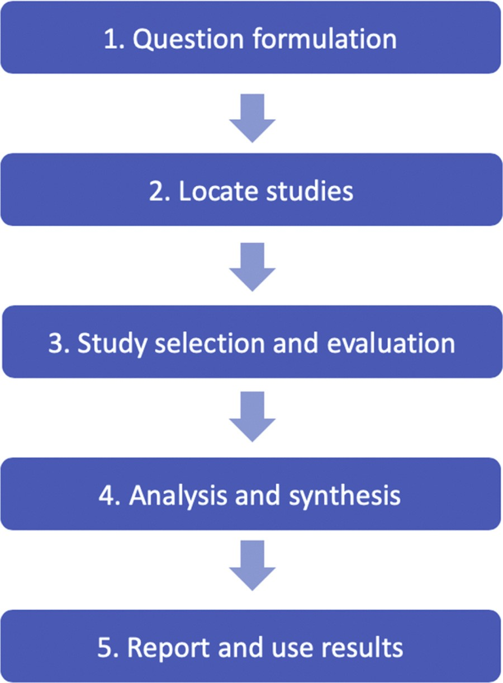

Fig. 3. Systematic literature review procedure.

urbanized city. Then, future areas of research in ZWM are proposed to address the implementation barriers identiﬁed. The intended audience of this research includes government decision makers, manufacturing companies and associations, waste collectors and converters, research institutions in Singapore and other countries and cities that seek to understand how current ZWM technologies can be applied to achieve advanced manufacturing and waste reduction goals. The ﬁndings of this research can be used to develop a roadmap that outlines the strategic research and development direction for building a ZWM ecosystem in Singapore and other urban settings. This review is designed to en- courage researchers, businesses, and decision-makers implement stra- tegies and activities for moving towards ZWM.

1. Materials and methods

This research applies the systematic literature review (SLR) meth- odology to conduct a review process that is replicable and transparent (Denyer and Tranﬁeld, 2009). Once the research questions were es- tablished, the systematic procedure outlined in Fig. 3 was used to ﬁnd and select relevant studies.

Apart from the academic literature, grey literature sources were included in this study as they provide updated sources of information regarding technologies applied in practice. These pieces of evidence suggest their real-world applicability to instances of manufacturing and waste-related issues.

* 1. *Question formulation*

The primary review question formulated was: What are the latest industry technologies in each theme of ZWM that can be implemented together to achieve both manufacturing and waste management goals in Singapore and similar cities? The secondary questions developed that support the primary question were:

1. How do the technologies under each theme contribute to achieving ZWM?
2. What future areas of research should be pursued to address the limitations of the technologies identiﬁed under the themes of the ZWM framework?
   1. *Locating studies*

Two decisions were made in the selection of the search engines and the keywords. Scopus and ScienceDirect were used to identify scientiﬁc papers related to the six themes of ZWM. Scopus was selected because it is the largest citation and abstract database while ScienceDirect was selected because the database contains many of the journals with stu- dies that are related to the topics being explored in this review. The general Google search engine was also used to ﬁnd grey literature sources such as business reports, news articles, and company informa- tion about technologies and businesses related to the ZWM themes that have already been implemented in the global market. Search keywords were determined through a two-step process. First, the six ZWM themes were used in the search engines. Then, related concepts and synonyms that frequently appeared in the ﬁrst search and were related to the research question were then used to narrow the search into a ﬁnal search string. The keywords for the search strings used in the search engines are listed in Table 2.

For the theme of waste to resource conversion and recycling, the search criteria were narrowed down to focus primarily on technologies for recycling wastes in the food, paper, plastics, and electronics sectors because those waste categories present the greatest opportunities for recycling in Singapore. In 2018, Singapore recycled only 56% of paper and cardboard wastes, 17% of food waste, and 4% of plastic waste (National Environment Agency of Singapore, 2019b). For electronic wastes, the National Environment Agency (NEA) reported that Singa- pore generated around 60,000 tonnes in 2014. This made Singapore the second-highest generator of electronic wastes in the East and Southeast Asia region (Honda et al., 2016).

Table 2

Keywords used in search strings for ZWM themes.

Concept Search string

Smart waste audit “smart waste audit” OR “waste audit”

Smart waste collection “smart waste collection” OR “smart waste” OR “smart waste bin” High value mixed waste processing “high value mixed waste processing” OR “mixed waste processing” Product recycling “product recycling” OR “product remanufacturing”

Food waste recycling “food waste recycling” OR “food waste recovery” OR “food waste to energy”

Paper and cardboard recycling “paper recycling technology” OR “waste paper recycling technology” OR “cardboard recycling technology” OR “waste

cardboard recycling technology”

Plastic recycling “plastic recycling technology” OR “waste plastic recycling technology”

Electronic waste recycling “e-waste recycling technology” OR “ewaste recycling technology” OR “electronic waste recycling technology” Design for zero waste “design for zero waste” OR “design for disassembly” OR “modular product technology”

Collaborative platform for industrial symbiosis “industrial symbiosis network” OR “industrial symbiosis tool” OR “industrial symbiosis platform”

4

Table 3

Inclusion and exclusion criteria for title and abstract screening.

Attribute Inclusion Exclusion

Field of study Field of study must be related to waste management and recycling, manufacturing, and environmental sustainability.

Context within ﬁeld Title/abstract contains cues on technology, systems, and processes to improve waste and resource management, reduction, and recycling in manufacturing industry practices.

Subject of discussion Title/abstract has to include discussion or description of the technology, systems, or process applied in improving waste and resource management, reduction and recycling in manufacturing processes. The technology, system, or process should elaborate on the functions and should be implementable or has been implemented.

Field of study is not related to waste management and recycling, manufacturing, and environmental sustainability (e.g. policy, ﬁnance, urban management and planning).

Title/abstract contains cues of related topics (e.g. advanced manufacturing technologies, material recovery technologies, computational methods), but do not directly discuss applications to improving environmental sustainability in manufacturing practices.

Title/abstract discusses principles and fundamental zero waste concepts; history of zero waste; zero waste cases analysis with no relation to technology, systems, or processes that support the objectives of ZWM.

* 1. *Study selection and criteria*

The main criteria for shortlisting the search results under each of the six themes for further analysis was technology which included hard- ware, software, and services. Only studies and other information pub- lished in 2008 and onwards were included to obtain contemporary research and state-of-the-art technologies applied in practice. Each type of information source was screened in a diﬀerent manner to ﬁlter out false positive results from the automated search engines as follows:

1. Scientiﬁc studies: The title and the abstract were screened
2. Business reports: The executive summaries and introductions were screened
3. Company websites: Homepages were screened
4. News articles: The title and the ﬁrst three paragraphs of the article were screened

Table 3 lists the criteria developed to determine topic relevance before further detailed selection.

The screening determined which studies, reports, or news articles were directly relevant to the scope of this research and would go through a full text review. As shown in Table 4, criteria were then developed to ensure the information was relevant for answering the research question.

The shortlist resulted in 52 research papers, business reports, web- sites, and news articles that went through a full text review.

The subsequent sections of this research describe the ﬁndings of the thematic analysis of six pre-deﬁned themes of ZWM and their tech- nologies. Section 4 discusses how the technologies in the themes can be integrated to achieve ZWM and examines the limitations the ZWM technologies may face during implementation in dense urban settings. Section 5 proposes future areas of research in ZWM that are needed to overcome the limitations of the technologies examined in this study.

1. State-of-the-art technologies in zero waste manufacturing

Each theme of ZWM addresses a group of technologies needed for waste generators, waste collectors, and waste to resource converters to move towards ZWM. Through the thematic review, technologies are

identiﬁed that the ZWM stakeholders could adopt to overcome their unique waste management challenges. An excel spreadsheet that clas- siﬁes the ZWM technologies and studies reviewed in this research is provided in the supporting information.

* 1. *Design for zero waste*

Design for zero waste focuses on designing products that use less materials and/or are easier to disassemble. This reduces the amount of waste generated, makes it easier to collect used parts, and makes it more feasible to recover parts or materials from the product at its end of life. In the manufacturing industry, design for disassembly (DfD) and additive manufacturing (AM) are able to achieve this goal. DfD is a design strategy that considers the future need to disassemble a product for repair, refurbishment, and recycling. Through DfD, valuable parts and materials that still have value can be easily recovered and used in the same or diﬀerent products. AM technology constructs products by directly joining materials layer by layer following a digital design template. AM products can be developed to more precise design spe- ciﬁcations and shapes from start to ﬁnish, which helps eliminate waste generated along the manufacturing process, compared to conventional manufacturing.

* + 1. *Design for disassembly*

Ameliorating product design during the development phase can increase the recovery rate of products and their materials. DfD guide- lines state that maximizing a product’s ability to be disassembled can be achieved during the design stage by looking at how to reduce the number of product parts, lower product disassembly costs, shorten disassembly time, and solve all the existing problems in disassembly (Soh et al., 2014). For DfD products to be successful and well received by customers, it is recommended that they meet 14 diﬀerent char- acteristics provided by Wang et al. (2014). To support decision-making in DfD, Low et al. (2014) proposed a tool based on modular product architecture.

Products with modular architectures are a notable example of DfD because they can be disassembled into a number of subassemblies, parts, and components. Each subassembly can be considered a module that can be independently created and then used again in other product

Table 4

Subject matter relevance criteria for full text review.

Type of paper Content proﬁle of paper Paper must contain

Conceptual Conceptual description of technology. Yet to present evidence of implementation.

Review and trends Description of industry trends and issues about a type of technology applicable to ZWM.

Empirical Description of how the technology works, what it can achieve, with evidence of successful testing or implementation.

Concept of the technology, demonstrable by the logic and design and applicable to ZWM themes.

Details about the development status, industry standards, challenges and gaps, of technology applicable to ZWM.

Details about the functions, processes, and outputs of the technology and the relationships between the steps, and what issues the technology solves.

5

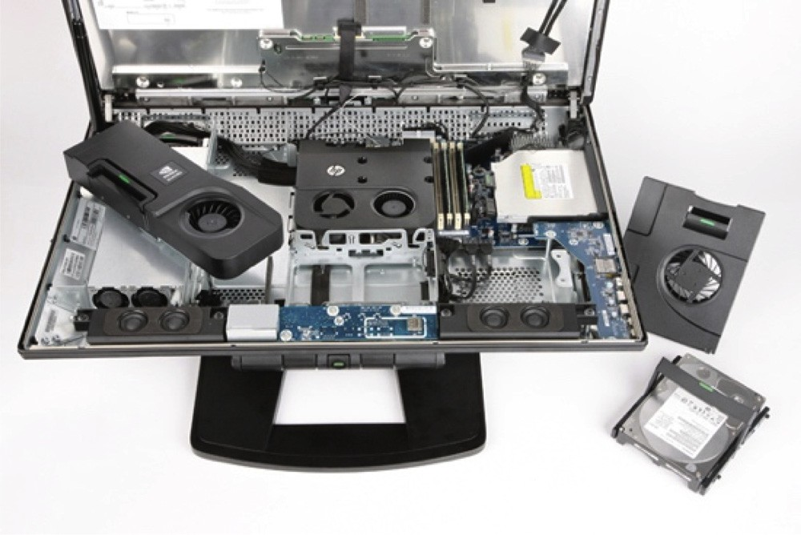

Fig. 4. Internal design of the HP Z1 computer.

systems (Ernst and Young, 2015; Sabaghi et al., 2016). Manufacturing products with modular architectures allows parts to be easily broken down into a number of standardized building blocks, which can be rearranged to create diﬀerent conﬁgurations and variants (Rios et al., 2015). Parts of modular products are also easily replaceable. One ex- ample of a modular product is Hewlett Packard’s HPZ1 computer as illustrated in Fig. 4.

The HPZ1 monitor contains all the machine’s workings and all hardware components can be removed for repair without the need for tools (Ellen MacArthur Foundation, 2013).

Modular construction of buildings has been shown to achieve the beneﬁts of DfD. Modular buildings make it easier to deconstruct them and recover the materials for other product supply chains, as opposed to completely demolishing them (Kamali et al., 2018; Kamali and Hewage, 2017). The company Yorkon manufactures modular components of buildings oﬀ-site and connects all the pieces of the ﬁnal building at the determined location as shown in Fig. 5.

Modular construction does not necessarily restrict the ﬁnished de- sign and can save money and time due to less disruption and wastes generated compared to onsite construction of a building from scratch (Kamali and Hewage, 2016).

* + 1. *Additive manufacturing*

AM technology produces objects from a three-dimensional (3D) model by joining materials layer by layer, directly from raw materials such as metal and plastic in powder, liquid, sheet, or ﬁlament form without the need for molds, tools, or dies. AM builds products to more precise design speciﬁcations which reduces waste material generated

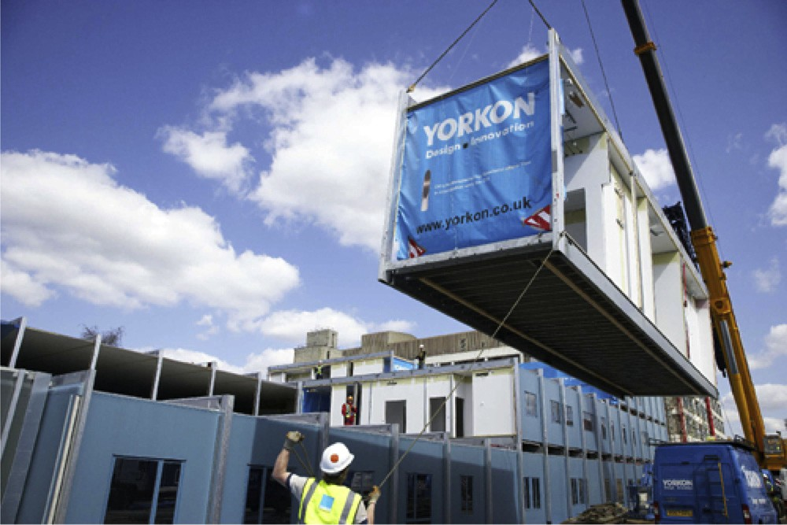

Fig. 5. Example of a modular building by Yorkon (Ellen MacArthur Foundation, 2013).

during product fabrication compared to traditional manufacturing (Niaki et al., 2019). 3D printing is the most well-known type of AM that allows products to be engineered to a speciﬁc order from the customer and spare-parts can be produced to precise speciﬁcations (Kreiger et al., 2014). 3D printed products are more ﬂexible in terms of customization capabilities. This enables manufacturing to happen outside of a factory and closer to the point where the product will be consumed (Kellens et al., 2017). Some multinational companies have invested in AM for enhancing their business. General Electric invested USD50 million in a factory that 3D prints 35,000 fuel nozzles each year because AM technology uses less material than conventional manufacturing pro- cesses which reduces production costs (Massachusetts Institute of Technology, 2013). Several shoe companies such as Adidas, Nike, Feetz, and United Nude, are now using 3D printing technology to give cus- tomers shoes that are custom made for them right at the store (CNN, 2017). 3D printed shoes use the exact amount of materials required and can help avoid generation of waste materials that typically occurs in conventional shoe production.

Design for zero waste contributes to building a ZWM ecosystem because it helps prevent waste generation right at the start of product life cycles. Making products that are easier to disassemble, re- manufacture, and refurbish increases opportunities for products and their components to be reused in the same or diﬀerent product life cycle. Conducting research to advance design for zero waste will sup- port product reuse, upgrade, and maintenance resulting in reduced consumption of raw materials and energy.

* 1. *Smart waste audit and reduction planning*

Smart waste audits comprise hardware and software solutions that analyze waste volumes, automatically segregate waste, and assess op- portunities for waste reduction and diversion though recycling or reuse. Current hardware research and development has been focused on waste bins that automatically segregate waste by analyzing the material content through cameras and sensors (Bin-e, 2017; CleanRobotics, 2016). On the software side, smart waste audits are carried out through online tools that use data analytics to review waste generation data, existing waste collection practices and costs, and current levels of onsite recycling (Ng et al., 2017). These digital tools then identify opportu- nities for increasing waste recycling and cost saving opportunities. Gershman, Brickner & Bratton, Inc. (GBB) developed an internet-based tool called Smart Engine that identiﬁes cost-saving opportunities for diﬀerent workplaces. The tool utilizes an extensive database of waste and recycling information from GBB’s 20 years of experience in the industry and national databases. After the tool was developed and tested, many businesses conducted their waste audits through Smar- tEngine (Gershman, Brickner, and Bratton, Inc., 2017). SMARTWaste is another online smart waste auditing tool developed by BRE. This tool was designed to simplify reporting for environmental compliance in construction projects by managing environmental data in construction and allows users to input the data from their projects. Users have re- ported that SMARTWaste helped reduce onsite waste generation by 40% (BRE, 2017).

Smart waste audits and reduction planning technologies contribute to building a ZWM ecosystem because they enable waste audits to be carried out more eﬃciently. Advanced hardware and software solutions for collecting and analyzing waste generation data at diﬀerent sites reduce the time and costs to complete waste audits and measure the potential for waste reduction and recycling.

* 1. *Smart waste collection*

Current trends in smart waste collection have resulted from new technology enablers that include geographic information systems (GIS), data access networks, sensors, and Internet-of-Things (IoT) (Shukla and Shukla, 2017). The global smart waste collection technology market is

6

expected to grow from USD57.6 million in 2016 to more than USD223 million in 2025 (Navigant Research, 2016). Companies leading in commercialized technology solutions for smart waste collection are Bigbelly Solar; Cognito Tech Solutions; Compology; Ecube Labs; Enevo; IoTsens; SmartBin; SmartUp Cities; System Level Solutions; Urbiotica; and WAVIoT.

Modern smart waste collection systems include an integrated net- work of sensors, smart waste bins, trucks, maps, and a data manage- ment center all integrated together to maximize eﬃciency of waste collection (Srikantha, 2017). They are designed to solve the current complicated and costly process composed of ineﬃcient routes serviced by a ﬂeet of trucks on disconnected and arbitrary schedules (Ecube Labs, 2017a). As a result, collection costs can represent nearly two- thirds of waste management expenditures (Gershman, Brickner, and Bratton Inc., 2015). In smart waste collection systems, sensors are set up at waste bins connected to a remote network. The sensors measure bin ﬁll levels and send the data to a central database that uses data analytics to monitor sensors and optimize collection routes by skipping empty or low traﬃc bins (Gutierrez et al., 2015). Algorithms are then used to conduct predictive analyses of data history to estimate ﬁll levels in advance. The results are then used to plan out optimized collection routes for waste hauling trucks that minimize pick-up points and the number of vehicles dispatched. Collection routes are sent to truck dri- vers through a mobile phone application in real time and can be up- dated by GPS navigation. The parameterization of the multitude of factors such as distances between points, facility options, and proces- sing costs is necessary to accurately model the complexities of multi- plicities and spatial heterogeneities in municipal solid waste systems (Cheng et al., 2017a, b). Fig. 6 illustrates components of a smart waste collection system.

The fundamental component of smart bins are sensors that can be attached to any type of waste bin and continuously measure ﬁll level, temperature, and bin tilt using ultrasonic wireless technology. Sensors are also capable of detecting all types of solid and liquid materials such as general waste, glass, waste oil, and lubricants. They can also perform geopositional tracking to ensure that owners always know the location of their containers (Omar et al., 2016). Wireless ultrasonic sensors also serve as a communication node that send waste bin information to a central data server through a cellular network. Future sensor tech- nology will be able to measure humidity, motion, or weight of the bin to provide better data about the composition of waste at diﬀerent sites. Other larger and more complex smart waste bins exist that provide

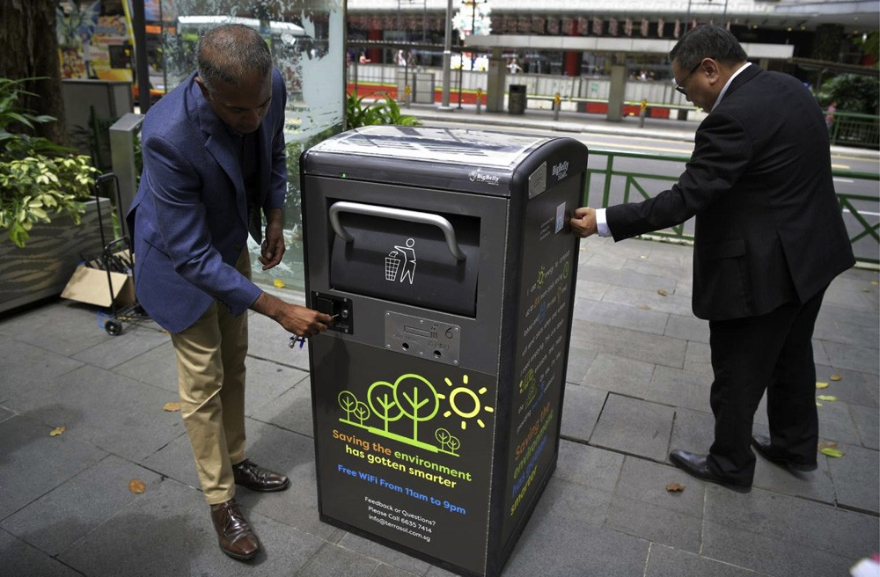

Fig. 7. Bigbelly smart waste bin.

services beyond ﬁll level monitoring and wireless data transfer. One example is the Bigbelly smart bin, as shown in Fig. 7.

The bin is powered by solar photovoltaic electricity, can compact waste within the receptacle to reduce volume and overﬂow, and is equipped with a Wi-Fi unit that can serve as a public internet hotspot (Bigbelly, 2017). The waste compacting feature helps reduce the col- lection trips needed to empty the bin. More advanced smart bins are being built with capabilities to automatically sort waste deposited into the bin, which would reduce labor, time, and costs in waste manage- ment (Bin-e, 2017). This waste sorting function is based on a combi- nation of mechanical and electronical components, and software with elements of artiﬁcial intelligence.

Data systems in smart waste collection monitor and optimize daily selection of waste bins to be emptied and calculate the routes and schedules accordingly. Powered by information and communications technology infrastructure, data about bin ﬁll level, locations of bins and trucks, road traﬃc congestion, time of day, and other factors are col- lected from all smart waste bins. Algorithms then process this data to calculate the most eﬃcient collection routes to be taken (Ecube Labs, 2017a). The data system then transmits the optimized collection routes directly to the drivers’ mobile phone or tablet computer. These online tools enable managers of smart waste collection systems to monitor all operations in real time from either a desktop computer or remotely on a mobile device. Smart waste collection online tools are designed to learn

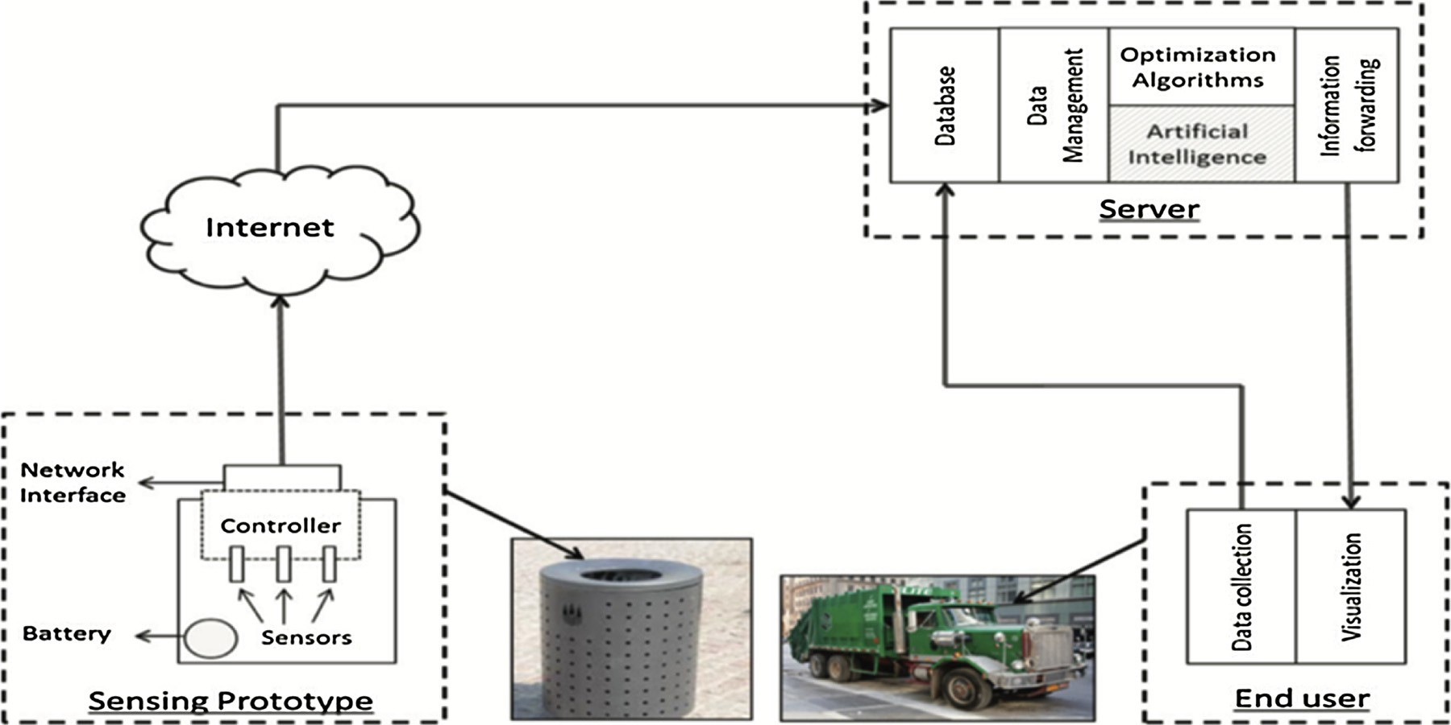

Fig. 6. Components of a smart waste collection system (Gutierrez et al., 2015).

7

from experience and can make decisions based not only on the daily waste level status but also on future waste forecasts, traﬃc congestion, balanced cost-eﬃciency functions, and other factors that humans are unable to foresee. The advanced data systems in smart waste collection enable optimized selection of trashcans to be collected which improves collection eﬃciency and reduces operation costs.

Many cities across the world have already implemented smart waste collection systems in urban management programs in tandem with IoT technology advancements (GreenBiz, 2017). Companies such as Ecube Labs and Bigbelly Solar have already successfully deployed their smart waste collection systems technologies at universities, city streets, train stations, and airports in Dublin, Los Angeles, Melbourne, Seoul, and Washington D.C (Bigbelly, 2017; Ecube Labs, 2017b). These projects have resulted in waste collection cost savings as high as 85%.

Smart waste collection technologies contribute to building a ZWM ecosystem because waste producers, collectors, and converters become digitally connected to enhance waste management operations. Waste management assets such as collection trucks are able to perform more eﬃciently because they can be dispatched along a route with bins at ﬁll levels that are maxed out or near maximum capacity, as opposed to driving through a collection route with bins at low ﬁll levels. Data from smart waste management systems and their components can be used to create strategies that identify the best route and time of day during the week that is best for collection. This reduces the amount of labor, trucks deployed, and fuel required to carry out waste collection operations. Eﬃcient collection of recyclables through smart waste collection sys- tems will also enable more conversion of waste to resources for other supply chains.

* 1. *High-value mixed waste processing*

Mixed waste processing (MWP) uses a combination of new and existing technologies at large facilities to sort out the recyclables from streams of mixed waste. The goal of high-value MWP is to achieve greater yields of recycled products that are valuable for end-users. One of the greatest challenges in achieving high-value MWP is developing technology that processes single streams of mixed waste and segregates products with very minimal contamination in a cost-eﬀective manner. Overall, the MWP industry is moving towards large regional single- stream facilities, as opposed to small-scale operations (Gershman, Brickner, and Bratton Inc., 2015). Modern MWP facilities are mature and employ demonstrated technology for processing MSW and cap- turing recyclables.

Nearly all modern MWP facilities include a pre-sort to eliminate bulky or prohibitive materials, a method to open bags, and screens that remove ﬁne materials (Gershman, Brickner, and Bratton Inc., 2016). Advancements in MWP are expected to be primarily focused on im- provements in identiﬁcation and segregation technologies such as op- tical sensors that can target and separate speciﬁc plastics. Optical units in modern material recovery facilities (MRFs) are mostly used to re- cover polyethylene terephthalate (PET) and high-density polyethylene (HDPE). However, optical units can also be used to recover other re- cyclable mixed plastics, frequently referred to as plastics grade #3 through #7. Table 5 provides details about state-of-the-art technologies used across all processes for MWP.

Combining MRFs and MWP systems have potential to signiﬁcantly increase both volume and total revenue from recycling materials (Gershman, Brickner, and Bratton Inc., 2015). Routing MRF residue to the MWP facility could allow for greater potential of reprocessing and recovery of recyclables. The MWP facility could also serve as the con- solidation point for all the non-recovered material output streams which would improve eﬃciency. This would allow the MRF to still recover high quality recyclables while the MWP facility would recover additional recyclables of adequate quality.

High-value MWP contributes to building a ZWM ecosystem by in- creasing recovery rates of valuable materials from mixed waste streams

and reduces the magnitude of waste sent to the landﬁll. Increasing MWP allows for greater segregation of waste that can be reused as re- sources in other supply chains. Even after residents have separated out recycled commodities, the average MSW stream may contain up to half of the total volume of recyclables, and in many cases more than half. Conducting research to improve high-value MWP will help reduce fu- ture landﬁll costs. The costs of landﬁlling waste will only rise due to the rapidly declining availability of landﬁll space. Another beneﬁt of im- proving high-value MWP is that the technology does not require con- sumer participation, education, or sorting behavior.

* 1. *Collaborative platform for industrial symbiosis*

Collaborative platforms for industrial symbiosis are an ongoing ﬁeld of research focused on developing digital technologies that identify suitable waste to resource matches and facilitates those exchanges be- tween diﬀerent companies in a speciﬁc area or region (Fraccascia and Yazan, 2018). This promotes industrial symbiosis, an association be- tween two or more industrial facilities or companies where wastes and by-products of one supply chain become resources for another. These platforms function similarly to social networking platforms such as LinkedIn, Uber, and Airbnb where people’s demands are matched with supplies of resources and products. Currently, several internet-based platforms exist that facilitate industrial symbiosis. Industry organiza- tions or facilitator companies usually oﬀer these internet-based plat- form tools that allow businesses to discuss synergies through symbiosis in a safe and common environment (Chertow and Park, 2015). Plat- forms that are commercialized or under development usually include an interface where users input data about the waste and resources they have available or desire; a database for storing all the information about the diﬀerent users and companies; and algorithms for matching dif- ferent users based on their waste and resource needs (Low et al., 2018; Raabe et al., 2017; Song et al., 2015). Table 6 provides details that distinguish each of the diﬀerent existing collaborative platforms de- signed to facilitate industrial symbiosis.

Expected future development of these platforms include software upgrades that use advanced data analytics and models to perform au- tomated waste recycle and reuse matches. This would allow human labor to focus on veriﬁcation and supervision instead of time-con- suming research and analysis. Research is being done to upgrade these platforms to enable material informatics. This uses data mining and machine learning processes to analyze large ensembles of primary and waste material data to deliver the knowledge to end-users that require them for product development (Ramakrishna et al., 2018). Another area of research for this technology is development of analytical tools that calculate the environmental and economic beneﬁts of the potential waste to resource exchanges and material processing systems using life cycle assessment (Jose and Ramakrishna, 2018). Future research is also being done to digitally connect all stakeholders involved in ZWM and have them interact on a cyber-physical environment as illustrated in Fig. 8.

A collaborative platform for industrial symbiosis contributes to building a ZWM ecosystem because these online platforms provide the necessary intelligence to connect all types of organizations to trade wastes and by-products between each other in an economically favor- able manner. Manufacturing companies usually lack the knowledge about what kind of wastes can be converted into resources. Even if the companies have the technical capacity in this area, practical concerns arise such as the business viability and the willingness of companies to become partners to carry out waste to resource exchanges. Collaborative platforms for industrial symbiosis can catalyze ZWM by providing greater knowledge about which waste and by-products can be recaptured in other product supply chains which reduces waste generation and primary resource consumption.

8

Table 5

State-of-the-art technologies used at MWP facilities (Gershman, Brickner, and Bratton Inc., 2016).

Technology Type of equipment used and process carried out

Conveyors Rubber and metal belts are used to move materials to and from processing equipment, sort stations, and to ﬁnal storage. Modern conveyors include belt cleaning mechanisms that remove ﬁne and wet materials that tend to stay on the belt.

Bag openers Mechanical parts that release materials from closed plastic trash bags without resizing or changing the contents. Most designs of bag openers allow large and unbreakable objects to pass through by exiting spring loads or other mechanisms without jamming the bag breaker.

Primary shredders Hammermills, grinders, and high-speed shredders are used to reduce the size of the waste. The downside to hammermills is that they create a lot of dust and ﬁnes, and do not work as well on materials such as plastic ﬁlm that does not shear or break easily.

Secondary shredders Secondary shredders are used only when additional size reduction of mixed waste is needed such as in the production of materials for refused-derived fuel, densiﬁcation, or other processes. Types of secondary shredders are high-speed, high inertia hammermills, medium-speed single rotor shredders, and low-speed shear shredders with multiple shafts and are almost always used in conjunction with primary size reduction.

Screens Mechanically separate materials by size. Types of screens include vibratory screens, trommel screens, disc screens, and ballistic screens. Each screen agitates and spreads out materials to break up loosely bound items and separate smaller items from larger ones.

Ferrous magnets Types of magnets currently used are belt magnets, head pulley magnets, and drum magnets. The belt magnet consists of a cleated rubber belt that travels between two non-magnetic pulleys over a central magnet that can either be a permanent magnet or an electromagnet. Head pulley magnets are permanent magnets set up as the head pulley of a conveyor. Drum magnets have non-magnetic steel covers that rotate about ﬁxed internal permanent or electromagnets.

Non-ferrous magnets Eddy current separator units are commonly used as a non-ferrous magnet to separate non-ferrous metals such as aluminum and copper from a stream of materials.

Air separation systems Air drum separators remove heavy or light items from the material stream, or to occasionally split high-volume streams into similar composition fractions.

Optical sorting systems Optical sorting systems use near-infrared light and sensors to recognize diﬀerent plastics at processing plans. The technology uses light to illuminate the material stream and sensors that collect the reﬂected or transmitted light to analyze the light properties using spectrometry. The spectrometry reveals the wavelengths that are reﬂected by the objects.

Densiﬁcation systems Densiﬁcation compacts resulting material streams from an MWP facility into a smaller, more transportable form that can be easily stored. These transportable forms include balers for recovered plastics and ﬁber or a residue compactor that presses the residue stream into a container. The two types of balers commonly used at MWP facilities are single-ram and double-ram.

* 1. *Waste to resource conversion and recycling*
     1. *Food waste to energy*

Mature technologies for converting food waste to energy uses bio- logical, thermal, and thermochemical reactions to yield products that can be used as raw energy. Anaerobic digestion and fermentation are the biological processes employed. Thermal and thermochemical pro- cesses use incineration, pyrolysis, gasiﬁcation, hydrothermal oxidation (Pham et al., 2015). The eﬃciency of food waste to energy conversion technologies is strongly reliant on pretreatment and quality of waste. Table 7 lists the energy products and by-product of each food waste to energy technology.

Each class of food waste to energy conversion technology has its own beneﬁts and challenges. Anaerobic digestion has been successfully commercialized to generate biogas from food waste. However, it is challenged by the duration of conversion since it can take 20-40 days for the microbial reaction to be completed (Pham et al., 2015). Fer- mentation has demonstrated itself to be a technically feasible process for producing ethanol from food waste. However, the overall economic viability of fermentation needs further research to determine ways to reduce the costs of converting food waste to ethanol. Waste incineration with heat recovery has been used to deal with food waste, but there are few studies that provide consistent information about the amount of energy recovered from incinerating food waste. Furthermore, food waste is not well-suited for incineration because of its high moisture

content and contains non-combustible components. Food waste that is incinerated is usually in the general ﬂow of MSW and is not treated in a separate group. Pyrolysis and gasiﬁcation are complex thermal pro- cesses involving chemical and physical interactions that take place at temperatures above 600 degrees Celsius in an oxygen-free environment (Pham et al., 2015). The syngas gas produced can be burned directly or be used as fuel for gas engines and turbines or be used as feedstock for producing chemicals such as methanol. Similar to incineration, the speciﬁc properties of the solid waste can signiﬁcantly aﬀect the waste to energy gasiﬁcation process. To date, there are not any gasiﬁcation and pyrolysis processes that can solely deal with food waste. Hydrothermal carbonization has received more research attention because it can deal with waste streams with moisture content as high as 80–90%. Hydro- thermal carbonization uses a wet process to convert food wastes to a high value energy-rich resource under autogenous pressure and low temperatures of 100 to 250 degrees Celsius. The energy-rich resource, often called hydrochar, is sterile, hygienic, and is easy to store and transport. It has been reported that the highly carbonized and energy- rich material has a composition equivalent to that of lignite coal (Berge et al., 2011). Hydrothermal carbonization technology therefore oﬀers an eﬃcient way of converting a wide variety of food wastes without the need for an energy-intensive drying process, which is a common re- quirement in other food waste to energy technologies.

Table 6

Collaborative platforms for industrial symbiosis that exist or are under development.

Name Distinguishing Features

The Materials Marketplace

*Pathway 21*

SYNERGie 4.0

*International Synergies*

Waste-to-Resources Matching Platform

*Singapore Institute of Manufacturing Technology*

SymbioSyS

*University of Cantabria*

Platform has engaged 23 large U.S. companies and facilitated 68 potential waste to resource matches, and has received several awards since 2015 (Pathway 21, 2019).

Software was developed using International Synergies’ project experiences. Currently being used by industrial symbiosis practitioners in nine countries to allow users to characterize, search, and match their company’s resources within a site and across multiple sites (International Synergies, 2019).

Currently under development and is targeting food manufacturing, consumer products, chemicals, and pharmaceutical sectors in Singapore (Raabe et al., 2017; Low et al., 2018).

Tool is based on ICT-web systems with a large database that stores both tacit knowledge of experiences and practices and explicit information about activities. Tool has been tested within an industrial park community consisting of 25 small and medium sized enterprises from diﬀerent industrial sectors (Álvarez and Ruiz-Puente, 2017).

9

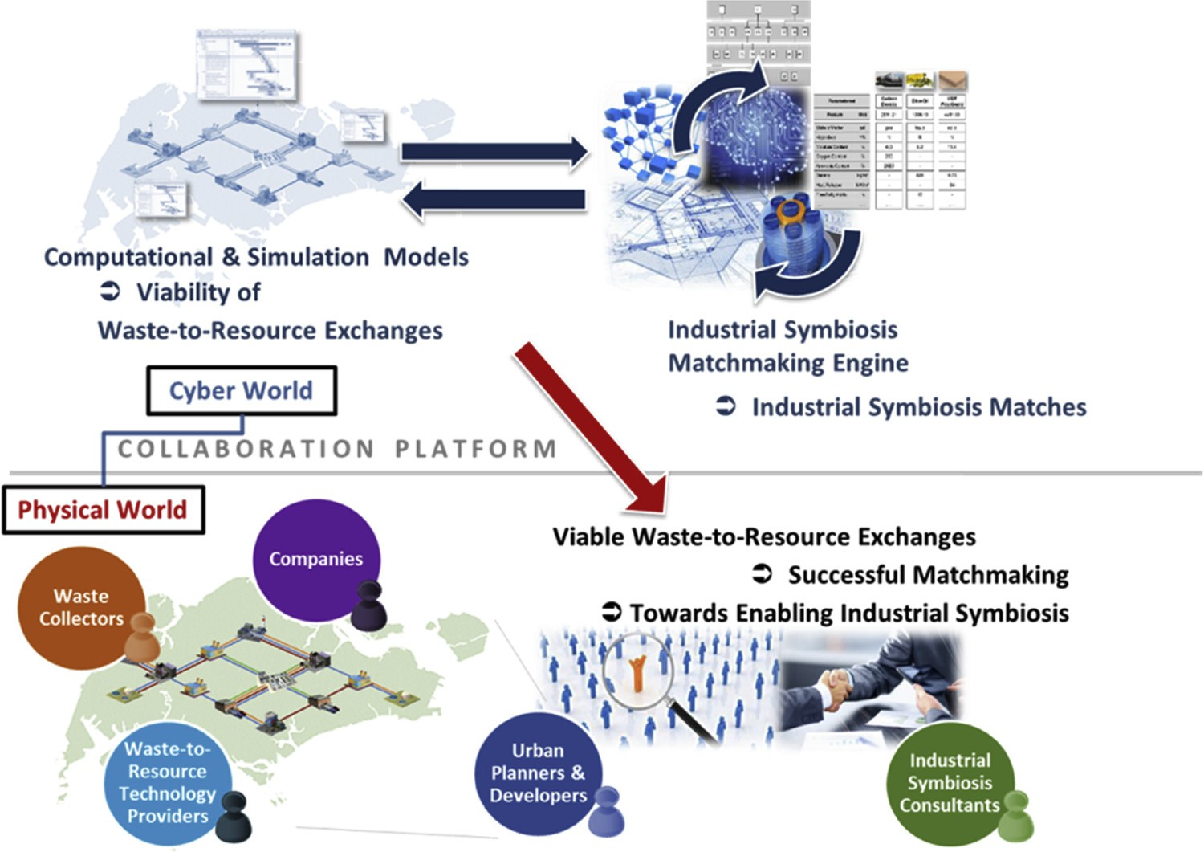

Fig. 8. Cyber-physical display of platform for waste-to-resource matching between companies.

* + 1. *Paper and cardboard*

Commercialized paper and cardboard recycling technologies and processes are similar across the world. The main diﬀerence between regions, countries, and cities is the manner in which waste paper and cardboard is collected to the recycling facilities. The current practice starts with shredding collected recycled paper in pulpers and then mixing the ﬁbres with water and chemicals, which are then heated into a slurry mix (Misman et al., 2008). Contaminants are then removed from the slurry mix and the mix is then put onto a conveyor belt to allow the ﬁbres to bond together. Heated metal rollers then dry the paper which is then made into large rolls for new paper products. Due to diﬀerent grades of paper, there is a limited amount of times that paper can be recycled. The length of paper ﬁbers become shorter after every round of recycling which reduces its grade. Advancements in paper and cardboard recycling technology can be achieved through improvements in process eﬃciency at factories (ABB, 2018). This en- tails reductions in energy and chemical use at all stages of the recycling process through increasing the use of heat recovery, cogeneration, self- generated biomass fuel, eﬃcient motors, and eﬃcient steam use.

* + 1. *Plastics*

Plastic recycling is currently done at large centralized facilities that take advantage of economies of scale in producing low-value products. There is strong demand for recycled plastic from manufacturing com- panies because recycled materials are a preferred choice for cost re- duction and reducing waste. State-of-the-art plastic recycling processes can be categorized under four diﬀerent classes as shown in Fig. 9.

Primary recycling is commonly known as re-extrusion and can only

handle clean or semi-clean scrap plastic after the contaminated parts are sorted out. This makes MSW not suitable for primary recycling because of high contamination. Secondary recycling uses screw extru- sion, injection moulding, and blow moulding to transform plastic ma- terials through mechanical means into low value products. The pro- cesses involved in secondary recycling include cutting and shredding, separating contaminants, and separating ﬂakes by ﬂoating. The ﬁnal recycled plastic product is stored and then resold after pigments and other additives have been added. Plastic strands are then extruded further to make pellets based on the requirements and then the ﬁnal products are manufactured. Tertiary recycling uses various methods such as pyrolysis, cracking, gasiﬁcation, and chemolysis to recycle plastic materials by recovering monomers from plastic solid waste through depolymerization. Tertiary recycling can be separated into two types of techniques, chemical and thermal recycling. Quaternary re- cycling incinerates plastic waste that has already gone through primary, secondary, and tertiary recycling to recover energy. This method is only done when there is no other way to dispose plastic waste that is no longer valuable in other supply chains. Incineration of plastic waste emits harmful air pollutants such as carbon dioxide, nitrous oxides, sulfur dioxide, volatile organic compounds, particulate matter, parti- culate-bound heavy metals, polycyclic aromatic hydrocarbons, poly- chlorinated dibenzofurans, and dioxins.

Recycled plastic materials can be used in a variety of products to replace ceramic, wood, and metals because plastics are very functional, hygienic, light, and economical. Recycled plastics are typically used to make new plastic bottles, containers, bags, and clothing materials. Another application of recycled plastic is in manufacturing plastic

Table 7

Main products and by-products of each type of food waste to energy technology (Pham et al., 2015).

|  |  |  |
| --- | --- | --- |
| Conversion process | Products | By-products |
| Anaerobic digestion | Gas (CH4 and CO2) | Sludge that can be used as a fertilizer after being treated |
| Ethanol fermentation | Ethanol, CO2 | Animal feed |
| Incineration | Heat, electricity | Ash |
| Pyrolysis | Char, oil or tar, gas (CO, CH4, hydrocarbons, H2, CO2) | Char that can be used as an oil amendment, activated coal or sorbent |
| Gasiﬁcation | Gas (CO, CH4, N2, H2, CO2) | Ash |
| Hydrothermal carbonization | Hydrochar and gas (mainly CO2) | Crude oil and process water (contains value-added chemicals) |

10

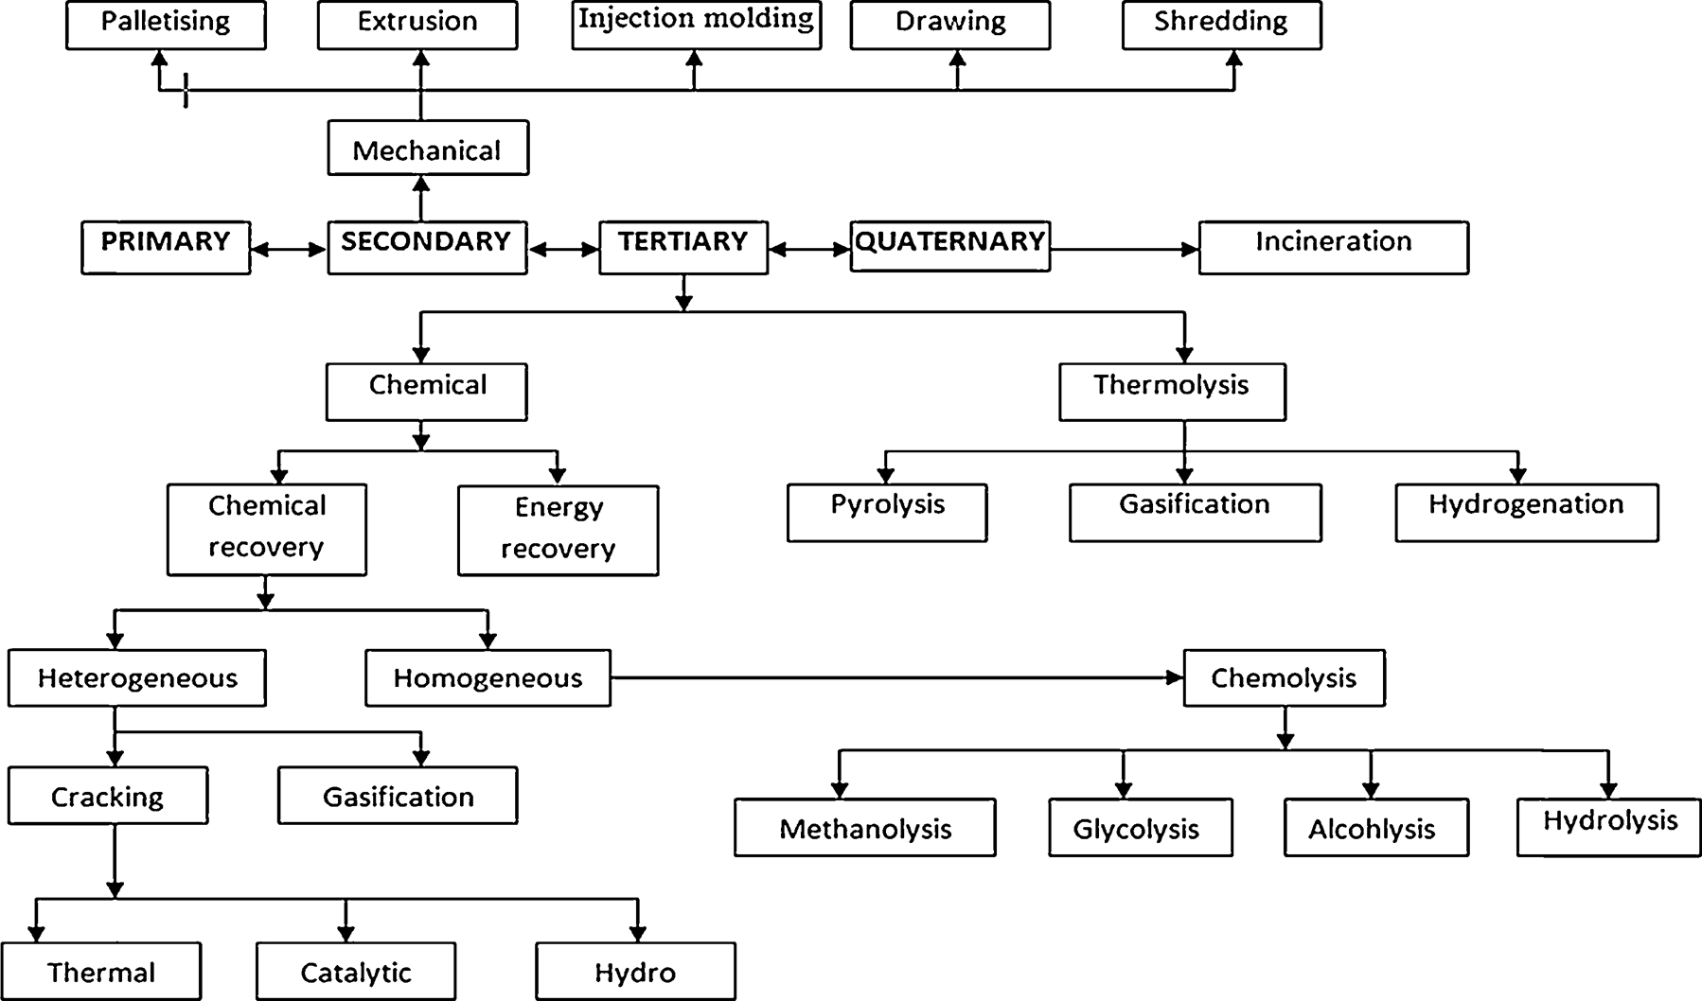

Fig. 9. Classiﬁcation of plastic waste recycling methods (Singh et al., 2016).

lumber which can be used to construct pier and dock surfaces, marine piling, fences, park benches, and outdoor decking. Plastic lumber mostly uses HDPE, LDPE, and PP as the feedstock. Another application of recycled plastic is in producing plastic ﬁlament for 3D printing. Several companies have developed machines that are able to shred and grind post-consumer plastic, speciﬁcally HDPE, which is then melted, extruded, and then spooled into the plastic ﬁlament. 3D printers then use the ﬁlament to make new plastic products. The variety of applica- tions available for recycled plastic material drives the demand to collect and recycle post-consumer plastic through the diﬀerent conversion methods.

* + 1. *Electronic waste*

Waste electrical and electronic equipment, also known as e-waste, has become a pressing environmental problem globally due to the rapid uptake of electrical and electronic equipment by consumers. In 2016, global e-waste generation reached 44.7 million metric tonnes and only 20% was recycled (Baldé et al., 2017). Asia generated the most e-waste followed by Europe, the Americas, Africa, and Oceana. The biggest challenge is that a majority of e-waste is not tracked and documented adequately and waste equipment is not recycled or treated properly. E- waste recycling is currently driven by prevention of hazardous heavy metals from damaging ecosystems and human health and capturing precious metals such as copper, steel, aluminum, and gold. Traditional e-waste recycling starts with manual disassembly and separation of the diﬀerent components. Then the components are categorized into parts that can be reused or need to be further processed for recycling. Parts that are unable to be disassembled are then sent through size reduction processes, removal of dust and debris, and then separation of metallic contents through magnets.

Pyrometallurgical and hydrometallurgical processes are currently practiced in industry to extract valuable metals from e-waste. Pyrometallurgical processes extract metals by directly burning e-waste in a blast furnace resulting in a product with 70–80% black copper by weight. The black copper is then put through a converter to be oxidized and then reduced in an anode furnace. Afterwards, the copper anode produced is further puriﬁed in a sulfuric acid electrolyte with other elements such as nickel, zinc, and iron. An issue with pyrometallurgical

recovery is that huge amounts of wastewater and residues are produced which can cause serious pollution if the wastes are not handled prop- erly. Furthermore, it is hard to recover metals other than copper through incineration and non-metallic materials cannot be recycled during the process. In hydrometallurgy, strong acids such as HNO3, HCl, or HClO4 are commonly used as leaching solvents to extract metals such as copper, lead, and zinc from e-waste. Cyanide leaching has also been done to extract gold from e-waste components. The challenge with these traditional methods of incineration and acid leaching is that the processes have low metal recovery rates and the chemicals used and wastes produced are hazardous to human health and the environment. More advanced methods of e-waste recycling exist that can achieve higher metal recovery rates, lower costs and resource inputs, and re- duce impacts to the environment and human health (Zhang and Xu, 2016). The challenges of some advanced methods are that they are still immature and have only shown successful results at the lab or pilot level and have high investment costs. The processes, inputs, and pro- ducts extracted through diﬀerent methods of e-waste recycling are

summarized in Table 8.

* + 1. *Remanufacturing*

Remanufacturing is another form of waste to resource conversion that focuses on bringing used products back to original or better con- ditions (Center for Remanufacturing and Reuse, 2017). Products that are easy to disassemble enable eﬃcient remanufacturing. Steps in the remanufacturing process are illustrated in Fig. 10.

Most remanufactured products are required to pass a set of quality standards before they are resent out for sale. Companies around the world that conduct remanufacturing activities are listed in Table 9.

Remanufacturing has been an undervalued part of the sustainable industries landscape with activities promoted only on a sector-by-sector basis. The prices of remanufactured products are also typically 60–80% lower compared to the cost of a new product (Centre for Remanufacturing and Reuse, 2017). The European Remanufacturing Network conducted a Remanufacturing Market Study to estimate the level of remanufacturing in the European Union and understand the barriers that need to be addressed to advance remanufacturing. Countries covered in this landscape review were Brazil, China,

11

Table 8

E-waste metal recovery processes, inputs, and products.

E-waste metal recovery method

Process details and inputs Products extracted

Pyrometallurgy Main processes include dismantling, smelting in a plasma arc furnace, drossing,

sintering, melting and reactions in a gas phase at high temperatures. Crushed scraps containing base and precious metals are burned in a high temperature furnace. Metals are then volatilized by a chemical reaction or by heat, and impurities are converted into slags.

Improved treatment of pollutants from incineration and puriﬁcation process compared to traditional pyrometallurgy.

Hydrometallurgy Can achieve more targeted metal recovery and pre-treatment, better control of chemical reaction and produces less pollution.

Uses more mild leaching agents such as chlorinate, ammonia-ammonium, non- cyanide lixiviants, and organic acids (i.e. citric acid and hydrogen peroxide). Metal extraction rates as high as 98% at lab/pilot scale.

Biometallurgy Bioleaching and biosorption are the two main techniques for metal recovery.

Bioleaching uses acidophilic group of bacteria to bioleach heavy metals. Biosorption uses biological materials to remove substances from solution in a physico-chemical and metabolism independent process.

Microorganisms used as biosorbents include bacteria, fungi, algae, actinomycetes, yeasts and some biowaste materials.

Technology currently successful at laboratory scale and has not been industrialized yet.

Electrochemical technology Highly energy eﬃciency process and uses a minimal amount of chemicals to

dissolve and recover metals on a cathode for further processing. An electrochemical cell maximizes energy eﬃciency of the process. The process of electrorecycling generates oxidizing agents at an anode in order to dissolve metals from the scrap matrix. The dissolved metals are then reduced at the cathode.

Technology has not been commercialized yet.

Supercritical technology An environmentally friendly method that decomposes organic polymers and

recycles metals since supercritical substances have unique properties such as low viscosities, high mass transport coeﬃcient, high diﬀusivity, and high solubility. Example supercritical substances used are supercritical water, supercritical methanol. Technology has not been commercialized yet.

High quality copper. Other pure solid metals that have been extracted include silver, gold, palladium, nickel, selenium, and zinc.

Copper, gold, silver, palladium extracted in solution

Copper, nickel, zinc, chromium, gold, silver extracted in solution

Pure solid copper, gold, silver

Almost all metals can be extracted at a high recovery rate. Output is a solid mixture of metals.

Vacuum metallurgical technology

Metals are separated based on diﬀerence in water pressure of the metal elements at the same temperature. Can separate and recycle diﬀerent metals from waste printed circuit boards under the guidance of separation criteria.

Four crucial processes of vacuum distillation of metals are heat transfer, evaporation, mass transfer and condensation.

Main environmental beneﬁt is wastewater pollution is not produced. Technology is still immature and has not been commercialized yet.

Cadmium, zinc, lead

Denmark, India, Japan, South Korea, Malaysia, Singapore, United Kingdom, and United States (European Commission, 2015). From the study, the major challenges of remanufacturing identiﬁed were:

1. Logistics chain: Costly and complicated collection of cores.
2. Compliance with quality requirements: Costly to ensure the quality of remanufactured products.
3. Long-term investment: Cost intensive research and development is required for remanufacturing and has a long payback period that can be too risky for some companies.
4. Too much transparency: Remanufacturing requires cooperation be- tween suppliers and customers, as well as an open value chain. This can give competitors an advantage and increase espionage.
5. Sales versus leasing: To counter customers’ skepticism of re- manufactured products, some companies lease their products to the customers. The inability to lease some product types was seen to be a potential barrier.
6. Complex with seemingly overlapping authorities and contradictory regulations from governments have deterred remanufacturing pro- gress in certain countries.
7. In middle income or developing countries, the remanufacturing sector is largely unregulated, quality varies, and counterfeiting is common.

Advancing research and implementation of technologies for re- cycling food, paper, cardboard, plastic, e-waste, and other post-con- sumer products contributes to building a ZWM ecosystem by increasing the amount of waste recovered for use as resources in other supply

chains and reduces reliance on virgin materials in manufacturing. Greater waste to resource conversion also reduces stress on the limited landﬁll capacity in diﬀerent countries and also reduces the amount of waste shipped abroad for disposal.

1. Discussion
   1. *Integrating ZWM technologies*

The review of state-of-the-art industry technologies and research revealed that there are many technology options that waste value chain stakeholders in Singapore and other countries can adopt to achieve ZWM. Applications of Internet-of-Things (IoT) technologies was found in the review to be an enabling factor for connecting diﬀerent stake- holders along the waste value chain. IoT is the connection of all tech- nologies to the internet and to each other that builds oﬀ cloud com- puting and networks of sensors that continuously collect and monitor data. Devices in IoT are not limited to smartphones, but also include everyday equipment such as coﬀee makers, washing machines, house- hold lighting, vehicles, and cash registers (Risteska Stojkoska and Trivodaliev, 2017). IoT has risen due to swift expansion of basic and aﬀordable internet access and growth in smartphone adoption. Smart waste collection systems demonstrated the application of IoT in cities through the use of the internet to connect sensors, smart bins, waste hauling trucks, and the waste management system. IoT technologies are also applicable to collaborative platforms for industrial symbiosis. This is because data covering waste volume, type, and cost from waste producers and recyclers can be shared between stakeholders to

12

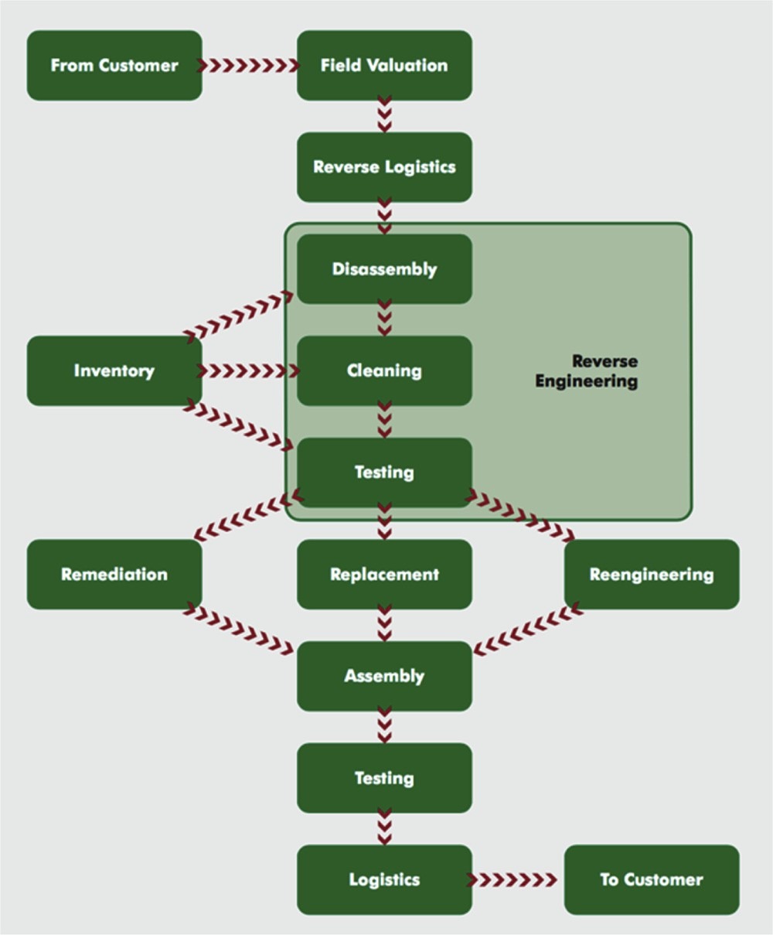

Fig. 10. Remanufacturing process diagram (Centre for Remanufacturing and Reuse, 2017).

Table 9

Companies engaged in remanufacturing organized by product sector.

Product sector Company

Machine tools Jones & Shipman, Millbrook, Douglas- Curtis, Marrill

Pumps Weir, Plenty, Sulzer, Johnson

Compressors Comptec, Flatwoods, J&E Hall, ThermoCom

Refrigeration installations Bond Group, Manor Concepts

Starter motors Sovereign

Automatic transmissions Mitchell-Cotts, ATP

Car and truck engines Autocraft, Ivor Searle, Perkins, Caterpillar

Photocopiers and printer consumables Xerox, Danwood, Greenstrike Excavation equipment Powerhire, Blackhill Engineering

Power turbines Alstom

Defense equipment Vickers, BAe Systems, ABRO Computer and telecoms equipment Sony, Solectron

facilitate feasible waste to resource matches and exchanges.

* 1. *Feasibility of ZWM technologies in Singapore*

Applying the ZWM framework introduced in this study can help decision-makers explore the technology options that can improve waste reduction in manufacturing and increase reuse, sorting, collection, and recycling along the entire waste value chain. However, there are several limitations existing ZWM technologies may face during implementation in the manufacturing and waste management sectors in dense urban cities such as Singapore. This section brieﬂy revisits Singapore’s man- ufacturing and waste management sectors and discusses the practical feasibility of implementing the technologies reviewed under the ZWM themes. Based on the barriers identiﬁed in implementing ZWM tech- nologies, future areas of research are recommended to help Singapore and other dense urban regions overcome them to transition to a circular

economy.

* + 1. *Manufacturing and waste management sectors*

Similar to many other nations and cities across the world, Singapore seeks to transition to a circular economy to meet their national zero waste goals while also advancing its manufacturing sector to boost economic growth. Singapore’s manufacturing sector is dominated by the key industry clusters of electronics, chemicals, biomedical sciences, logistics, and transport engineering that contribute to 20–25% of the country’s GDP (Enterprise Singapore, 2019). Singapore is globally ranked as the fourth largest exporter of high-tech goods and many leading multinational companies across diﬀerent industrial sectors have chosen Singapore as a strategic manufacturing hub (Economic Development Board of Singapore, 2018). In terms of sustainability, the Singapore Institute of Manufacturing Technology operates a Sustain- able Manufacturing Centre that assists companies in Singapore improve energy, water, and material eﬃciency and waste reduction across their entire manufacturing supply chain using both hardware and software solutions.

Singapore currently operates a well-organized waste collection and disposal system to manage waste generated across all economic activ- ities, but it still requires improvements to boost its overall recycling rate. Wastes are collected by four public waste collector companies which are Colex Environmental Pte. Ltd, SembWaste Pte. Ltd, Veolia ES Singapore Pte Ltd, and 800 Super Waste Management Pte. Ltd. Waste collection in Singapore is divided into six regions of which the four companies are responsible for managing separately. The waste collected are sent to sorting facilities where recyclables are separated, and the rest is sent to Singapore’s four waste-to-energy incineration plants. The incineration ash and waste deemed unrecyclable are sent to Semakau Landﬁll for ﬁnal disposal. Singapore’s main goal in becoming a zero waste nation is to increase its recycling rate to 70% by 2030 from its current rate of 60%. Today, about 37% of waste generated in Singapore is incinerated and 3% of waste generated is sent to the landﬁll. As shown in Fig. 11, paper and cardboard, plastic, and food were the waste streams with the highest volumes, but lowest recycling rates.

As a result, paper and cardboard, plastic, and food waste as well as electronic wastes have become the target waste streams to be addressed in Singapore’s Zero Waste Masterplan that is undergoing public con- sultation (MEWR, 2019a,b). One large scale project the Government of Singapore has invested in to improve waste management is develop- ment of an integrated waste management facility (IWMF) that is ex- pected to start operating in 2022. The key waste streams to be handled at the IWMF are incinerable wastes at 5800 tonnes/day, household recyclables at 250 tonnes/day, food waste at 400 tonnes/day, and de- watered sludge at 800 tonnes/day (National Environment Agency of Singapore, 2018b). To address e-wastes, the Government of Singapore will implement extended producer responsibility system to cover ﬁve categories which are information and communications technology, such as mobile phones and computers; solar panels; batteries; lamps and large household appliances such as refrigerators, air-conditioners, washing machines and dryers (NEA, 2018a).

* + 1. *Implementation barriers of ZWM technologies*

Opportunities exist to reduce waste generation and recover value from the high volumes of waste sent to the incinerator, but several barriers need to be overcome with regards to the feasibility of tech- nologies reviewed under the ZWM themes. Speciﬁc technologies under the ZWM themes face fewer implementation barriers compared to others in Singapore to help transition to a circular economy. In the theme of design for zero waste, the feasibility of design for disassembly to impact existing products consumed in Singapore varies depending on the speciﬁc technology. In the case of building construction, modular construction of buildings has already demonstrated high feasibility. In the case of Singapore, the Housing Development Board (HDB) has al- ready committed to having 35% of all new public housing projects be

13

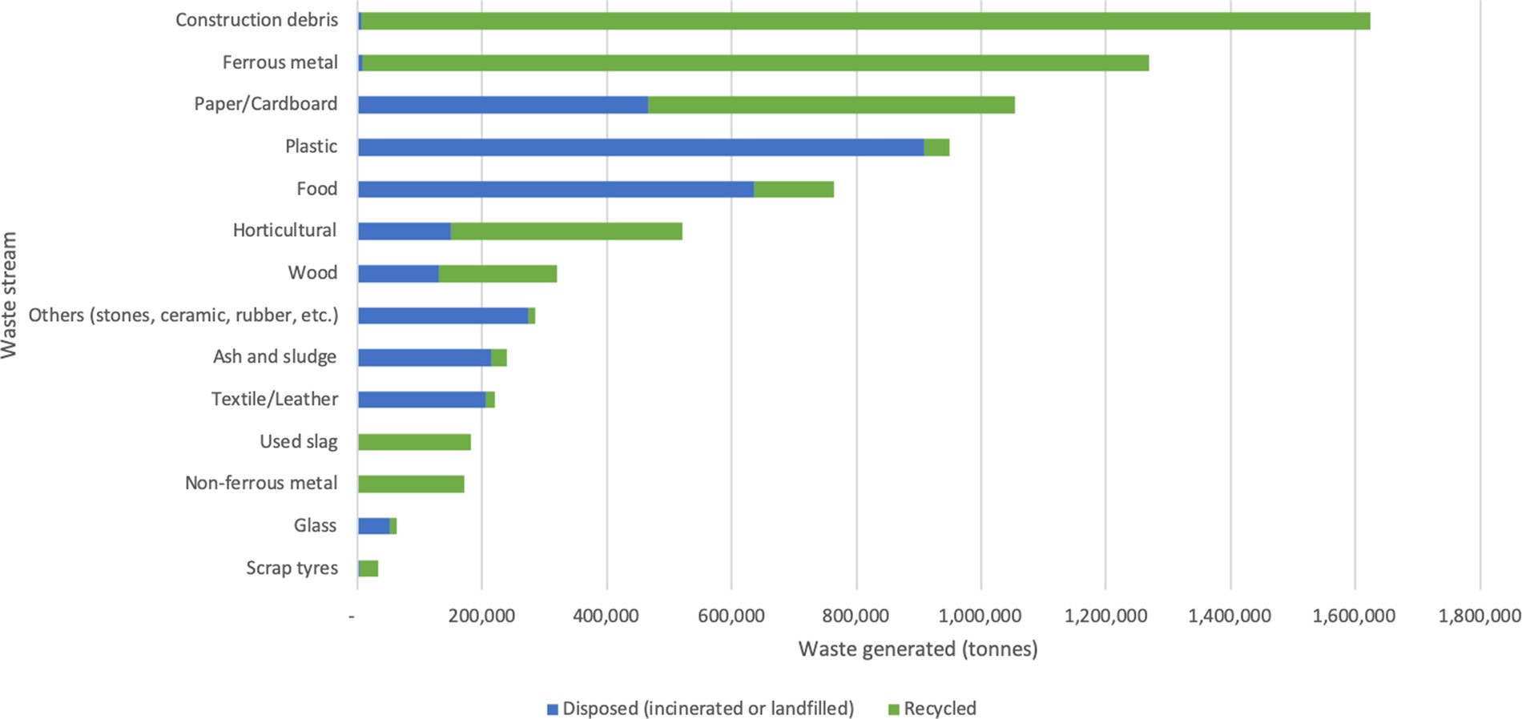

Fig. 11. Volume of waste disposed and recycled in Singapore in 2018.

constructed by using modular units produced at the factory instead of onsite construction (HDB, 2017). The beneﬁts the HDB will gain from using prefabricated preﬁnished volumetric construction technology is improvement in productivity by 50% (HDB, 2017) and reduced waste generation from construction, reduced noise and dust at the construc- tion site, and fewer incidences of wet construction joints all while having a higher quality home. Using modular construction is expected to increase costs by about 8%, but the higher construction costs will be oﬀset by manpower savings (Channel NewsAsia, 2017).

Implementation of additive manufacturing technology in Singapore is being actively researched and developed (National Research Foundation, 2018) which will reduce generation of waste plastics, construction materials, and metals as well as improve energy eﬃciency in manufacturing processes in Singapore. Individual products designed for disassembly are feasible to produce in Singapore due to the country’ capabilities in high-performance manufacturing technology. However, even if products designed for disassembly are produced in Singapore, the waste reduction beneﬁts within the country would be dependent on whether a majority of those products are used in Singapore or exported abroad. As shown in Table 10, an analysis of Singapore’s 2012 input output tables, the latest dataset publicly available, reveals that 75% of the goods and services households in Singapore consumed from the manufacturing sector were imported from abroad (Singapore Department of Statistics, 2012).

At the product group level, over 90% of the food products consumed in Singapore are imported from overseas (Agri-Food and Veterinary

Authority of Singapore, 2019). Therefore, although Singapore is highly capable of manufacturing products designed for disassembly, the waste reduction beneﬁts would be limited in the case where an overwhelming majority of households in Singapore consume products imported from abroad that are not designed for disassembly instead of equivalent products designed for disassembly and manufactured in Singapore.

Smart waste audit and reduction technologies are feasible to im- plement on the software side for waste data management and bench- marking. However, the physical process of waste data collection is the technical barrier that needs to be overcome. Unlike countries such as Japan, the U.S., and the UK that typically sort their wastes on site through specialized bins, a majority of post-consumer waste generated in Singapore’s residential and commercial premises is commingled and therefore highly heterogenous in composition. State-of-the-art smart waste bins are able to measure the overall volume of waste generated, but they lack the ability to measure the volumes of waste by material type, which is information that is more valuable for detailed waste reduction planning. Countries and other dense urban centers such as Singapore require hardware technologies that are able to eﬃciently measure the volume of waste generated and estimate its material composition.

Smart waste collection technologies have been highly feasible to implement in Singapore’s waste collection system. One of Singapore’s four public waste collectors 800 Super has already implemented smart waste collection sensors at its compacters in bin centers in the towns of Tampines and Pasar Ris (Channel NewsAsia, 2018). The NEA has stated

Table 10

Private consumption of goods and services in Singapore, 2012.

|  |  |  |  |  |  |  |
| --- | --- | --- | --- | --- | --- | --- |
| Sector | Domestic | Imports |  | Domestic and Imports | Domestic share | Import share |
| Manufacturing | 5.4 | 16.6 |  | 22 | 25% | 75% |
| Utilities | 2.7 | 0 |  | 2.7 | 100% | 0% |
| Construction | 0 | 0 |  | 0 | 0% | 0% |
| Other goods | 0 | 1.5 |  | 1.5 | 0% | 100% |
| Wholesale and retail trade | 12.7 | 0 |  | 12.7 | 100% | 0% |
| transportation and storage | 6.7 | 1.3 |  | 8 | 84% | 16% |
| Accommodation and food services | 12.4 | 0 |  | 12.4 | 100% | 0% |
| Information and communications | 2.9 | 0.1 |  | 3 | 97% | 3% |
| Finance and insurance | 8.3 | 0 |  | 8.3 | 100% | 0% |
| Business services | 22.3 | 0 |  | 22.3 | 100% | 0% |
| Other services | 24.8 | −0.2 |  | 24.6 | 101% | −1% |
| Total | 98.2 | 19.3 |  | 117.5 | 84% | 16% |
| Values in billion U.S. dollars. |  |  |  |  |  |  |
|  |  |  | 14 |  |  |  |

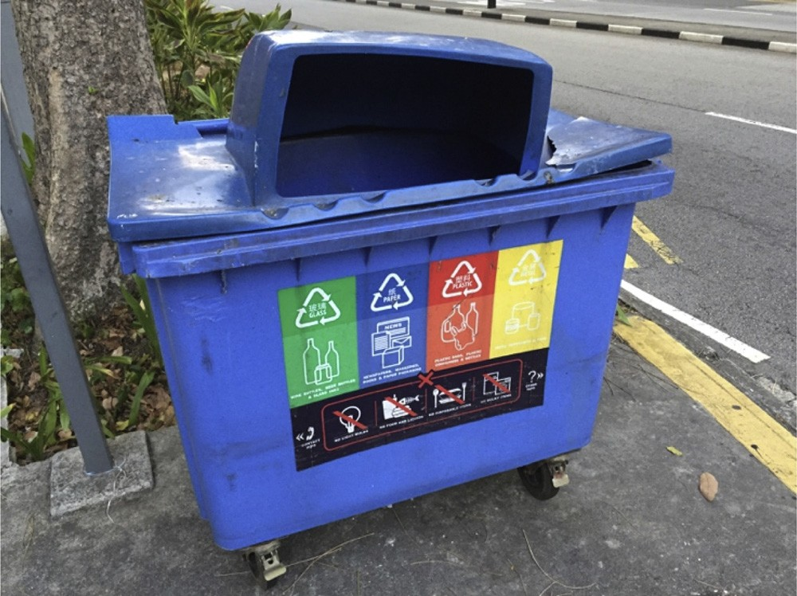

Fig. 12. Single-stream recycling collection bin in Singapore.

that the new smart waste collection systems have improved eﬃciency and will not result in increases in domestic waste collection fees. Fur- thermore, NEA will progressively roll out smart waste collection system through public waste collection companies by the end of 2021. Smart waste bins have not faced technical barriers in implementation. Many commercial premises in Singapore have already set up smart waste bins (Big Belly Solar, 2018).

The feasibility of implementing technologies for high-value mixed waste processing has not been an issue in Singapore since the country currently has several material recovery facilities operating which have helped the country maintain its recycling rate at 60%. However, the remaining 40% of mixed waste that is not recycled is of very low quality and as a result it is sent to the incinerators. Increasing the quality of the remaining 40% of mixed waste is necessary to increase the overall re- cycling rate. As shown in Fig. 12, Singapore provides blue bins for re- sidents to mix together all recyclables.

Similar to other countries around the world, many non-recyclable materials are often mixed in with the recyclables in Singapore which causes contamination. According to the NEA, 40% of waste disposed in bins is contaminated and is not recoverable for recycling (Channel NewsAsia, 2019b). In residential settings, waste chutes are provided where residents are able to conveniently mix all wastes in a bag and throw it away (MEWR, 2019a,b). Although this practice enables an eﬃcient waste collection system, it increases contamination of mate- rials that are then no longer recoverable for recycling. Research is therefore needed to determine methods or technologies that would

prevent contamination of recyclable waste streams. Smaller scale sorting facilities that are suitable for dense urban and residential areas that consumers can conveniently access would be able to reduce the amount of recyclable materials that get sent to the incinerator due to contamination.

Collaborative platforms for industrial symbiosis face few technical barriers for implementation in Singapore. This technology relies pri- marily on digital systems and would require minimal to nearly no changes in physical infrastructure to implement (Yeo et al., 2019). Many sharing economy-based services are already actively used in Singapore and so a similar digital platform focused on waste to resource matching and exchanges between individuals and companies is tech- nically feasible. One of the challenges that may arise during the initial stages of implementation would be achieving a critical mass of users for the collaborative platform to successfully facilitate industrial symbiosis exchanges. The impact on Singapore’s waste management system through implementing collaborative platforms for industrial symbiosis would be a reduction in the amount of waste materials that get mixed in with waste sent to incinerators. Instead, users would be directly mat- ched to a market where their waste could be recycled to gain value and not need to rely on the existing waste collection and recycling system. Singapore’s severe lack of land space for development presents a major limitation in feasibility of implementing the technologies re- viewed under the theme of waste to resource conversion and recycling (Zhou and Zhao, 2016; Murakami, 2018). With a total land area of 720 square kilometers, Singapore has the third highest population density in the world at 7,916 people per square kilometer (World Bank Group, 2017). Competition for land is therefore tough and oﬀers little oppor- tunity to implement new large-scale mixed-waste processing and seg- regation facilities, recycling centers, and waste digestors. As Singa- pore’s population is 100% urbanized, implementation of these large- scale technologies in urban space-constrained environments could en- counter public backlash due to the disruptive eﬀects of waste conver- sion technologies such as foul odors and loud noises. In the case of food waste, Singapore has a high potential for improvement as only 16% of it is recycled and the volume of food waste generated continues to grow

annually as shown in Fig. 13.

The new IWMF that will begin operating in 2022 is expected to treat 400 tonnes of food waste per day alone which would only increase the recycling rate to at most 34%, which still leaves more room for im- provement. However, large scale food waste recycling facilities de- signed to treat as high as 800 tonnes of food waste per day have proven to be unsuccessful in Singapore due to contamination and poor logistics in food waste collection (Eco-Business, 2011). Food waste is typically generated in many distributed locations. Therefore, implementation of additional food waste digesters to successfully increase the amount of

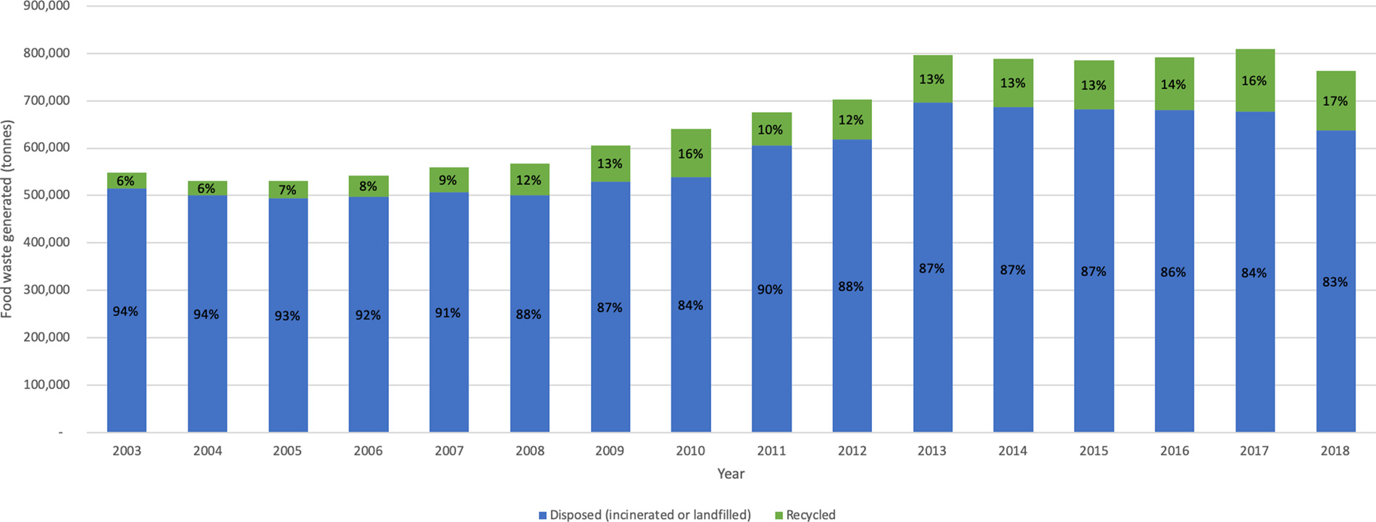

Fig. 13. Food waste generation in Singapore between 2003–2018.

15

food waste recycled will require conventional large scale technologies to be scaled down to match the volumes generated at the diﬀerent sites and also be located closer to the source to avoid logistical issues (Lou et al., 2012). Systems will need to be designed in a way that have a very low level of disturbance to people in residential and commercial areas.

Paper recycling currently stands at 50% and oﬀers more potential for increasing waste recovery. In Singapore, waste paper that is re- cyclable is sorted, baled, and shipped overseas for recycling since there are no paper mills in Singapore. Restrictions in land use does not make it feasible for implementing new paper recycling facilities in Singapore. However, the amount of waste paper disposed can be reduced by in- creasing the amount of waste paper collected, sorted, and baled. Existing technologies for collecting and sorting paper include conveyor belts, balers, trucks, which are all very large in size. The space occupied by such equipment and storage space are limitations to increasing the rate of waste paper recovery in highly dense urban regions such as Singapore.

Plastic recycling currently stands at 4% which presents a high op- portunity for improvement. Currently, a majority of the plastic that Singapore recycles is done outside of the country. In 2016, Singapore exported nearly 42,000 tonnes of plastic waste to China, Malaysia, Vietnam and Indonesia (United Nations, 2016) representing about 81% of the plastic waste Singapore recycled and 5% of the total plastic waste generated. Singapore has therefore relied on its larger neighboring countries with large scale facilities to deal the process of shredding and washing waste plastics for recycling or through chemical recycling. The processes of collection and sorting of waste plastics however is taken care of by public waste collectors and other companies in Singapore. Even if Singapore were able to implement large scale plastic facilities to create products from recycled plastic waste, other than electricity and fuel, the issue of plastic waste contamination would still need to be resolved. More than 50% of waste plastics collected by recycling fa- cilities in Singapore are incinerated because they are highly con- taminated (Today, 2018). Therefore, the issue of preventing con- tamination of waste plastics should be addressed if mechanical recycling methods are to be used to boost the plastic recycling rate in Singapore far beyond 4%. Tertiary plastic recycling to high value fuels through thermochemical conversion methods could also serve as al- ternative to mechanical plastic recycling to deal with the high mixture and impurities in Singapore’s plastic waste streams (Khoo, 2019).

For e-waste streams, using pyrometallurgical methods to recycle the 60,000 tonnes of e-waste produced in Singapore annually will face implementation barriers due to high costs, high energy intensity, and toxic fumes that pollute the environment. Voluntary programs led by industry currently exist where companies accept diﬀerent types of e- wastes and send them oﬀ to partner companies for recycling (NEA, 2019a). A total of 15 companies in Singapore are listed as oﬃcial partners for e-waste recycling (NEA, 2019a) of which two of these companies publicly state that they use hydrometallurgical methods to recover valuable materials in e-waste. These companies carry out their operations in facilities sited on industrial premises. Hydrometallurgical methods have attracted more attention in research and development in Singapore. Nanyang Technological University, the French Alternative Energies and Atomic Energy Commission, and NEA have invested USD14.8 million to develop a research center focused on less toxic e- waste recycling using hydrometallurgical methods along with other non-pyrometallurgical techniques (Channel NewsAsia, 2019a,b). Re- manufacturing would also be a feasible method Singapore can use to reduce the amount of electronics and electrical equipment that have to be recycled. Research and development and implementation of re- manufacturing in industry is already active in Singapore at research institutes such as the Advanced Remanufacturing and Technology Centre (ARTC) that collaborates with 65 members ranging from global multinational corporations to small and medium enterprises (ARTC, 2019).

1. Future research areas in ZWM

To overcome the limitations that current ZWM technologies may face during implementation in Singapore and other dense urban set- tings around the world, several areas of research are recommended.

1. Smart bins that measure waste material composition: To ad- vance smart waste audit and reduction planning, smart waste bins need to be able to collect data about the material composition of the waste disposed in the bin. This type of data is valuable for organi- zations to monitor the type of waste they produce and then make strategic waste reduction plans that target speciﬁc waste streams. Identifying the waste composition in a smart waste bin would be especially useful for countries and cities that typically use single bins for disposing both wastes and recyclable items.
2. Small and medium sized waste sorting technologies: Although the global mixed waste processing industry is moving towards large regional single-stream facilities, small and medium sized sorting facilities are still needed in urban centers that have higher waste generation levels. Research is needed to design waste sorting and material recovery facilities and equipment that have lower space requirements so that they can be sited within or closer to urban centers. Having smaller waste sorting facilities distributed in urban centers could reduce the logistical demands as the facilities would be closer to the sources of waste generation.
3. Matching consumers with remanufacturing services: Households that use products produced domestically or imported from abroad may not know that their product can be repaired or refurbished to extend its useful life and may not know where to access such services. Certain company-speciﬁc products imported from abroad that can be remanufactured may not have their com- pany’s service available in the country the product is used in. However, there may be small-medium enterprises that have the technical capability to remanufacture diﬀerent products regardless of the company the product is manufactured from. Industrial sym- biosis platforms should not only focus on waste to resource ex- changes, but also help match consumers with remanufacturing ser- vice providers. These types of matches would help facilitate remanufacturing of products that are designed to be repaired or disassembled regardless of whether the product was imported or produced domestically.
4. Life cycle impact evaluation models for IS platforms: Multilevel models that evaluate the life cycle impacts of all waste to resource exchanges in closing the resource loop are needed in industrial symbiosis platforms to prevent environmental burden shifting. These models can help businesses and other stakeholders of a col- laborative platform understand and design better systems to gain both environmental and economic costs and beneﬁts from closing resource loops (Low et al., 2016, 2014, 2012; Low et al., 2018). Government entities and city planners can also use these models to measure performance in meeting environmental sustainability tar- gets.
5. Small scale food waste digesters: Dense urban settings present space limitations for implementing large scale digesters for recycling a region’s food waste. Implementation experience has shown that large scale digesters in urban settings face ﬁnancial issues due to logistical challenges. Research is therefore needed in developing smaller food waste digestion systems that can be sited close to the source of generation such as residential areas or commercial dining areas and sized for the speciﬁc daily food waste volumes. The technical issues that need to be overcome are reducing odor and noise from the small scale digesters to avoid disturbance to people nearby.
6. Reducing contamination of consumer waste streams: Technologies for recycling waste such as plastics and paper and cardboard are already mature, but recycling rates are still low. One

16

major cause of this is that many recyclable materials become highly contaminated when mixed with other waste streams. The con- taminated recyclable materials are sent to the landﬁll or incinerator because they are no longer economic to recycle. Research is needed in developing technologies that are able to recycle materials that are contaminated or technologies that can reduce the contamination of disposed materials to overcome this issue which would help boost the volume of materials that are recycled.

1. Conclusion

As more nations continue to implement waste import bans, gov- ernments and businesses that were highly reliant on exporting their wastes abroad are now faced with the challenge of ﬁnding alternative solutions to manage their growing volumes of wastes. Moving beyond traditional end-of-pipe waste disposal methods and transitioning to a circular economy is critical to overcoming the global waste challenge in a holistic manner. ZWM can aid in the transition by developing man- ufacturing systems that minimize waste generation across entire value chains and maximizing the use of wastes as resources in other supply chains. To enable ZWM, stakeholders such as generators, collectors, and converters and recyclers will need to know what technologies they can implement to fulﬁll their role in the waste value chain. This study proposes a framework for ZWM comprising six themes of (i) design for zero waste; (ii) smart waste audit and reduction planning; (iii) smart waste collection; (iv) high-value mixed waste processing; (v) colla- borative platform for industrial symbiosis; (vi) waste to resource con- version and recycling. The framework aims to help stakeholders in the waste value chain identify the technologies they can implement to achieve ZWM.

Through a systematic review approach, state-of-the-art technologies and research literature under the six themes of the ZWM framework were identiﬁed and examined. The ﬁndings of the review revealed that there are many mature technologies under each theme of ZWM that stakeholders can implement to address their challenges. The technolo- gies include additive manufacturing, design for disassembly, modular products and buildings, smart waste auditing tools, smart waste bins and smart waste collection systems, material recovery and mixed waste processing technologies and facilities, digital platforms for enabling industrial symbiosis, remanufacturing, and technologies for recycling waste streams of food, paper and cardboard, plastics, and electronics and electrical equipment. The use of IoT technologies in smart waste collection systems showed that IoT technologies should be applied to ZWM overall so that waste generators, collectors, and converters can be integrated on a single system that shares data to facilitate greater waste to resource exchanges. The feasibility and technical limitations of im- plementing the ZWM technologies in highly dense urban centers were then discussed by using the case of Singapore. To overcome the tech- nical limitations of ZWM technologies and make them more feasible to implement in urban centers, it is recommended that future research is pursued in scaling down waste sorting facilities and food waste diges- ters, developing smart waste bins that collect data about waste material composition, and improving collaborative platforms for industrial symbiosis so that they can measure the life cycle impacts of waste to resource exchanges and match consumers with product re- manufacturing services. The ﬁndings of this study can be used by countries and cities to develop a roadmap for ZWM. In Singapore and other similar countries and urban settings, implementing the technol- ogies and conducting activities that contribute to the themes of ZWM through a roadmap will help transform the manufacturing sector by decoupling economic growth from environmental degradation and bolster resource security.

Appendix A. Supplementary data

Supplementary material related to this article can be found, in the

online version, at doi:https://doi.org/10.1016/j.resconrec.2019. 104438.

References

ABB, 2018. Improving Process Eﬃciency and Product Quality for Pulp & Paper Industry. [WWW Document]. <http://new.abb.com/cn/en/smart-technology/smart-> manufacturing-and-production/pulp-paper-industry (Accessed 2.1.18). .

Advanced Remanufacturing Technology Centre, 2019. Advanced Remanufacturing Technology Centre Homepage [WWW Document]. [https://www.a-star.edu.sg/artc](http://www.a-star.edu.sg/artc) (Accessed 3.14.19).

Agri-Food and Veterinary Authority of Singapore, 2019. The Food We Eat. [WWW Document]. [https://www.ava.gov.sg/explore-by-sections/food/singapore-food-](http://www.ava.gov.sg/explore-by-sections/food/singapore-food-) supply/the-food-we-eat (Accessed 3.10.19). .

Álvarez, R., Ruiz-Puente, C., 2017. Development of the tool SymbioSyS to support the transition towards a circular economy based on industrial symbiosis strategies. Waste Biomass Valori. https://doi.org/10.1007/s12649-016-9748-1.

Baldé, C.P., Forti, V., Gray, V., Kuehr, R., Stegmann, P., 2017. The Global E-Waste Monitor 2017. [WWW Document]. http://collections.unu.edu/eserv/UNU:6341/ Global-E-waste_Monitor_2017 electronic_single_pages_.pdf (Accessed 20.2.2018). United Nations University.

Berge, N.D., Ro, K.S., Mao, J., Flora, J.R.V., Chappell, M.A., Bae, S., 2011. Hydrothermal carbonization of municipal waste streams. Environ. Sci. Technol. 45, 5696–5703. https://doi.org/10.1021/es2004528.

Bigbelly, 2017. Smart City Solutions. [WWW Document]. <http://bigbelly.com/> solutions/city/ (Accessed 11.4.17). .

BigBelly Solar, 2018. JTC Puts up More ‘smart’ Waste Bins That Alert Cleaners via SMS When Full. [WWW Document]. <http://bigbelly.com.sg/jtc-puts-up-more-smart-> waste-bins-that-alert-cleaners-via-sms-when-full/ (Accessed 3.14.19). .

Bin-e, 2017. Bin-e [WWW Document]. URL <http://www.bine.world/> (Accessed 10.3.17). Boston Consulting Group, 2017. BCG Launches Industry 4.0 Accelerator Program and Its First Asian Innovation Centre for Operations (ICO) in Singapore. [WWW Document].

[https://www.bcg.com/en-sea/d/press/3april2017-asian-innovation-centre-for-](http://www.bcg.com/en-sea/d/press/3april2017-asian-innovation-centre-for-) operations-150605 (Accessed 5.22.18). .

BRE, 2017. SMARTWaste Brochure. [WWW Document]. <http://www.smartwaste.co.uk/>

ﬁlelibrary/downloads/SmartWaste-Brochure.-June-2017.pdf (Accessed 4.10.18). .

Center for Remanufacturing and Reuse, 2017. What Is Remanufacturing? [WWW Document]. <http://www.remanufacturing.org.uk/what-is-remanufacturing.php> (Accessed 8.4.17). .

Channel NewsAsia, 2019a. New S$20 Million Lab to Develop Less Toxic E-Waste Recycling Methods. [WWW Document]. [https://www.channelnewsasia.com/news/](http://www.channelnewsasia.com/news/) singapore/ntu-cea-launch-20m-joint-lab-e-waste-recycling-11339564 (Accessed 3.14.19). .

Channel NewsAsia, 2019b. Zero Waste Masterplan to Focus on Electronics, Packaging, Food Waste: Masagos. [WWW Document]. [https://www.channelnewsasia.com/](http://www.channelnewsasia.com/) news/singapore/singapore-year-towards-zero-waste-masterplan-masagos-11198238 (Accessed 3.14.19). .

Channel NewsAsia, 2018. Smart Waste System in Tampines, Pasir Ris Alerts Collection Crew When Nearly Full. [WWW Document]. [https://www.channelnewsasia.com/](http://www.channelnewsasia.com/) news/singapore/smart-waste-system-tampines-pasir-ris-alerts-collection-crew- 10719228 (Accessed 3.14.19). .

Channel NewsAsia, 2017. HDB To Expand Use of Prefabrication Building Methods in BTO Projects. [WWW Document]. [https://www.channelnewsasia.com/news/singapore/](http://www.channelnewsasia.com/news/singapore/) hdb-to-expand-use-of-prefabrication-building-methods-in-bto-9189786 (Accessed 3.14.19). .

Cheng, G., Huang, G., Dong, C., Xu, Y., Chen, J., 2017a. Distributed Mixed-integer Fuzzy Hierarchical Programming for Municipal Solid Waste Management. Part II: Scheme Analysis and Mechanism Revelation. pp. 8711–8721. https://doi.org/10.1007/ s11356-017-8574-8.

Cheng, G., Huang, G., Dong, C., Xu, Y., Chen, X., Chen, J., 2017b. Distributed mixed- integer fuzzy hierarchical programming for municipal solid waste management. Part I: system identiﬁcation and methodology development. Environ. Sci. Pollut. Res. 24, 7236–7252. https://doi.org/10.1007/s11356-016-8284-7.

Chertow, M., Park, J., 2015. Scholarship and practice in industrial symbiosis: 1989–2014. Taking Stock of Industrial Ecology. https://doi.org/10.1007/978-3-319-20571-7_5.

CleanRobotics, 2016. Intoducing Trashbot. [WWW Document]. [http://www.](http://www/) cleanrobotics.com/2016/11/15/IntroducingTrashbot/ (Accessed 9.9.17). .

CNN, 2017. Addidas Unveils New 3D Printed Shoes. [WWW Document]. [http://money.](http://money/) cnn.com/2017/04/07/technology/adidas-3d-printed-shoe/index.html (Accessed 10.20.17). .

Denyer, D., Tranﬁeld, D., 2009. Producing a systematic review. The SAGE Handbook of Organizational Research Methods. pp. 671–689. https://doi.org/10.1080/ 03634528709378635.

Eco-Business, 2011. Food Waste Recycler Folds. [WWW Document]. https://www.eco- business.com/news/food-waste-recycler-folds/ (Accessed 3.10.19). .

Economic Development Board of Singapore, 2018. Advanced Manufacturing. [WWW Document]. [https://www.edb.gov.sg/en/our-industries/industries-and-key-](http://www.edb.gov.sg/en/our-industries/industries-and-key-) activities/advanced-manufacturing.html (Accessed 3.10.19). .

Ecube Labs, 2017a. CleanCAP, The Ultrasonic Fill-Level Sensor. [WWW Document]. <http://ecubelabs.com/integrated-waste-management/ultrasonic-ﬁll-level-sensor/> (Accessed 9.12.17). .

Ecube Labs, 2017b. Case Studies. [WWW Document]. <http://ecubelabs.com/case-> studies/ (Accessed 9.5.17). .

Ellen MacArthur Foundation, 2013. Engineering the Circular Economy: A Field Manual

17

for Re-Designing a Regenerative Economy.

Enterprise Singapore, 2019. SME Portal Singapore. [WWW Document]. [https://www.](http://www/) smeportal.sg/content/smeportal/en/industries/manufacturing.html (Accessed 3.14.19). .

Ernst and Young, 2015. Modular product design: reducing complexity, increasing eﬃ- cacy. Performance 7 (1), 56–63.

European Commission, 2015. Remanufacturing Market Study. European Commission. Available from: <http://www.remanufacturing.eu/assets/pdfs/remanufacturing-> market-study.pdf.

Fraccascia, L., Murat Yazan, D., 2018. The Role of Online Information-Sharing Platforms on the Performance of Industrial Symbiosis Networks. https://doi.org/10.1016/j. resconrec.2018.03.009.

Gershman, Brickner, and Bratton Inc, 2015. The Evolution of Mixed Waste Processing Facilities 1970 - Today. Gershman, Brickner, and Bratton Inc.. Available from: https://plastics.americanchemistry.com/Education-Resources/Publications/The- Evolution-of-Mixed-Waste-Processing-Facilities.pdf.

Gershman, Brickner, and Bratton Inc, 2016. Supplemental Report: The Evolution of Mixed Waste Processing Facilities—Technology and Equipment Guide. Gershman, Brickner, and Bratton Inc.. Available from: https://plastics.americanchemistry.com/Education- Resources/Publications/The-Evolution-of-Mixed-Waste-Processing-Facilities- Technology-and-Equipment-Guide.pdf.

Gershman, Brickner, and Bratton, Inc, 2017. Implementation of SmartEngine™ Online Waste Audit and Business Recycling Promotion Tool (Solid Waste Authority of Central Ohio). [WWW Document]. <http://gbbinc.com/services/commercial-and-> industrial-recycling/implementation-of-smartengine-online-waste-audit-and- business-recycling-promotion-tool (Accessed 9.18.17). Gershman, Brickner, and Bratton, Inc.

Ghisellini, P., Cialani, C., Ulgiati, S., 2016. A review on circular economy: the expected transition to a balanced interplay of environmental and economic systems. J. Clean. Prod. 114. https://doi.org/10.1016/j.jclepro.2015.09.007.

GreenBiz, 2017. IoT And Smart City Trends Boost Smart Waste Collection Market. [WWW Document]. [https://www.greenbiz.com/article/iot-and-smart-city-trends-](http://www.greenbiz.com/article/iot-and-smart-city-trends-) boost-smart-waste-collection-market (Accessed 10.20.17). .

Gutierrez, J.M., Jensen, M., Henius, M., Riaz, T., 2015. Smart waste collection system based on location intelligence. Procedia Comput. Sci. 61, 120–127. https://doi.org/ 10.1016/j.procs.2015.09.170.

Housing Development Board, 2017. New Initiatives to Boost Construction Productivity in HDB Projects. [WWW Document]. [https://www.hdb.gov.sg/cs/infoweb/press-](http://www.hdb.gov.sg/cs/infoweb/press-) release/new-initiatives-to-boost-construction-productivity (Accessed 3.14.19). .

International Synergies, 2019. SYNERGie 4.0. [WWW Document]. [https://www.](http://www/) international-synergies.com/what-we-do/synergie40/ (Accessed 3.20.19). .

Jose, R., Ramakrishna, S., 2018. Materials 4.0: materials big data enabled materials discovery. Appl. Mater. Today 10, 127–132. https://doi.org/10.1016/j.apmt.2017. 12.015.

Kamali, M., Hewage, K., 2017. Development of performance criteria for sustainability evaluation of modular versus conventional construction methods. J. Clean. Prod. 142, 3592–3606. https://doi.org/10.1016/j.jclepro.2016.10.108.

Kamali, M., Hewage, K., 2016. Life cycle performance of modular buildings: a critical review. Renew. Sustain. Energy Rev. 62, 1171–1183. https://doi.org/10.1016/j.rser. 2016.05.031.

Kamali, M., Hewage, K., Milani, A.S., 2018. Life cycle sustainability performance as- sessment framework for residential modular buildings: Aggregated sustainability indices. Build. Environ. 138, 21–41. https://doi.org/10.1016/j.buildenv.2018.04.

019.

Kellens, K., Baumers, M., Gutowski, T.G., Flanagan, W., Lifset, R., Duﬂou, J.R., 2017. Environmental dimensions of additive manufacturing: mapping application domains and their environmental implications. J. Ind. Ecol. 21 (S1), S49–S68. https://doi.org/ 10.1111/jiec.12629.

Khoo, H.H., 2019. LCA of plastic waste recovery into recycled materials, energy and fuels in Singapore. Resour. Conserv. Recycl. 145, 67–77. https://doi.org/10.1016/j. resconrec.2019.02.010.

Kreiger, M.A., Mulder, M.L., Glover, A.G., Pearce, J.M., 2014. Life cycle analysis of dis- tributed recycling of post-consumer high density polyethylene for 3-D printing ﬁla- ment. J. Clean. Prod. 70, 90–96. https://doi.org/10.1016/j.jclepro.2014.02.009.

Lee, J., Bagheri, B., Kao, H.A., 2015. A Cyber-Physical Systems architecture for Industry 4.0-based manufacturing systems. Manuf. Lett. 3, 18–23. https://doi.org/10.1016/j. mfglet.2014.12.001.

Lou, X.F., Nair, J., Ho, G., 2012. Field performance of small scale anaerobic digesters treating food waste. Energy Sustain. Dev. 16, 509–514. https://doi.org/10.1016/j. esd.2012.06.004.

Low, J.S.C., Lu, W.F., Song, B., 2014. Product Structure-Based Integrated Life Cycle Analysis (PSILA): a technique for cost modelling and analysis of closed-loop pro- duction systems. J. Clean. Prod. 70, 105–117. https://doi.org/10.1016/j.jclepro. 2014.02.037.

Low, J.S.C., Lu, W.F., Lee, H.M., Bin, S., 2012. Methodology for modelling the eco-eﬃ- ciency of closed-loop product life cycles. Electron. Goes Green 2012, 1–6 2012+ (EGG).

Low, J.S.C., Tjandra, T.B., Lu, W.F., Mien, H., 2016. Adaptation of the Product Structure- based Integrated Life cycle Analysis (PSILA) technique for carbon footprint modelling and analysis of closed-loop production systems. J. Clean. Prod. 120, 105–123. https://doi.org/10.1016/j.jclepro.2015.09.095.

Low, J.S.C., Tjandra, T.B., Yunus, F., Si Ying, C., Tan, D.Z.L., Raabe, B., Ng, Y.T., Yeo, Z., Bressan, S., Ramakrishna, S., Herrmann, C., 2018. A collaboration platform for en- abling industrial symbiosis: application of the database engine for waste-to-Resource matching. Procedia CIRP 69, 849–854. https://doi.org/10.1016/j.procir.2017.11.

075.

Massachusetts Institute of Technology, 2013. Additive Manufacturing, GE, the World’s Largest Manufacturer, is on the Verge of Using 3-D Printing to Make Get Parts. [WWW Document]. [https://www.technologyreview.com/s/513716/additive-](http://www.technologyreview.com/s/513716/additive-) manufacturing/ (Accessed 10.7.17). .

Ministry of the Environment and Water Resources, Government of Singapore, 2015.

Sustainable Singapore Blueprint. Ministry of the Environment and Water Resources, Government of Singapore. Available from: [https://www.mewr.gov.sg/docs/default-](http://www.mewr.gov.sg/docs/default-) source/module/ssb-publications/41f1d882-73f6-4a4a-964b-6c67091a0fe2.pdf.

Ministry of the Environment and Water Resources, G. of S, 2019a. Public Consultation, Zero Waste Master Plan. [WWW Document]. [https://www.towardszerowaste.sg/](http://www.towardszerowaste.sg/) consultation/ (Accessed 3.14.19). .

Ministry of the Environment and Water Resources, G. of S, 2019b. Rubbish Chutes: Curse of Convenience [WWW Document]. [https://www.mewr.gov.sg/ssb/our-targets/](http://www.mewr.gov.sg/ssb/our-targets/) resource-sustainability/domestic-recycling-rate.

Ministry of Trade and Industry of Singapore, 2017. Speech by Minister Iswaran at the Future of Manufacturing (FoM) Summit @ Singapore 2017. [WWW Document]. [https://www.mti.gov.sg/NewsRoom/Pages/Speech-by-Minister-Iswaran-at-the-](http://www.mti.gov.sg/NewsRoom/Pages/Speech-by-Minister-Iswaran-at-the-) [Future-of-Manufacturing-(FoM)-Summit-@-Singapore-2017.aspx](mailto:Future-of-Manufacturing-(FoM)-Summit-@-Singapore-2017.aspx) (Accessed 5.22.18). .

Misman, M., Raﬁdah, S., Alwi, W., Manan, Z.A., 2008. State-of-the-art for paper recycling.

International Conference on Science and Technology (ICSTIE). pp. 11–15.

Murakami, J., 2018. The Government Land Sales programme and developers’ willingness to pay for accessibility in Singapore, 1990–2015. Land Use Policy 75, 292–302. https://doi.org/10.1016/j.landusepol.2018.03.050.

National Environment Agency of Singapore, 2018a. NEA to Implement E-Waste Management System For Singapore By 2021. [WWW Document]. https://www.nea. gov.sg/media/news/news/index/nea-to-implement-e-waste-management-system-

for-singapore-by-2021 (Accessed 3.14.19). .

National Environment Agency of Singapore, 2018b. Integrated Waste Management Facility. National Environment Agency of Singapore. Available from: [https://www.](http://www/) nea.gov.sg/our-services/waste-management/waste-management-infrastructure/ integrated-waste-management-facility.

National Environment Agency of Singapore, 2019a. National Voluntary Partnership for E- Waste Recycling. [WWW Document]. [https://www.nea.gov.sg/programmes-grants/](http://www.nea.gov.sg/programmes-grants/) schemes/national-voluntary-partnership-for-e-waste-recycling (Accessed 3.14.19). .

National Environment Agency of Singapore, 2019b. Waste Statistics and Overall Recycling. [WWW Document]. <http://www.nea.gov.sg/energy-waste/waste-> management/waste-statistics-and-overall-recycling (Accessed 3.14.19). National Environment Agency.

National Geographic, 2017. A Whopping 91% of Plastic Isn’t Recycled. [WWW Document]. https://news.nationalgeographic.com/2017/07/plastic-produced- recycling-waste-ocean-trash-debris-environment/ (Accessed 2.13.18). .

National Research Foundation of Singapore, 2018. RIE 2020 Plan, Advanced Manufacturing and Engineering. [WWW Document]. [https://www.nrf.gov.sg/](http://www.nrf.gov.sg/) rie2020/advanced-manufacturing-and-engineering (Accessed 3.14.19). .

National Research Foundation of Singapore, 2016. Research Innovation Enterprise 2020 Plan: Winning the Future Through Science and Technology. National Research Foundation of Singapore. Available from: [https://www.nrf.gov.sg/rie2020/](http://www.nrf.gov.sg/rie2020/) advanced-manufacturing-and-engineering.

Navigant Research, 2016. Smart Waste Collection. Navigant Research. Available from: [https://www.navigantresearch.com/reports/smart-waste-collection](http://www.navigantresearch.com/reports/smart-waste-collection).

Ng, Y.T., Tan, Y.S., Jonathan, J.S.C., 2017. Internet of things for real-time waste mon- itoring and benchmarking: waste reduction in manufacturing shop ﬂoor. Procedia CIRP 61, 382–386. https://doi.org/10.1016/j.procir.2016.11.243.

Niaki, M.K., Torabi, S.A., Nonino, F., 2019. Why manufacturers adopt additive manu- facturing technologies: the role of sustainability. J. Clean. Prod. 222, 381–392. https://doi.org/10.1016/j.jclepro.2019.03.019.

Omar, M.F., Termizi, A.A.A., Zainal, D., Wahap, N.A., Ismail, N.M., Ahmad, N., 2016. Implementation of spatial smart waste management system in Malaysia. IOP Conf. Ser.: Earth Environ. Sci. 1–9. https://doi.org/10.1088/1755-1315/37/1/012059.

Pathway 21, 2019. The Materials Marketplace. [WWW Document]. https://pathway21. com/ (Accessed 3.20.19). .

Pham, T.P.T., Kaushik, R., Parshetti, G.K., Mahmood, R., Balasubramanian, R., 2015. Food waste-to-energy conversion technologies: current status and future directions. Waste Manage. 38, 399–408. https://doi.org/10.1016/j.wasman.2014.12.004.

Raabe, B., Low, J.S.C., Juraschek, M., Herrmann, C., Tjandra, T.B., Ng, Y.T., Kurle, D., Cerdas, F., Lueckenga, J., Yeo, Z., Tan, Y.S., 2017. Collaboration platform for en- abling industrial symbiosis: application of the by-product exchange network model. Procedia CIRP 61, 263–268. https://doi.org/10.1016/j.procir.2016.11.225. Elsevier B.V.

Ramakrishna, S., Zhang, T.Y., Lu, W.C., Qian, Q., Low, J.S.C., Yune, J.H.R., Tan, D.Z.L., Bressan, S., Sanvito, S., Kalidindi, S.R., 2018. Materials informatics. J. Intell. Manuf. 1–20. https://doi.org/10.1007/s10845-018-1392-0.

Rios, F.C., Chong, W.K., Grau, D., 2015. Design for disassembly and deconstruction - challenges and opportunities. Procedia Eng. 118, 1296–1304. https://doi.org/10. 1016/j.proeng.2015.08.485.

Risteska Stojkoska, B.L., Trivodaliev, K.V., 2017. A review of Internet of Things for smart home: challenges and solutions. J. Clean. Prod. 140, 1454–1464. https://doi.org/10. 1016/j.jclepro.2016.10.006.

Sabaghi, M., Mascle, C., Baptiste, P., 2016. Evaluation of Products at Design Phase for an Eﬃcient Disassembly at End-of-Life. https://doi.org/10.1016/j.jclepro.2016.01.007.

Shukla, S., Shukla, N., 2017. Smart waste collection system based on IoT (Internet of things): a survey. Int. J. Comput. Appl. 162, 975–8887.

Singapore Department of Statistics, 2012. Singapore Supply, Use and Input-Output Tables 2012. [WWW Document]. [https://www.singstat.gov.sg/](http://www.singstat.gov.sg/ﬁnd-data/search-by-theme/)ﬁ[nd-data/search-by-theme/](http://www.singstat.gov.sg/ﬁnd-data/search-by-theme/) economy/national-accounts/publications-and-methodology (Accessed 3.14.19). .

18

Singh, N., Hui, D., Singh, R., Ahuja, I.P.S., Feo, L., Fraternali, F., 2016. Recycling of plastic solid waste: a state of art review and future applications. Compos. Part B Eng. 115, 409–422. https://doi.org/10.1016/j.compositesb.2016.09.013.

Singh, S., Ramakrishna, S., Gupta, M.K., 2017. Towards zero waste manufacturing: a multidisciplinary review. J. Clean. Prod. 168, 1230–1243. https://doi.org/10.1016/j. jclepro.2017.09.108.

Soh, S.L., Ong, S.K., Nee, A.Y.C., 2014. Design for disassembly for remanufacturing: methodology and technology. Procedia CIRP 15, 407–412. https://doi.org/10.1016/ j.procir.2014.06.053.

Song, B., Yeo, Z., Low, J.S.C., Jiewei, D.K., Kurle, D., Cerdas, F., Herrmann, C., 2015. A big data analytics approach to develop industrial symbioses in large cities. Procedia CIRP 29, 450–455. https://doi.org/10.1016/j.procir.2015.01.066.

Srikantha, N., 2017. Waste management in IoT- enabled smart cities: a survey. Int. J. Eng.

Comput. Sci. 6, 21507–21512. https://doi.org/10.18535/ijecs/v6i5.53.

Stock, T., Seliger, G., 2016. Opportunities of sustainable manufacturing in industry 4.0.

Procedia CIRP 40, 536–541. https://doi.org/10.1016/j.procir.2016.01.129.

Today, 2018. How Singapore’s Plastic Waste Is Recycled. [WWW Document]. https:// [www.todayonline.com/singapore/how-singapores-plastic-recycled-3](http://www.todayonline.com/singapore/how-singapores-plastic-recycled-3) (Accessed 3.14.19). .

Tseng, M.L., Tan, R.R., Chiu, A.S.F., Chien, C.F., Kuo, T.C., 2018. Circular economy meets industry 4.0: can big data drive industrial symbiosis? Resour. Conserv. Recycl. https://doi.org/10.1016/j.resconrec.2017.12.028.

United Nations, 2018. Word Urbanization Prospects: The 2018 Revision. [WWW Document]. https://population.un.org/wup/Publications/Files/WUP2018-KeyFacts. pdf.

United Nations, 2016. United Nations Comtrade Database - International Trade Statistics. [WWW Document]. https://comtrade.un.org/data/ (Accessed 3.10.19). .

Wang, P., Liu, Y., Ong, S.K., Nee, A.Y.C., 2014. Modular design of machine tools to fa- cilitate design for disassembly and remanufacturing. Procedia CIRP 15, 443–448.

https://doi.org/10.1016/j.procir.2014.06.085.

World Bank, 2018. What A Waste 2.0. [WWW Document]. https://openknowledge. worldbank.org/handle/10986/30317.

World Bank, 2017. World Bank Open Data Population Density. [WWW Document]. https://data.worldbank.org/indicator/EN.POP.DNST (Accessed 3.10.19). .

World Economic Forum, 2016. We can recycle everything we use, including cigarette butts and toothbrushes. So Why Don’t We? . [WWW Document]. [https://www.](http://www/) weforum.org/agenda/2016/10/we-can-recycle-everything-we-use-so-why-don-t-we/ (Accessed 5.20.18).

Yeo, Z., Masi, D., Low, J.S.C., Ng, Y.T., Tan, P.S., Barnes, S., 2019. Tools for promoting industrial symbiosis: a systematic review. J. Ind. Ecol. https://doi.org/10.1111/jiec. 12846.

Young, C.-Y., Ni, S.-P., Fan, K.-S., 2010. Working towards a zero waste environment in Taiwan. Waste Manage. Res. 28, 236–244. https://doi.org/10.1177/ 0734242X09337659.

Zaman, A.U., 2015. A comprehensive review of the development of zero waste man- agement: lessons learned and guidelines. J. Clean. Prod. 91, 12–25. https://doi.org/ 10.1016/j.jclepro.2014.12.013.

Zhang, L., Xu, Z., 2016. A review of current progress of recycling technologies for metals from waste electrical and electronic equipment. J. Clean. Prod. 127, 19–36. https:// doi.org/10.1016/j.jclepro.2016.04.004.

Zheng, P., wang, H., Sang, Z., Zhong, R.Y., Liu, Y., Liu, C., Mubarok, K., Yu, S., Xu, X., 2018. Smart manufacturing systems for Industry 4.0: conceptual framework, sce- narios, and future perspectives. Front. Mech. Eng. China 13, 137–150. https://doi. org/10.1007/s11465-018-0499-5.

Zhou, Y., Zhao, J., 2016. Assessment and planning of underground space use in Singapore. Tunn. Undergr. Sp. Technol. 55, 249–256. https://doi.org/10.1016/j.tust. 2015.12.018.

19